**ANSWERS**

**Q1. create vm instance and host a sample website**

**First we need to create container**

**Then deploy that container in vm instance**

**>git clone** [**https://github.com/learning-zone/website-templates/above-educational-bootstrap-responsive-template**](https://github.com/learning-zone/website-templates/above-educational-bootstrap-responsive-template)

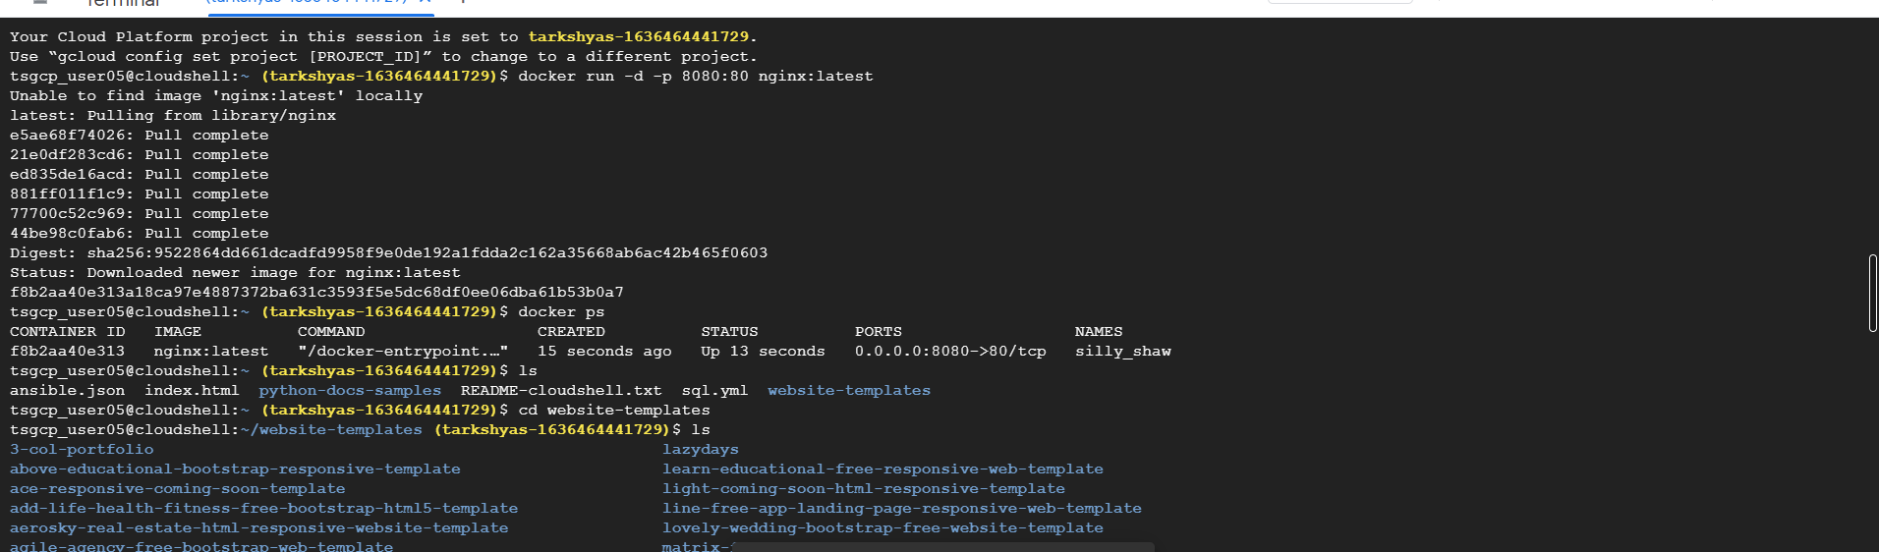

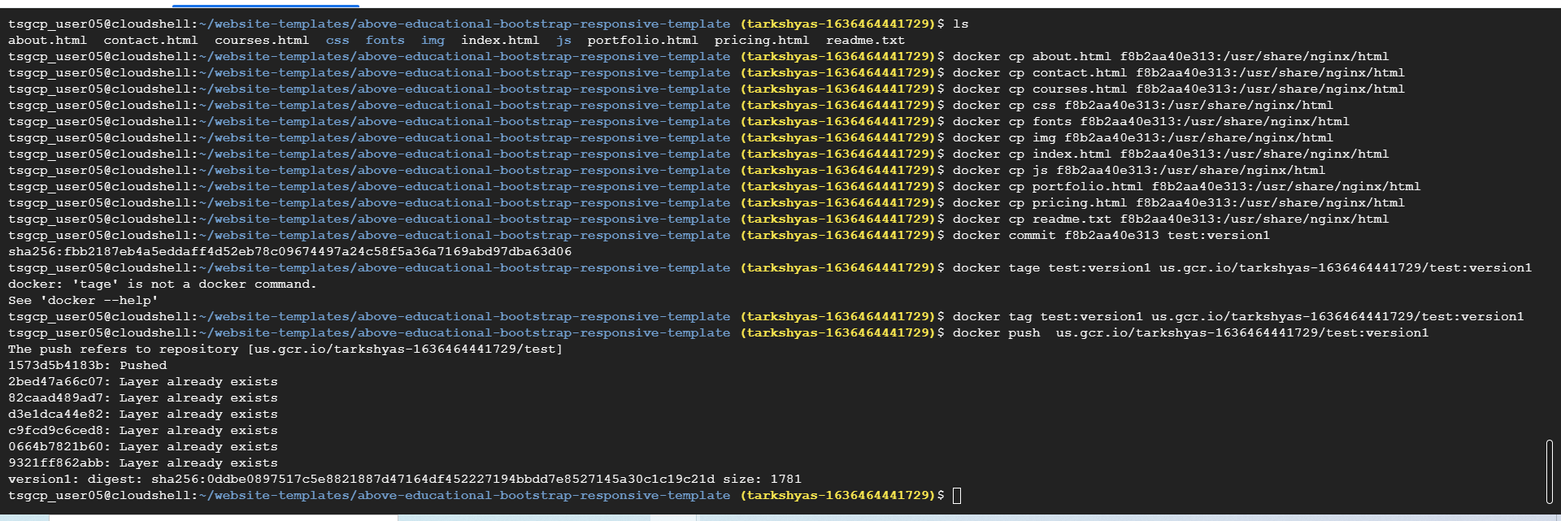

**Vm instance creation:**

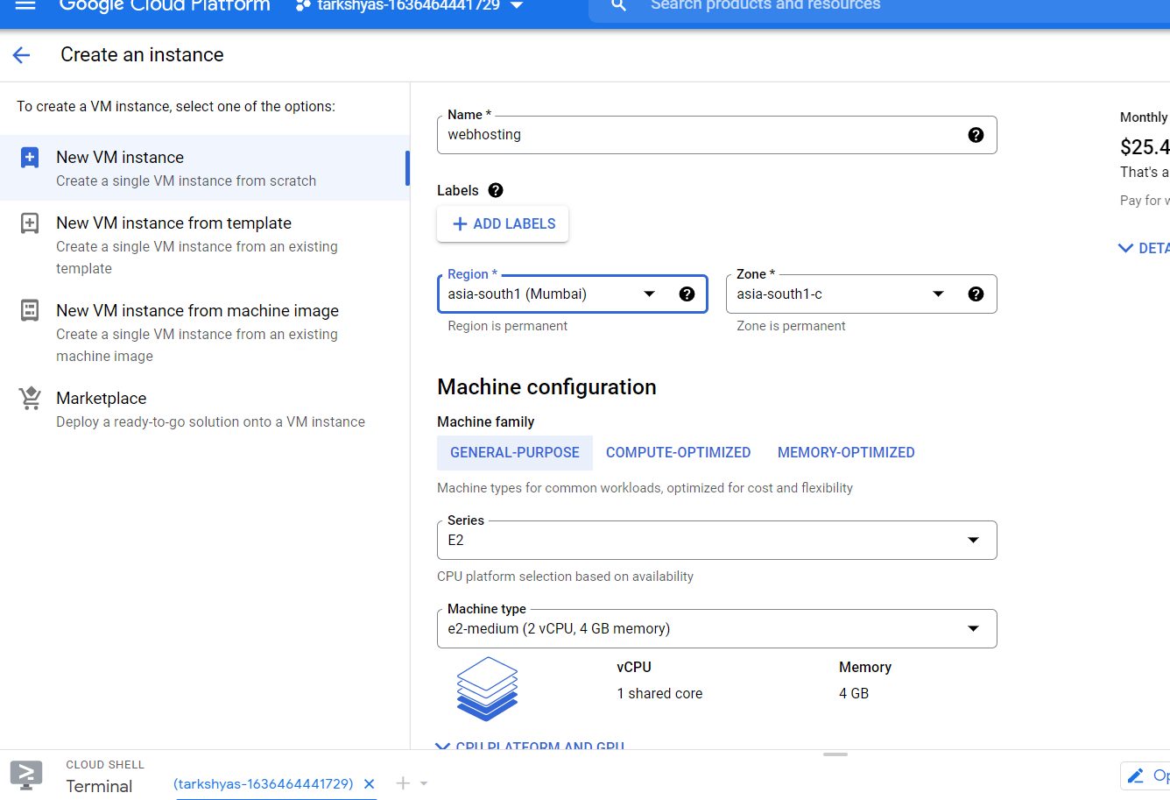

**Deploying container:**

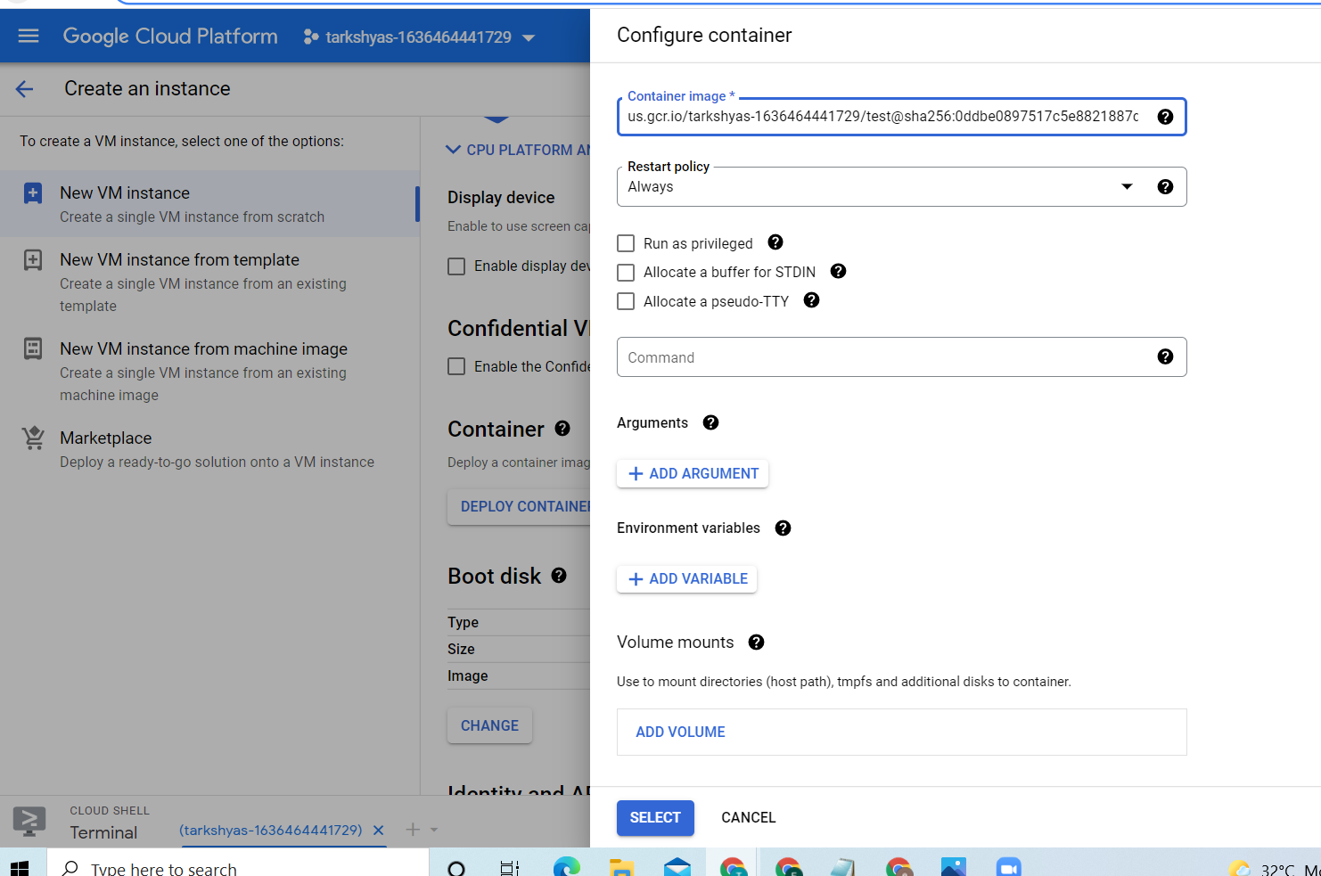

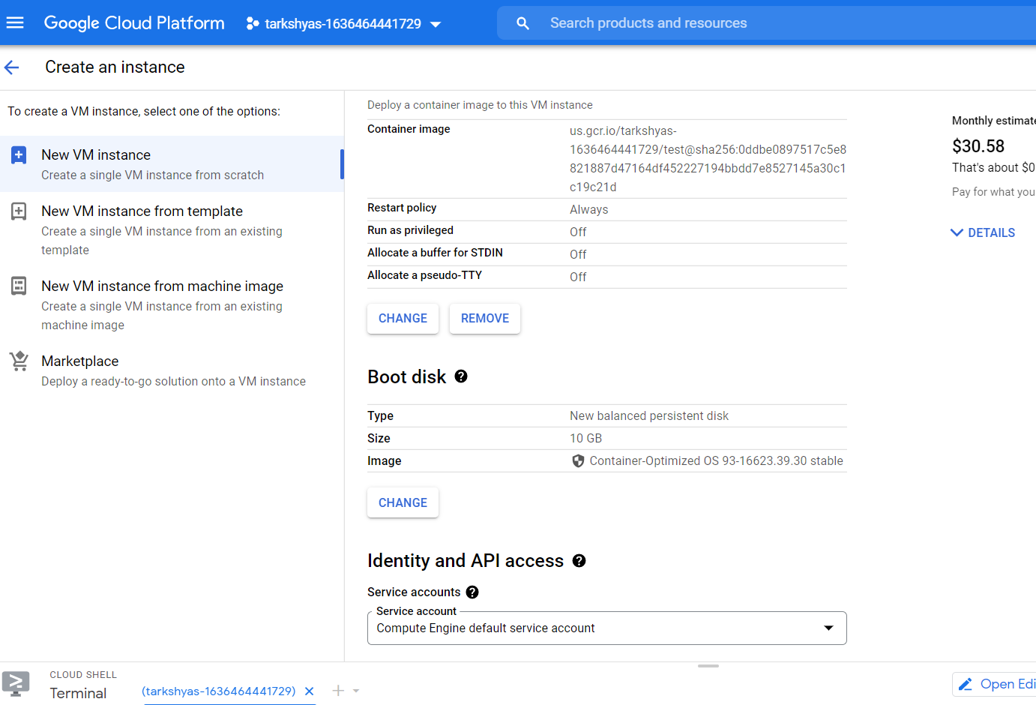

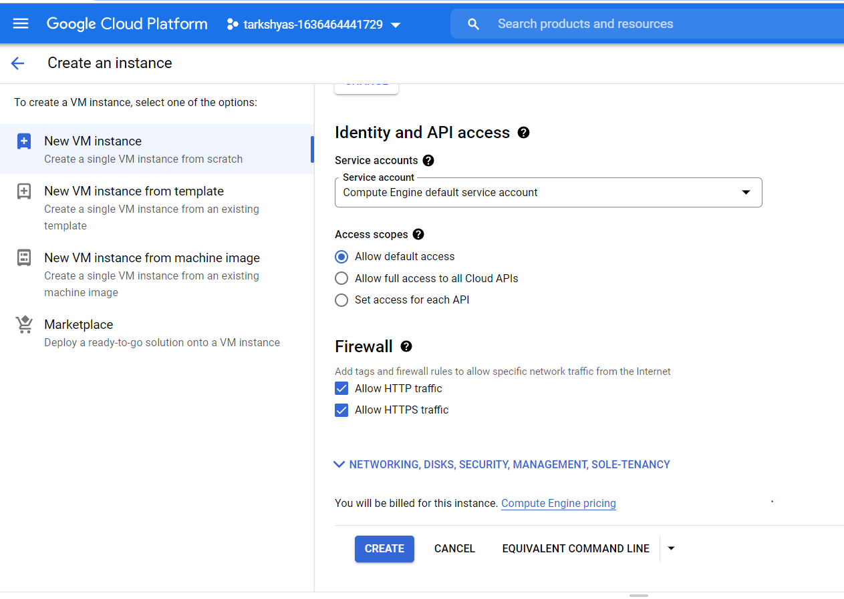

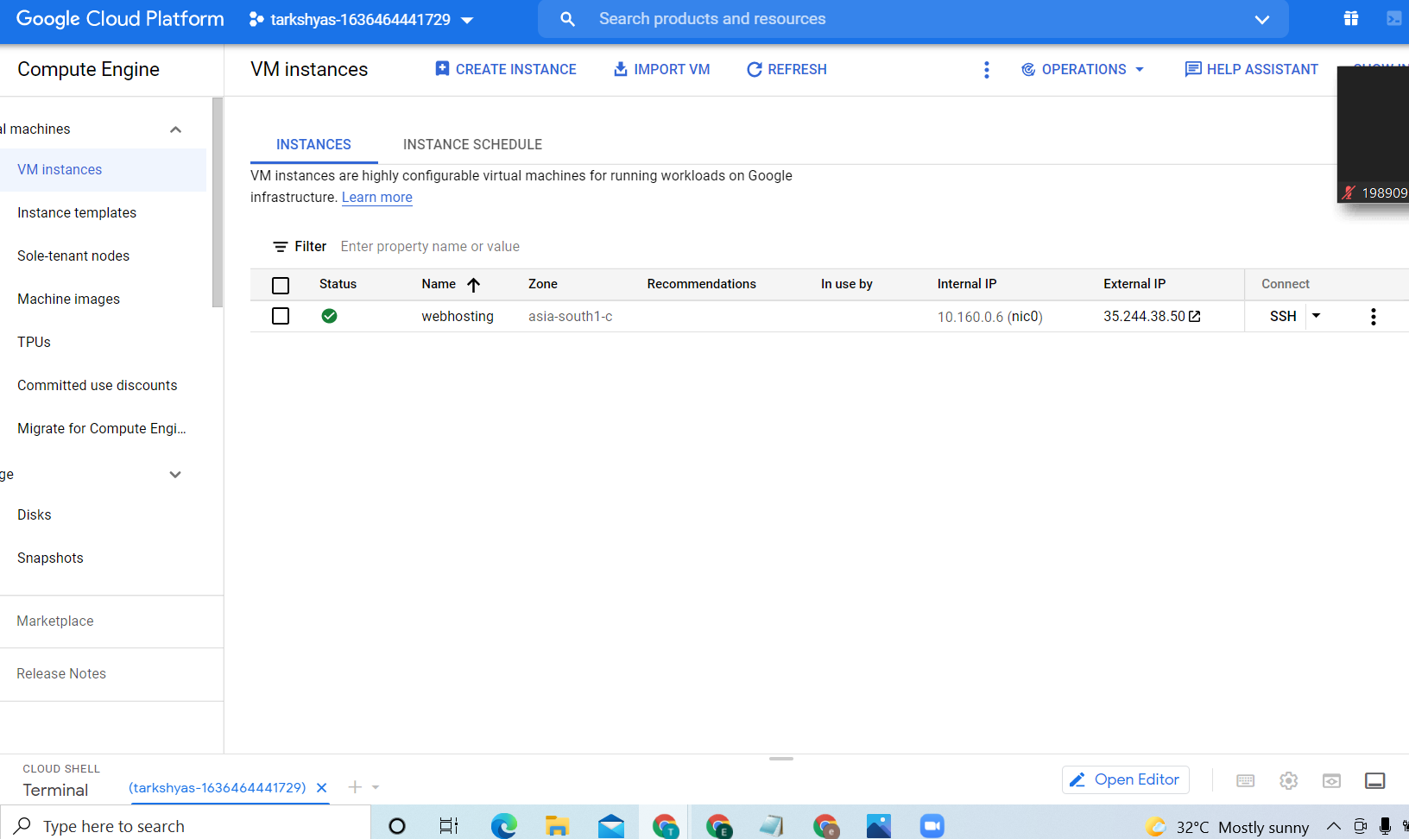

**Copy the external ip and browse on the search engine**

**Output:**



**Q2. VPC Network to communicate between 2 vm instances present in different network**

**Create two vpc network with firewall rules**

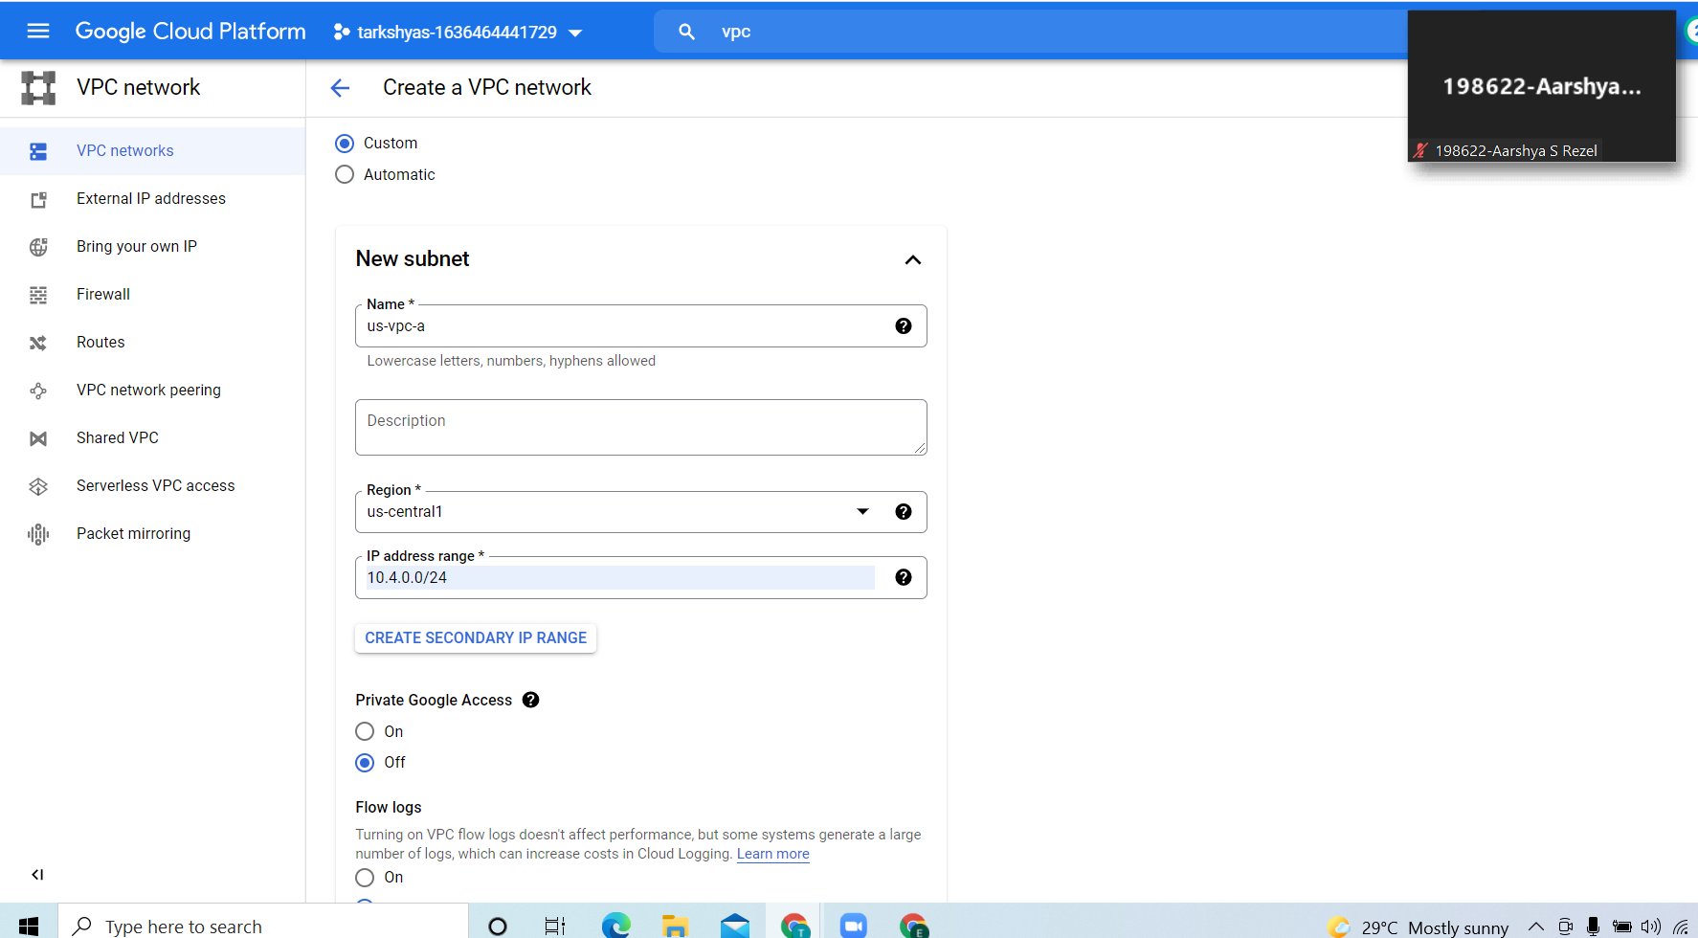

**Vpc network in us region**

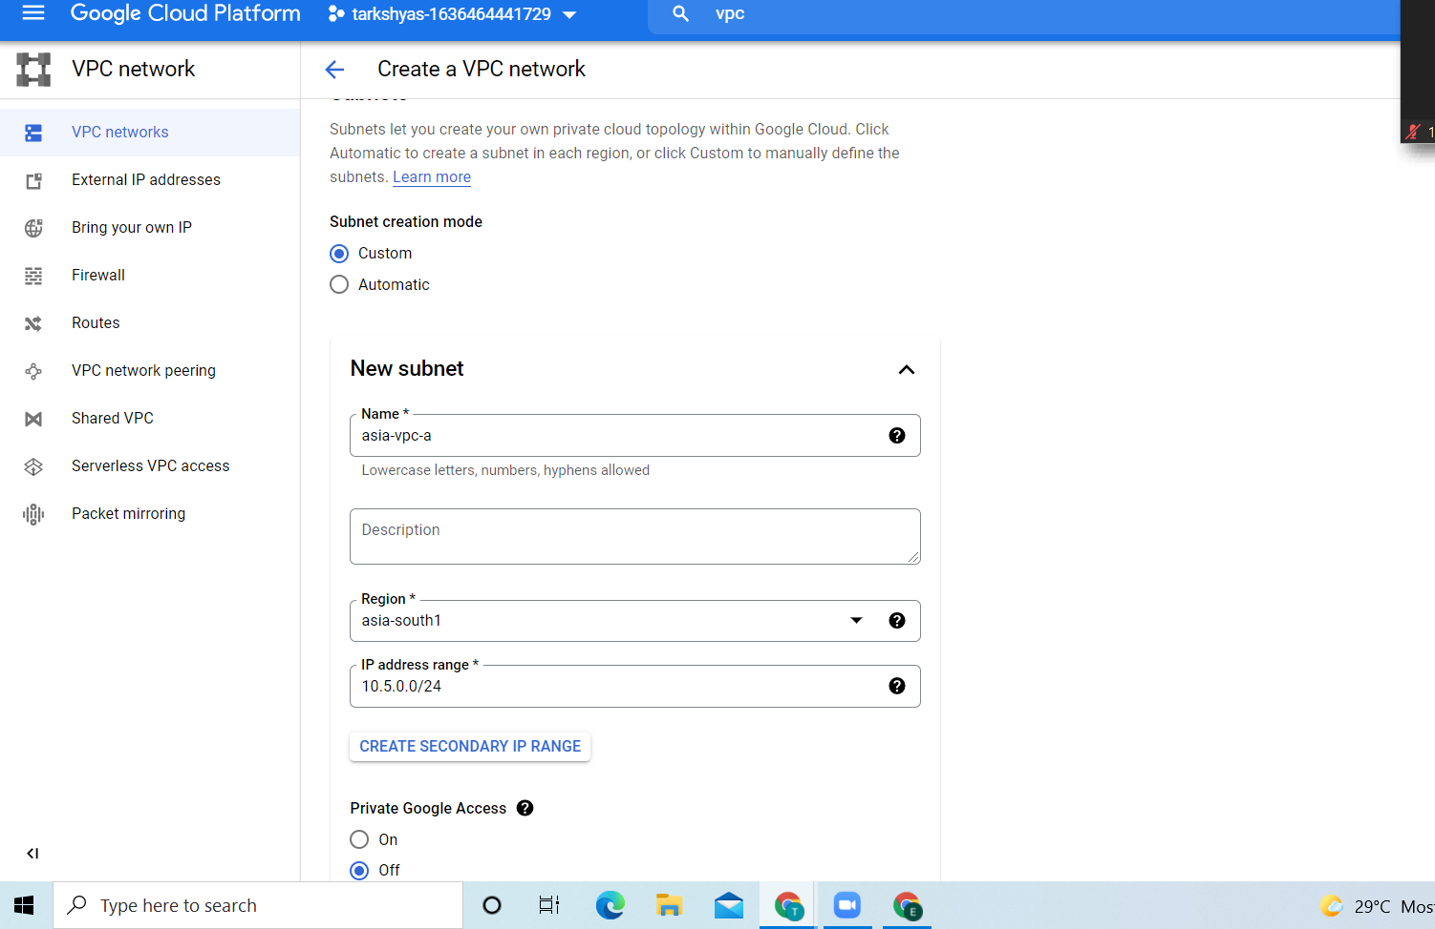

**Vpc network in Asia region**

**Adding firewall rules:**

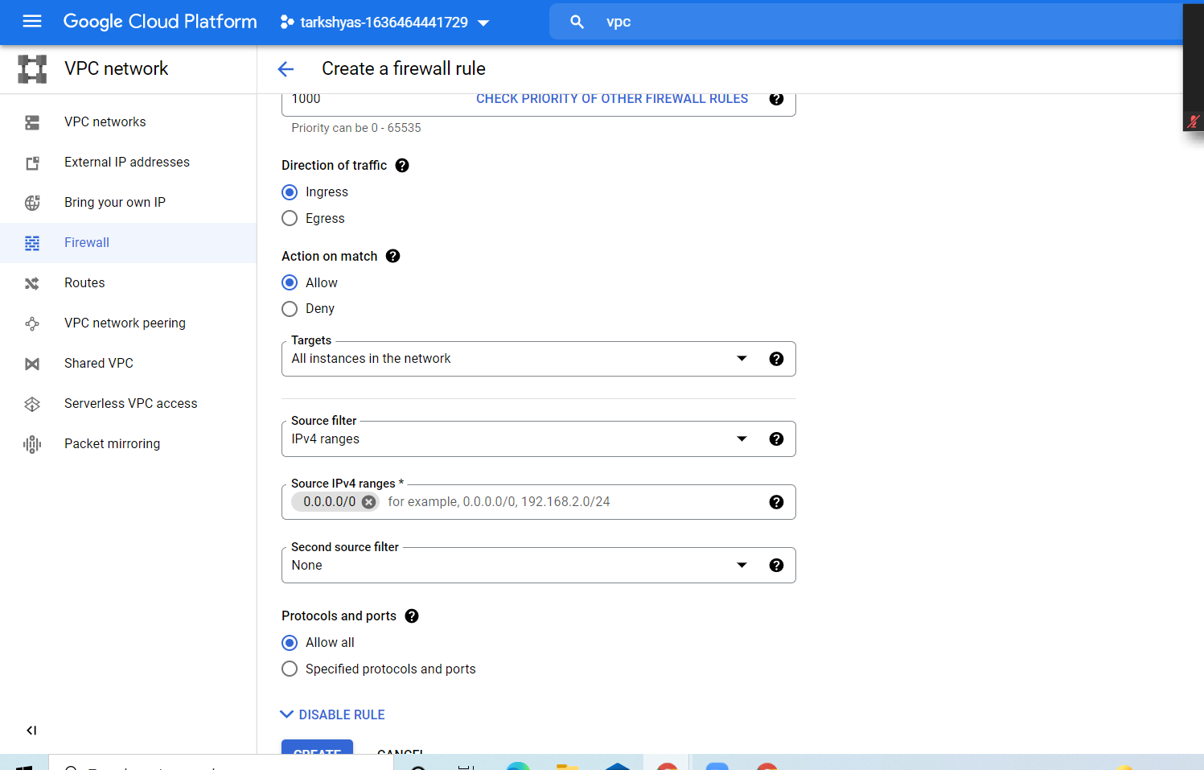**create two vm instance and set the network interfaces for both the vm instances as created networks in different region.**

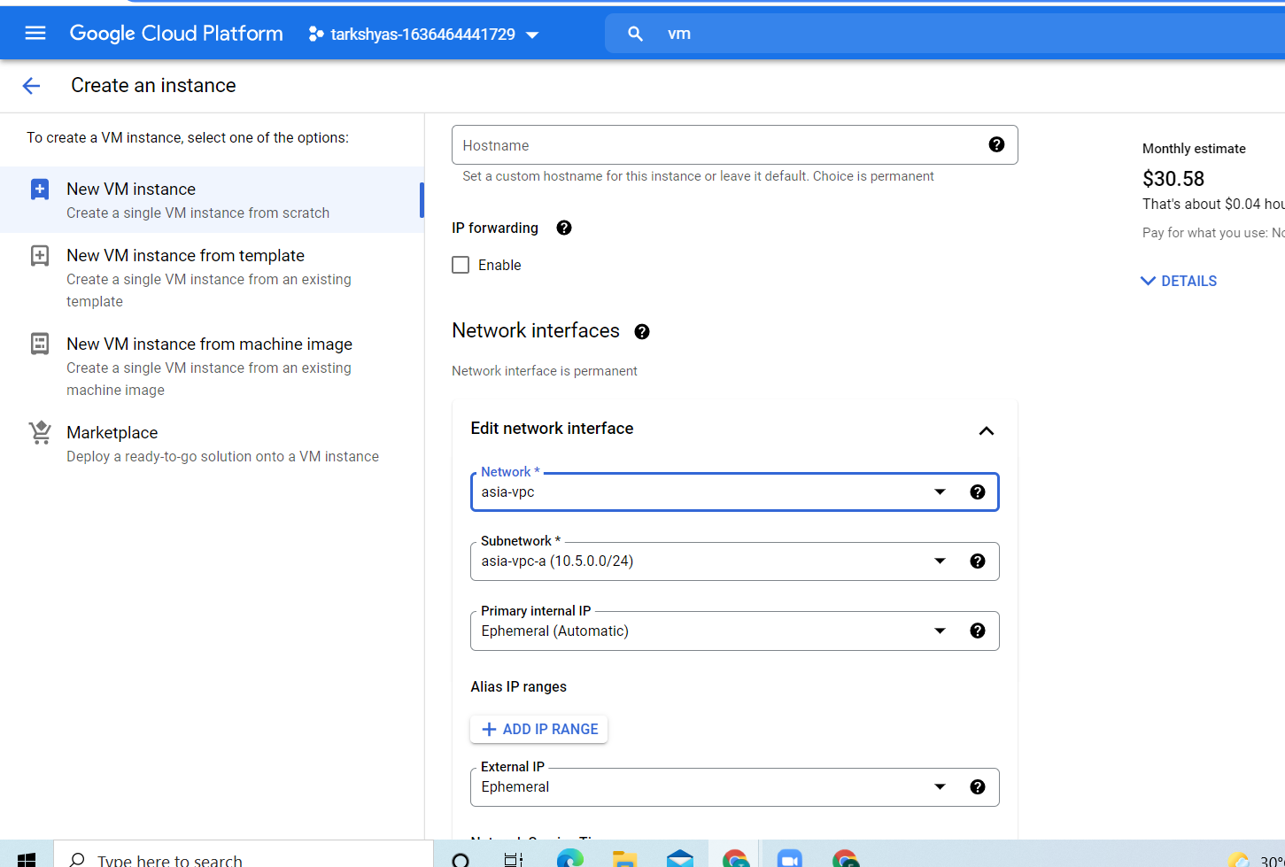

**vm instances in two different regions are created.**

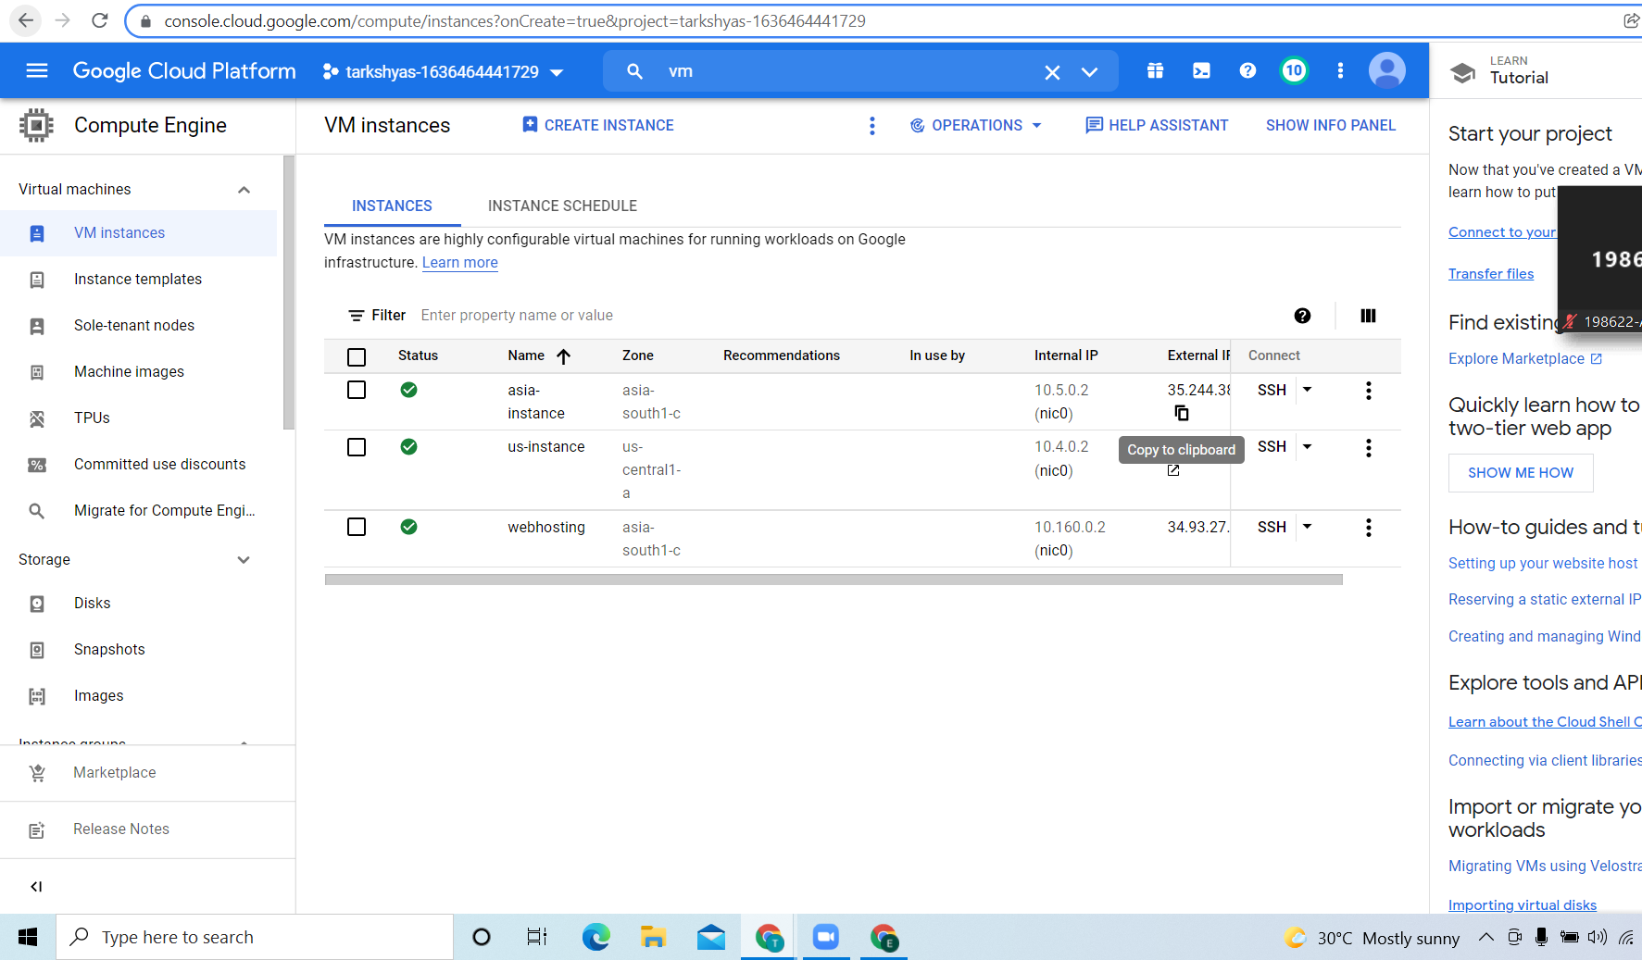

**In order to connect to the two vm instances we need to create VPN network.**

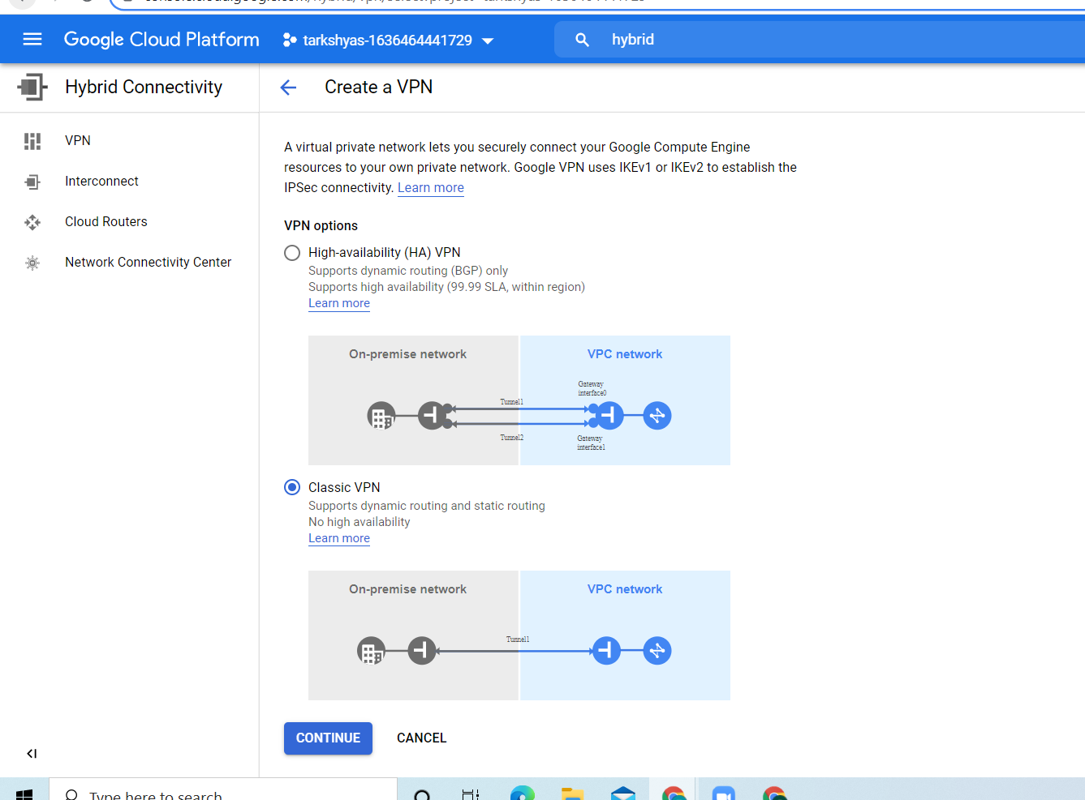

**Set name and region for the VPN network and select the reserved ip address.**

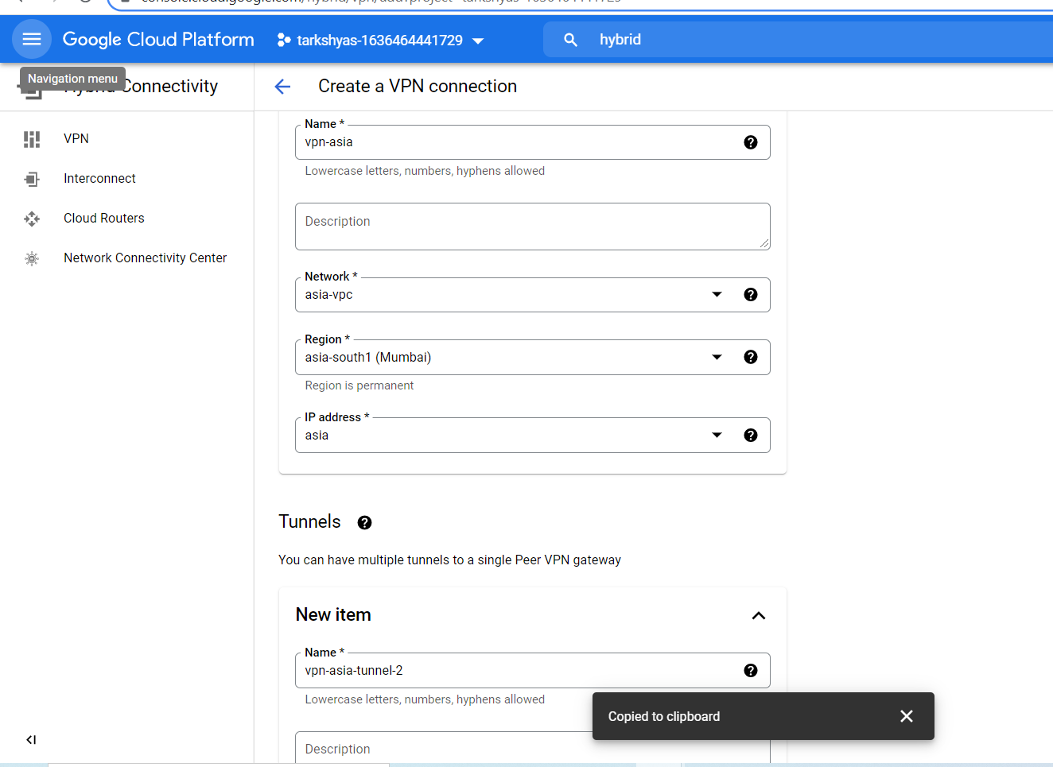

**For tunnels, the remote peer ip address should be the reserved ip address of the network created in another region. Then create and copy the key generated.**

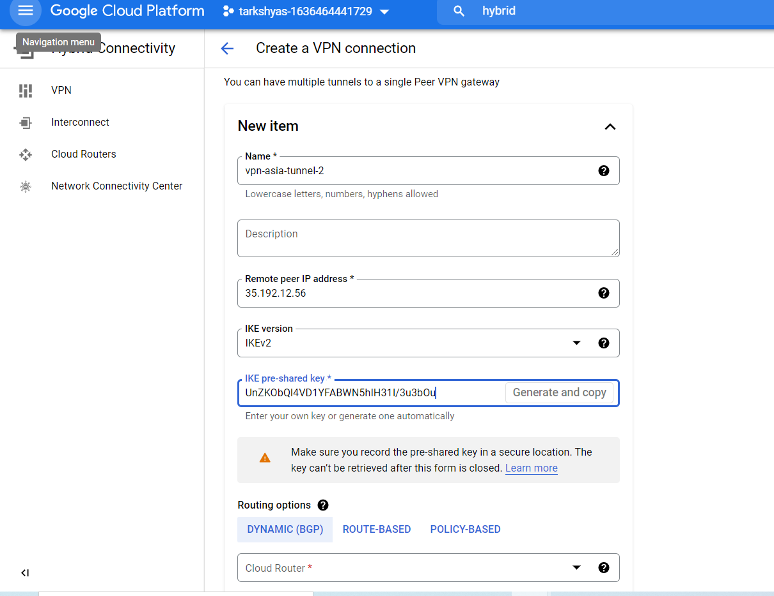

**we have 3 routing options :**

**1. Dynamic based**

**2. Route-based**

**3. Policy-based**

**Here we are using dynamic based. Therefore, we need cloud router.**

**Creation of cloud router.**

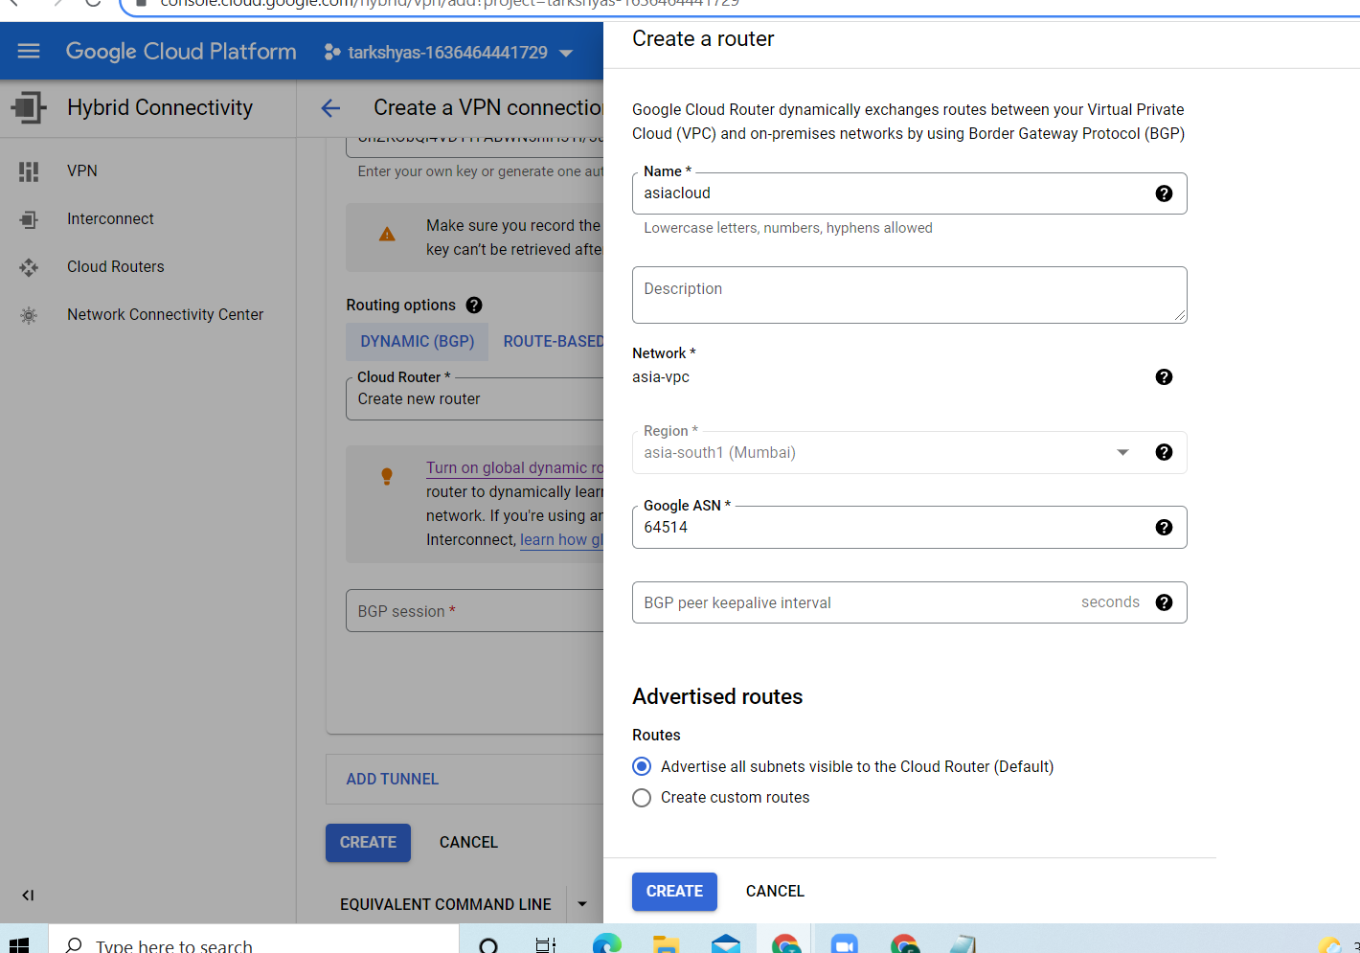

**Next we need to add bgp session**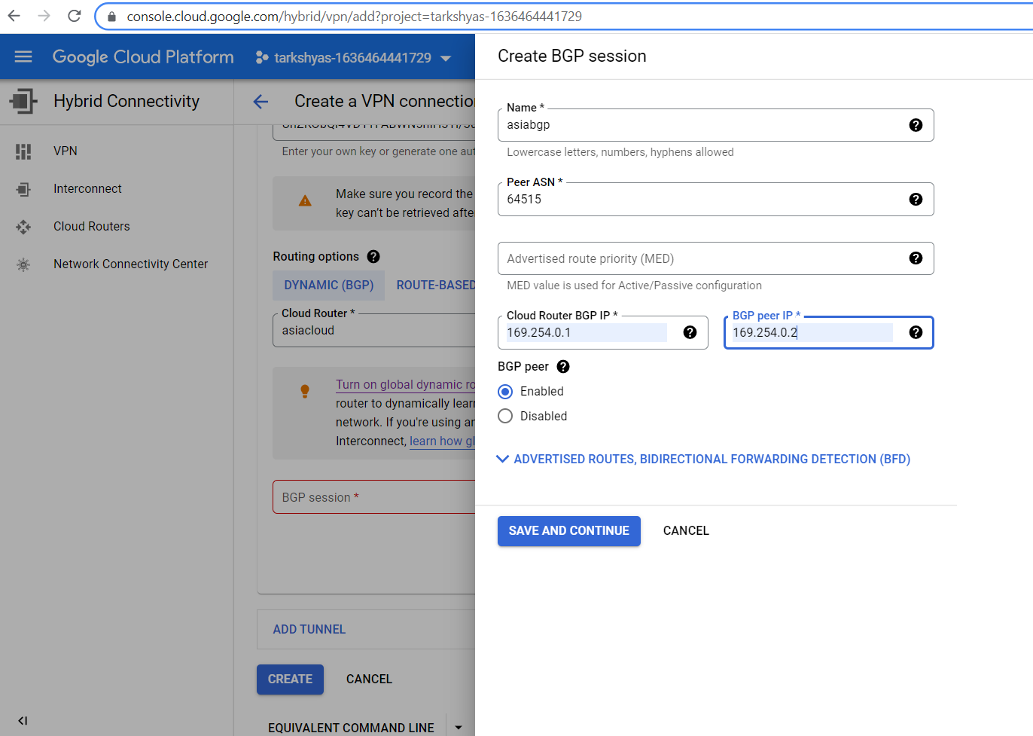

**Similarly we need do the same steps for making the other VPN tunnel**

**Vpn tunnels are created.**

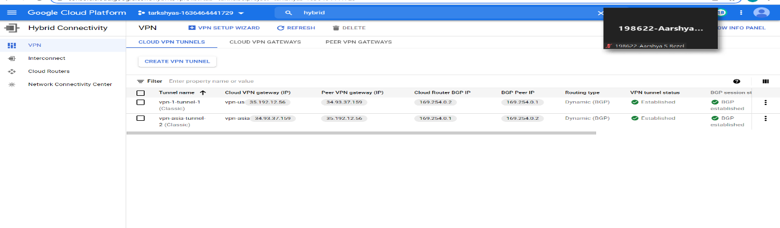

**Vpn gateways are created.**

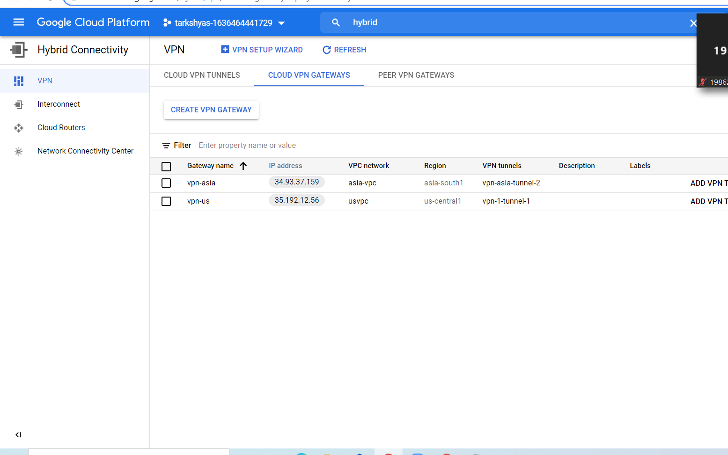

**Vpn tunnels:**

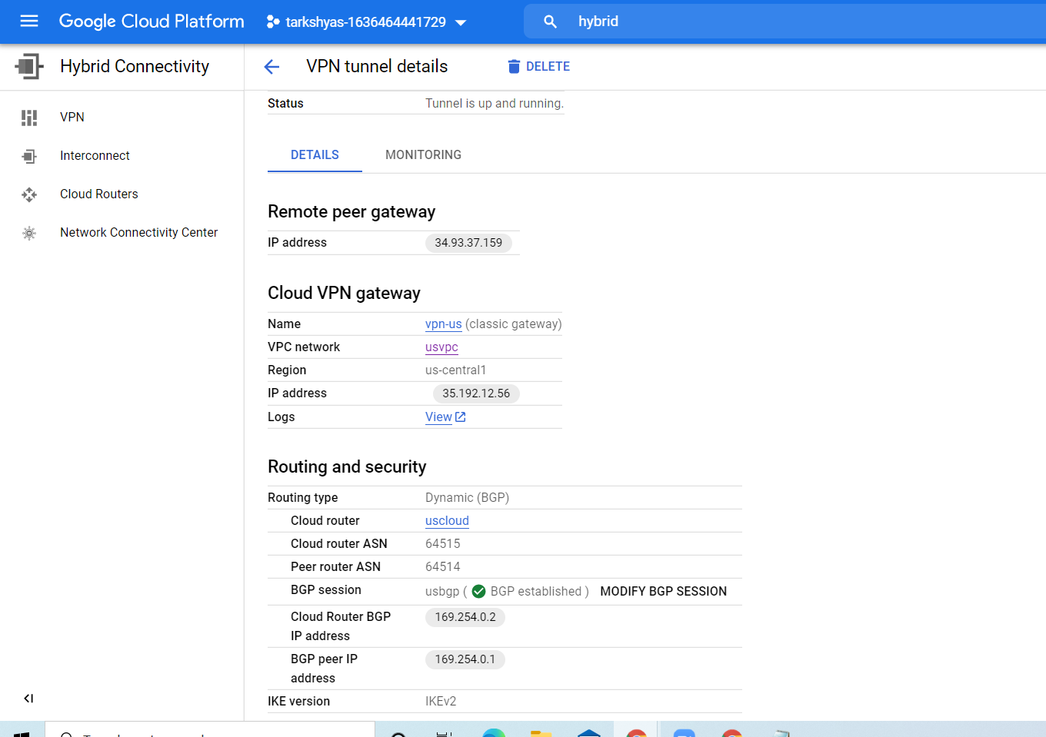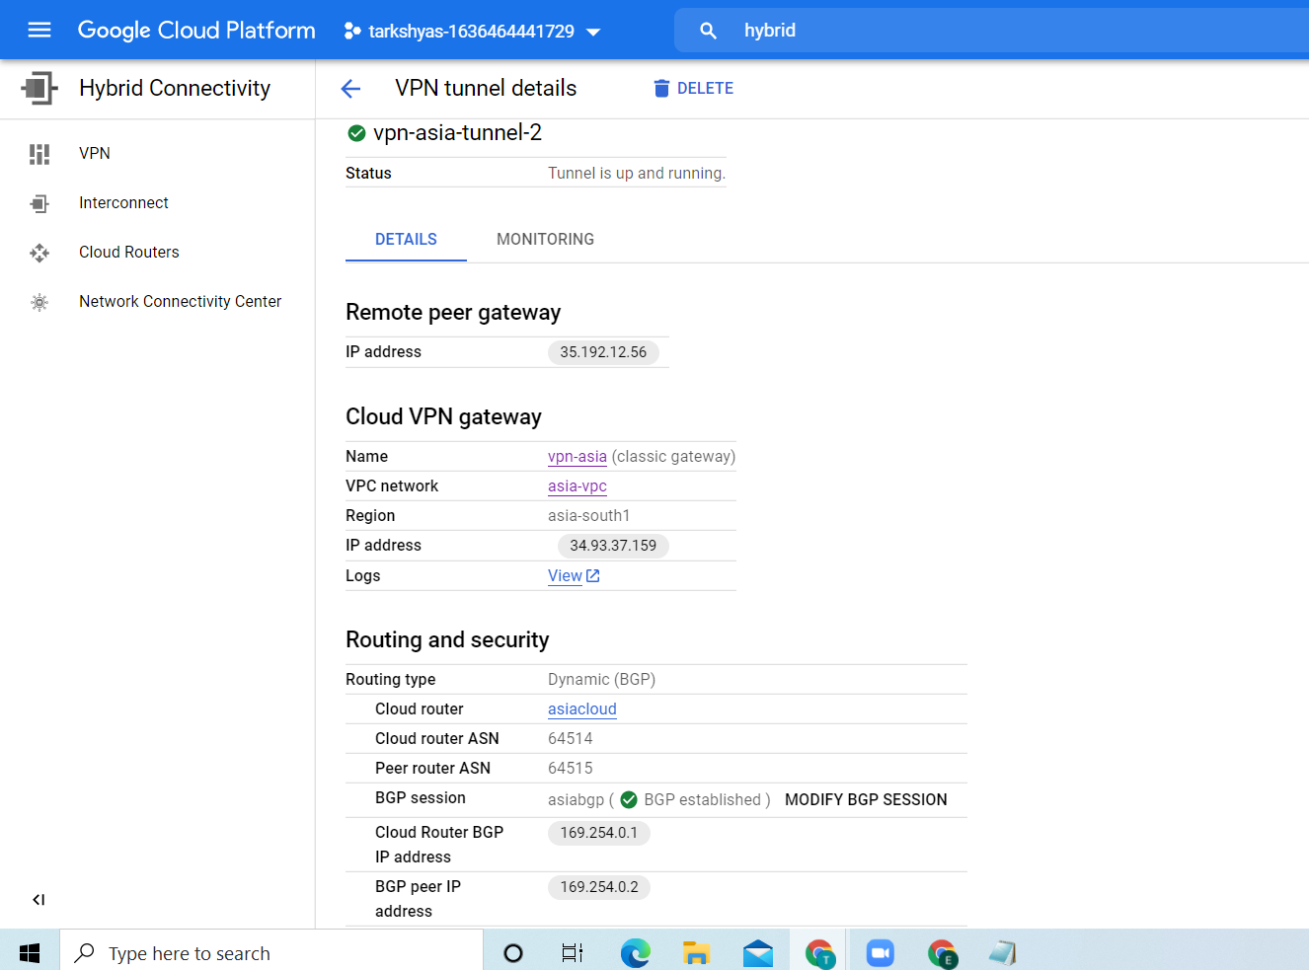

**After successful creation of vpn networks ,the two vm instances in different regions can easily communicate.**

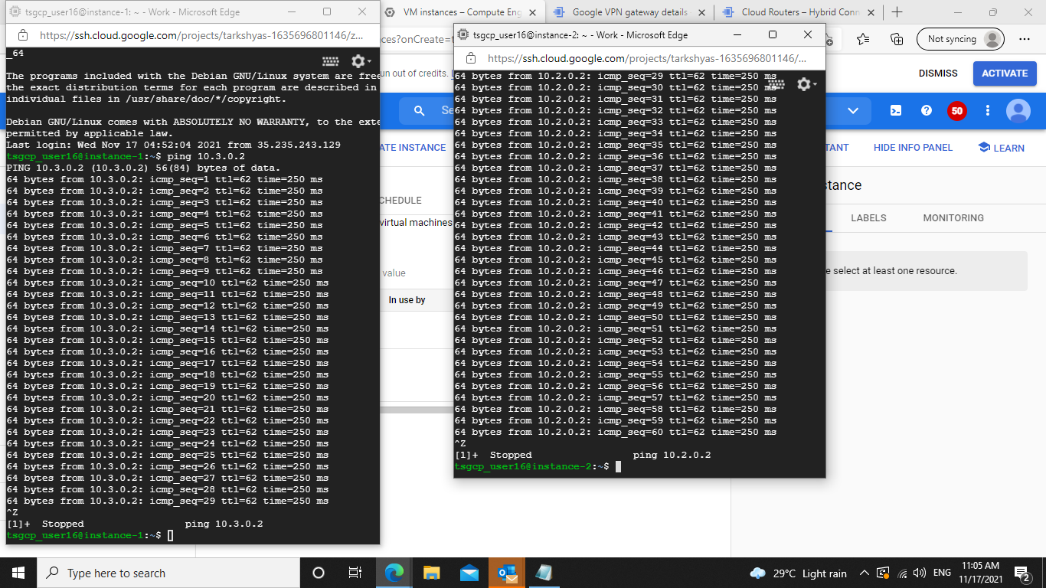

**Q3. & Q4. App Engine standard and flexible environment**

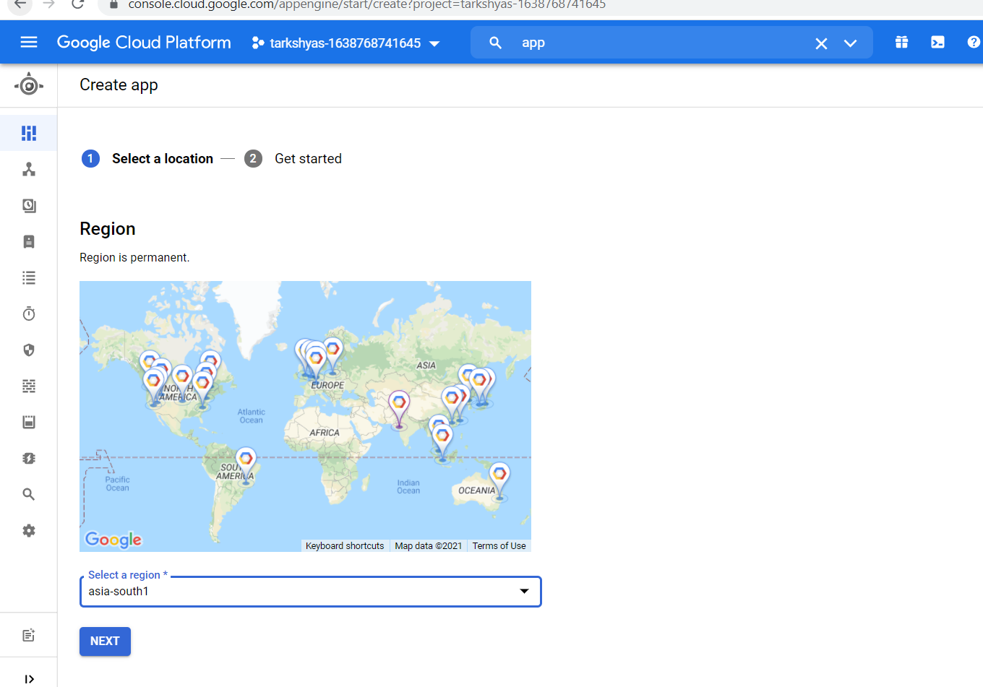

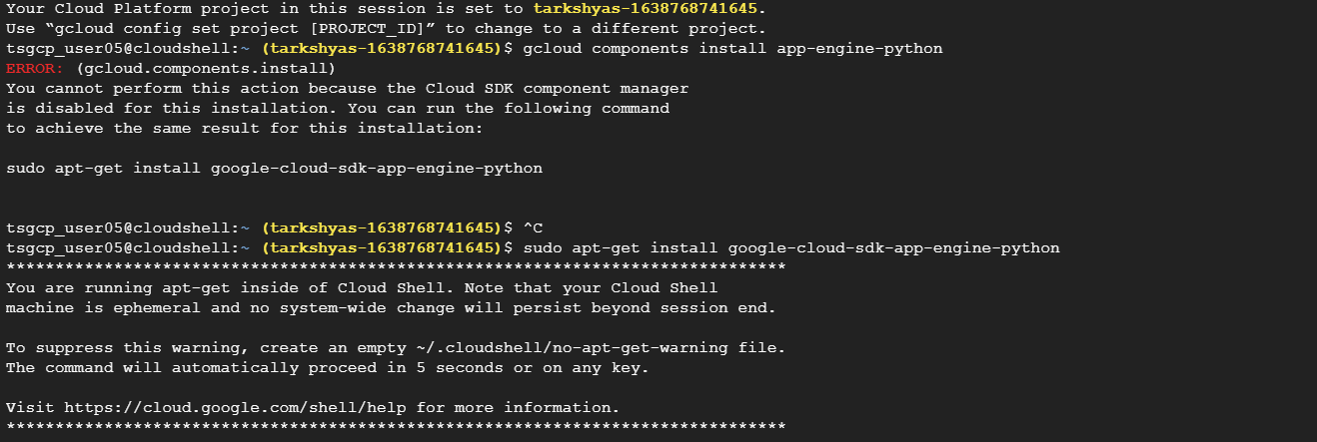

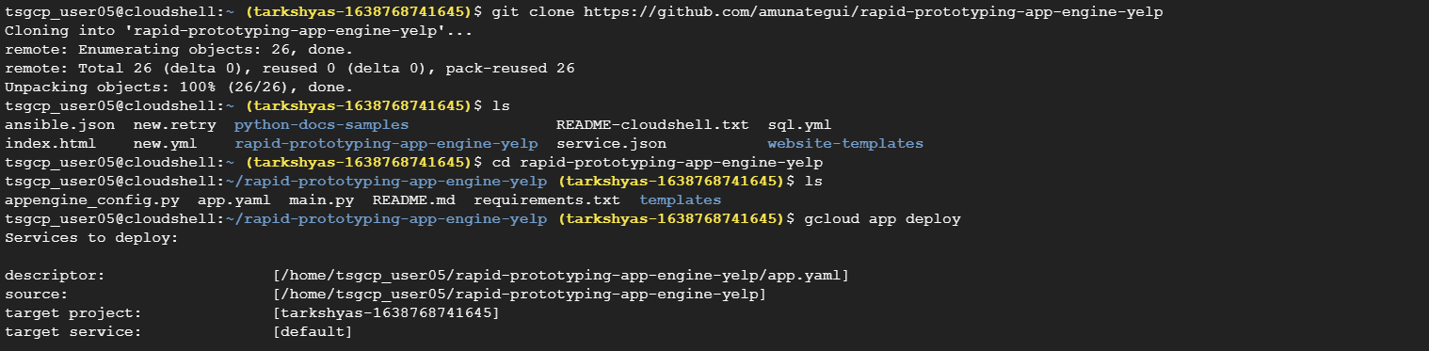

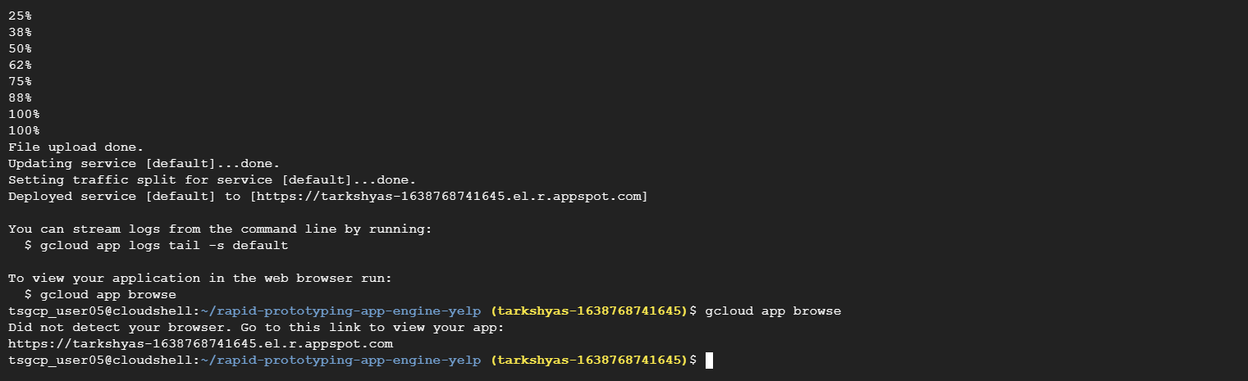

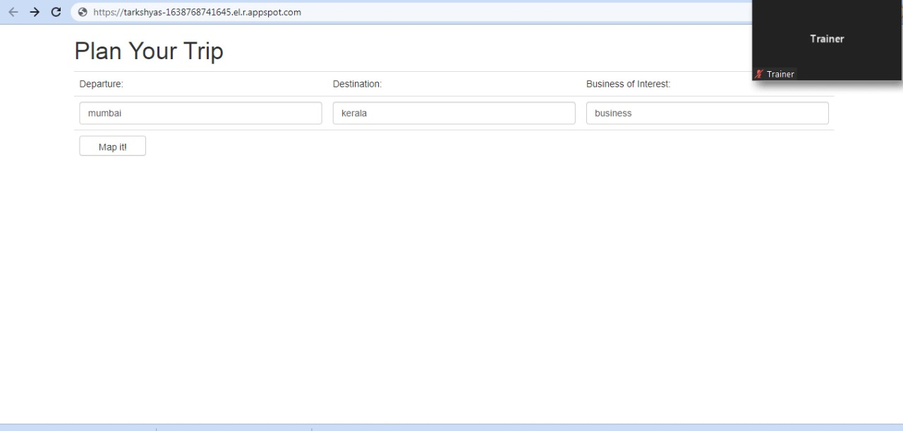

**Q7. VPC PEERING**

**Create two vpc networks And then add firewall rules:**

**Vpc network for asia region.**

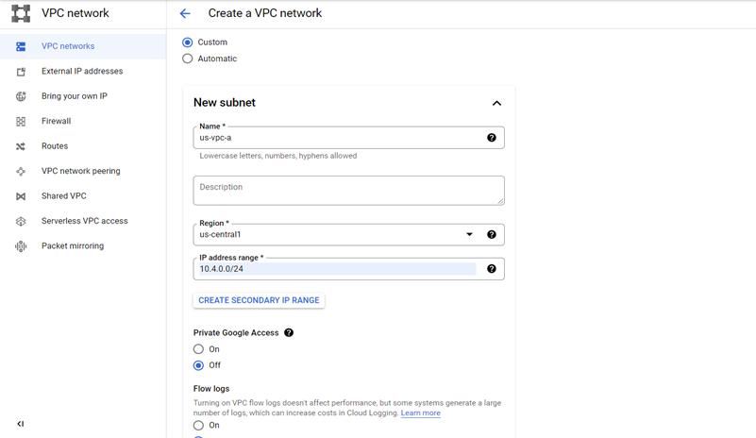

**Vpc network for us region.**

**Adding firewall rules:**

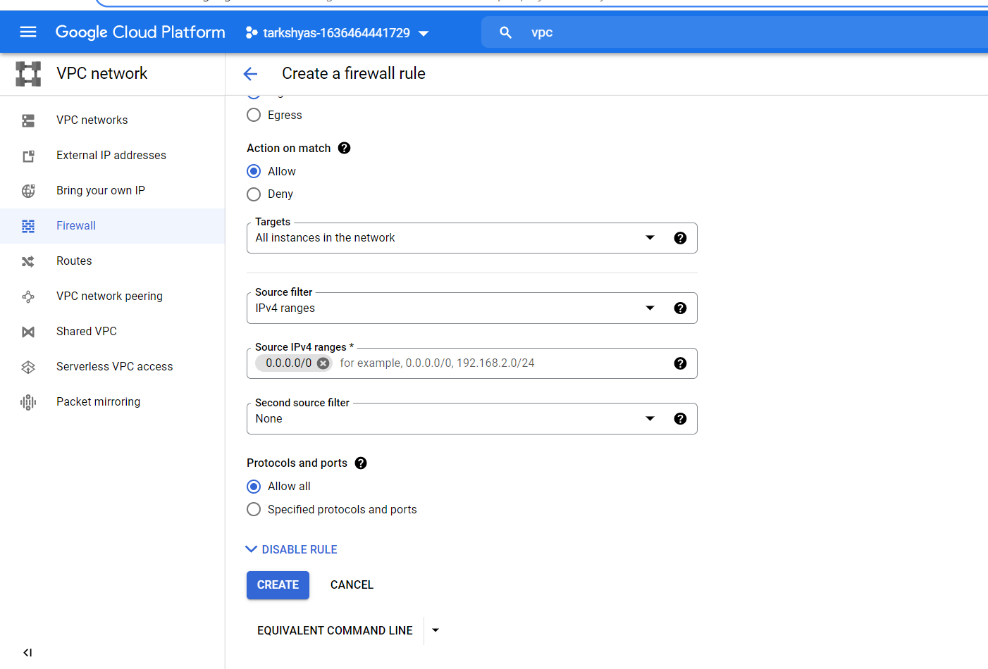

**Then create two vm instances with appropriate networks.**



**VM instances are created.**



**Vpc peering of both the networks.**

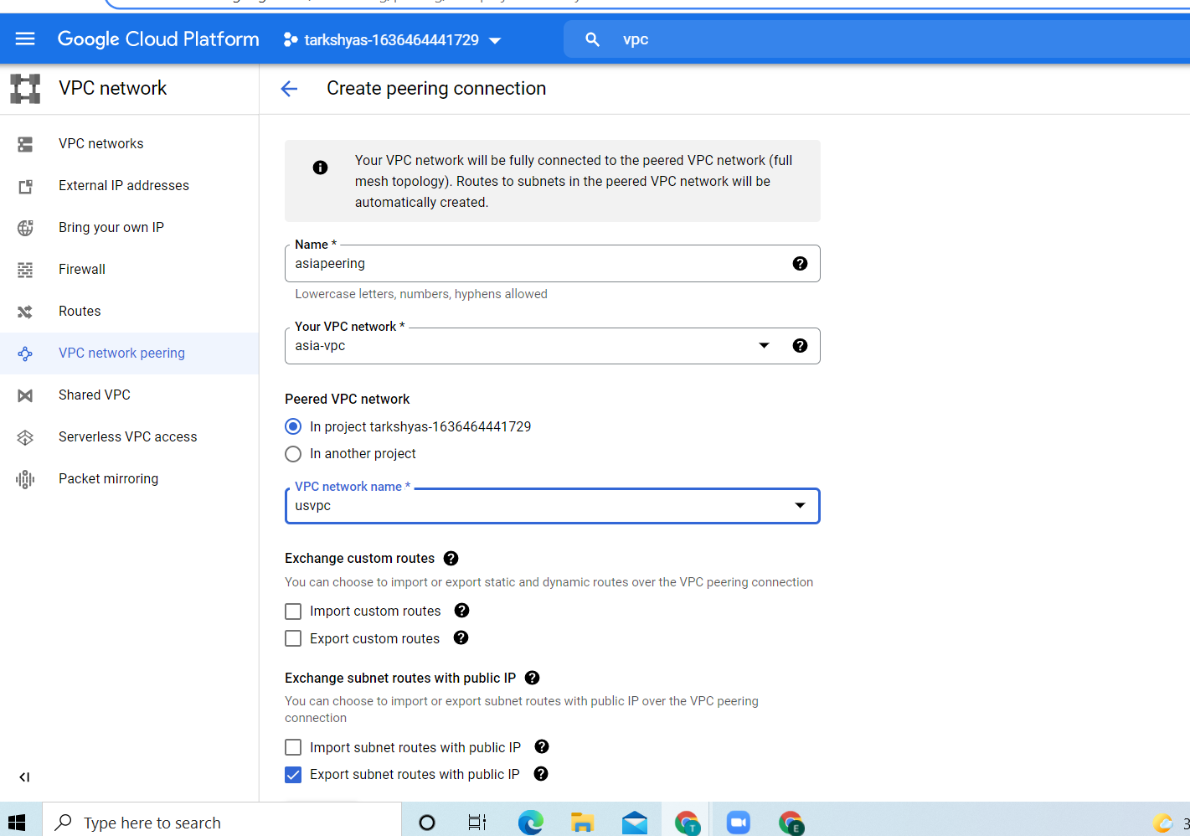

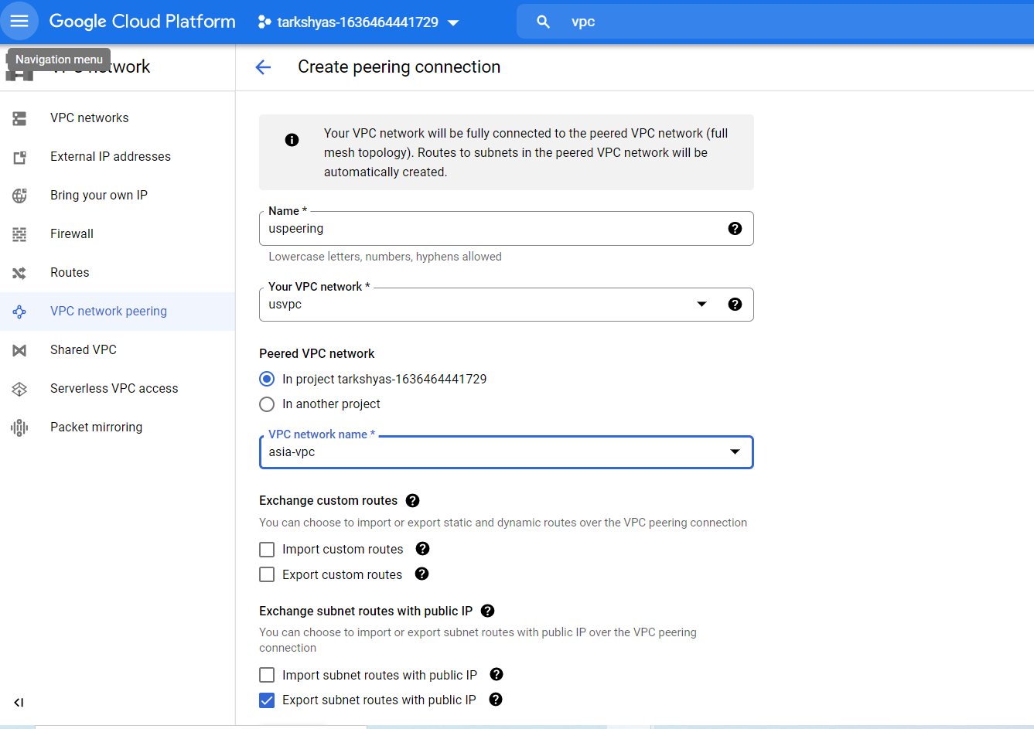

**Peering completed:**

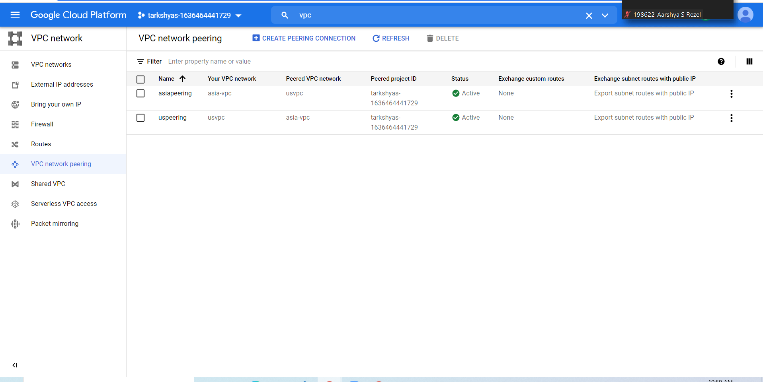



**Q10. GKE**

**In order to host a website using Kubernetes we need to create container.**

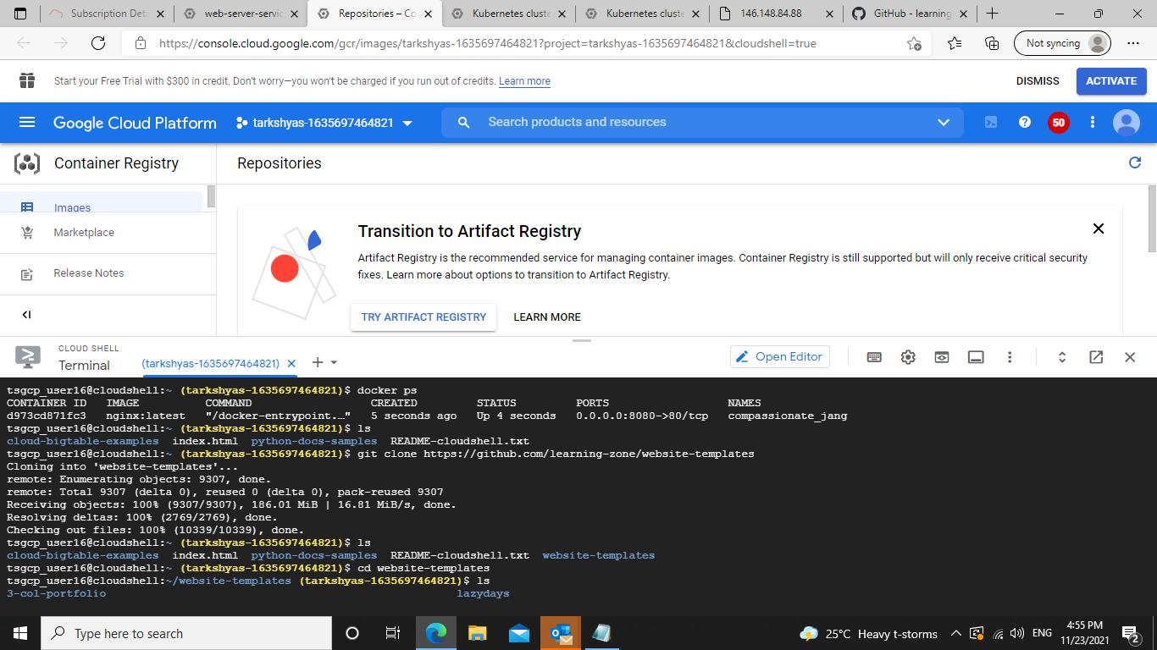

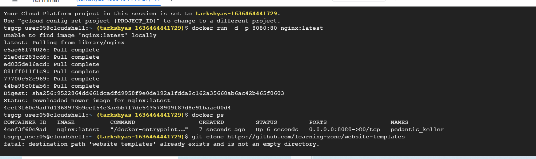

**To start the docker:**

**>docker run –d –p 8080:80 nginx:latest**

**To get the container details:**

**>docker ps**

**Copy the container Id.**

**git clone command :**

**> git clone** [**https://github.com/learning-zone/website-templates/above-educational-bootstrap-responsive-template**](https://github.com/learning-zone/website-templates/above-educational-bootstrap-responsive-template)

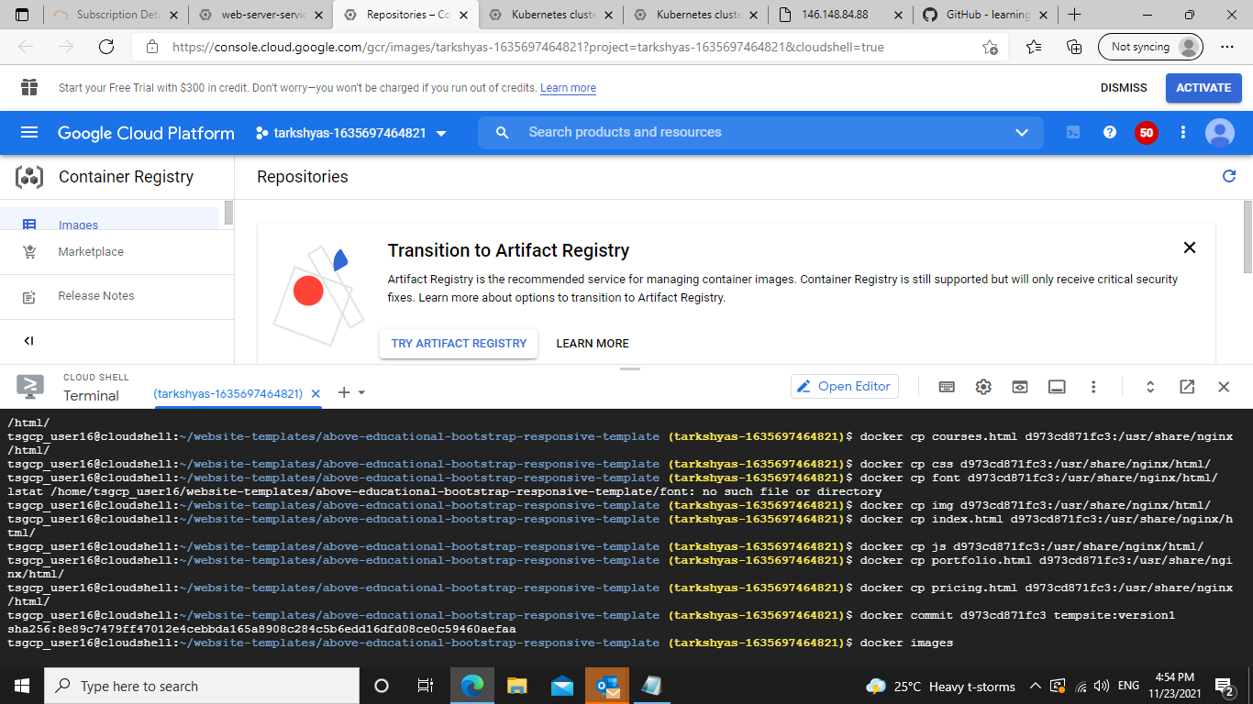

**Then change the directory using cd command and list all the file inside that directory using ls command. Then copy each and every files using :**

**>docker cp filename containerid :/usr/share/nginx/html**

**Then commit the files :**

**> docker commit containerid name:version**

**After that we need to deploy the container**

**For that , we need to tag and push the container**

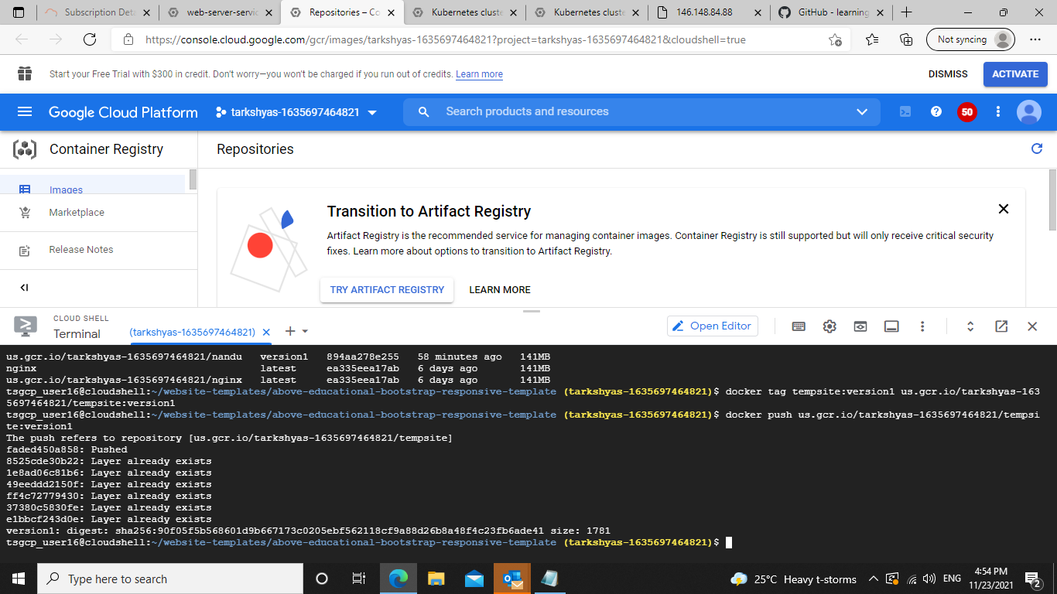

**We can preview the webpage by the preview option in the shell.**

**Then create kubernetes engine:**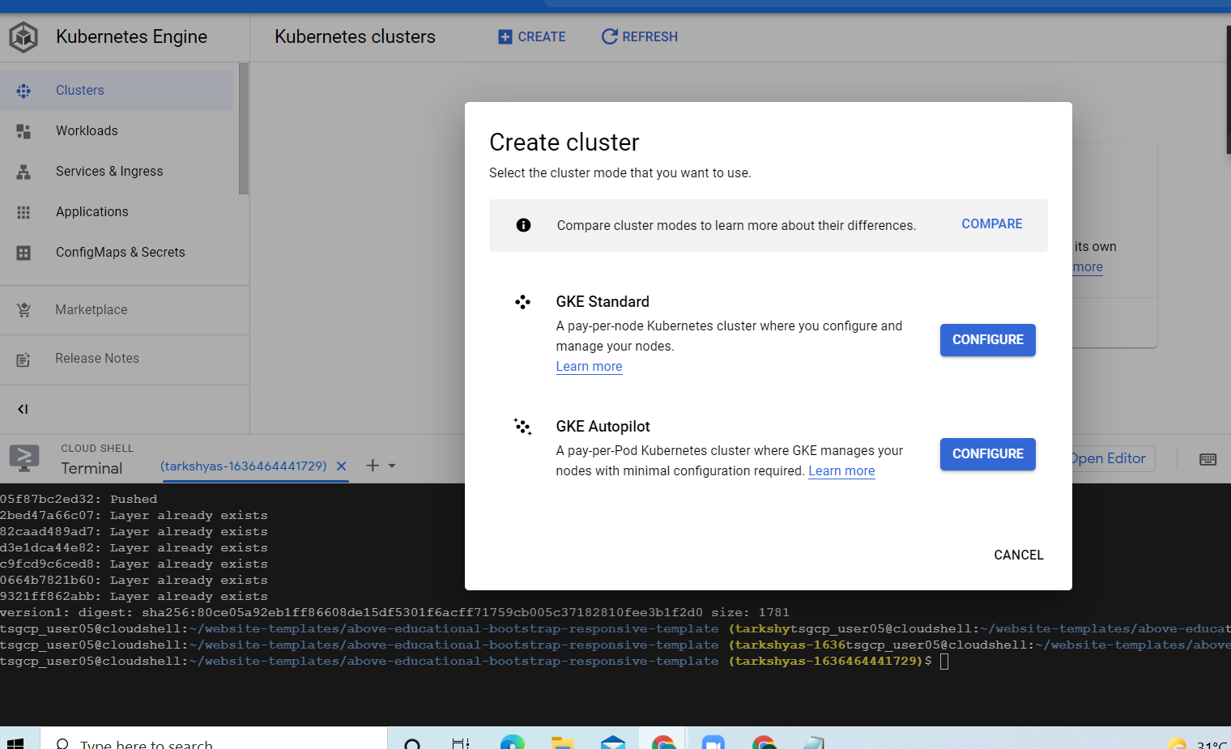

**Select GKE standard**

**Then create the cluster and connect it with the shell.**

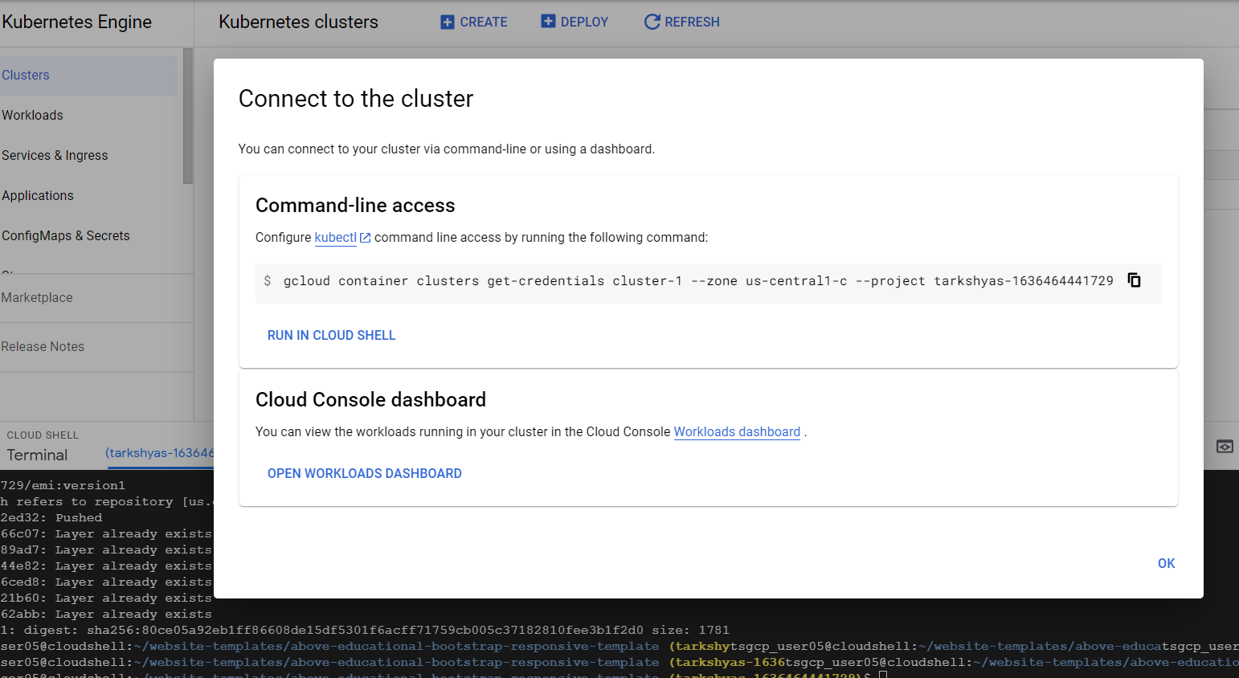

**Copy and run this command in the shell**

**After establishing the connection, we need to create and expose the deployment of the Kubernetes engine.**

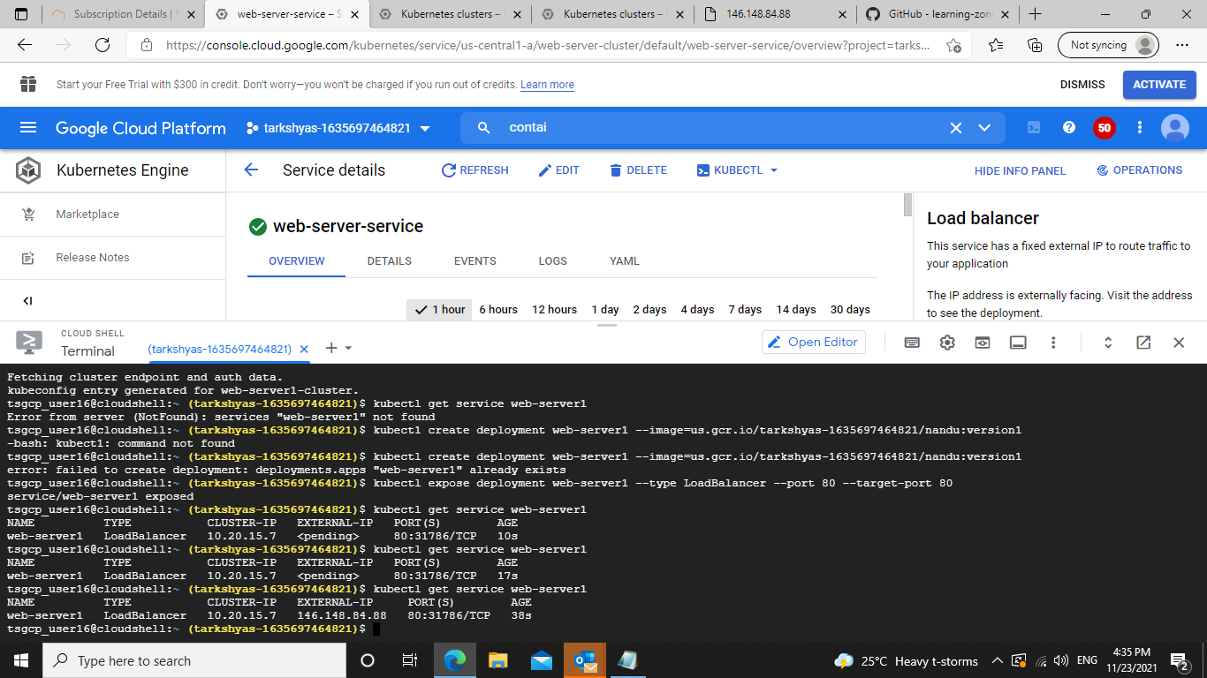

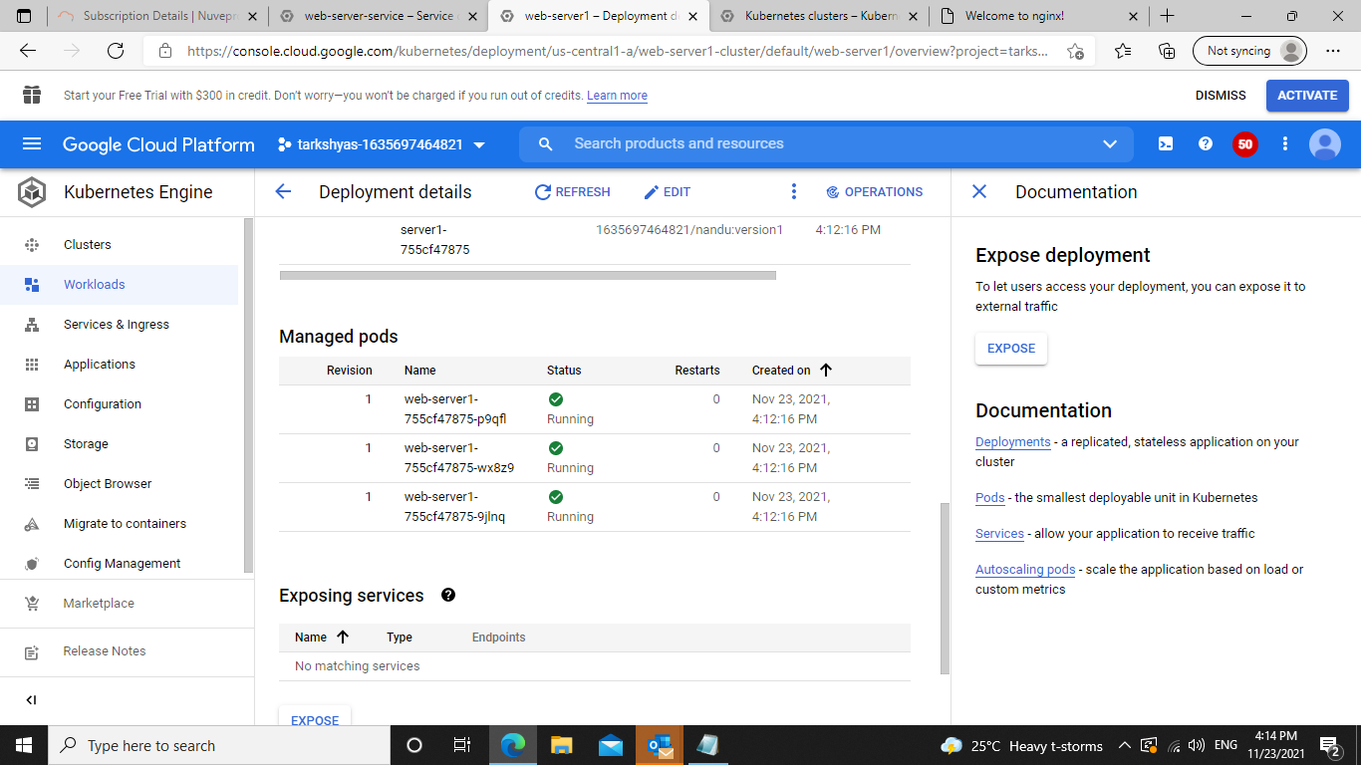

**Output :**



**Q9. LOAD BALANCER**

**Create instance template**

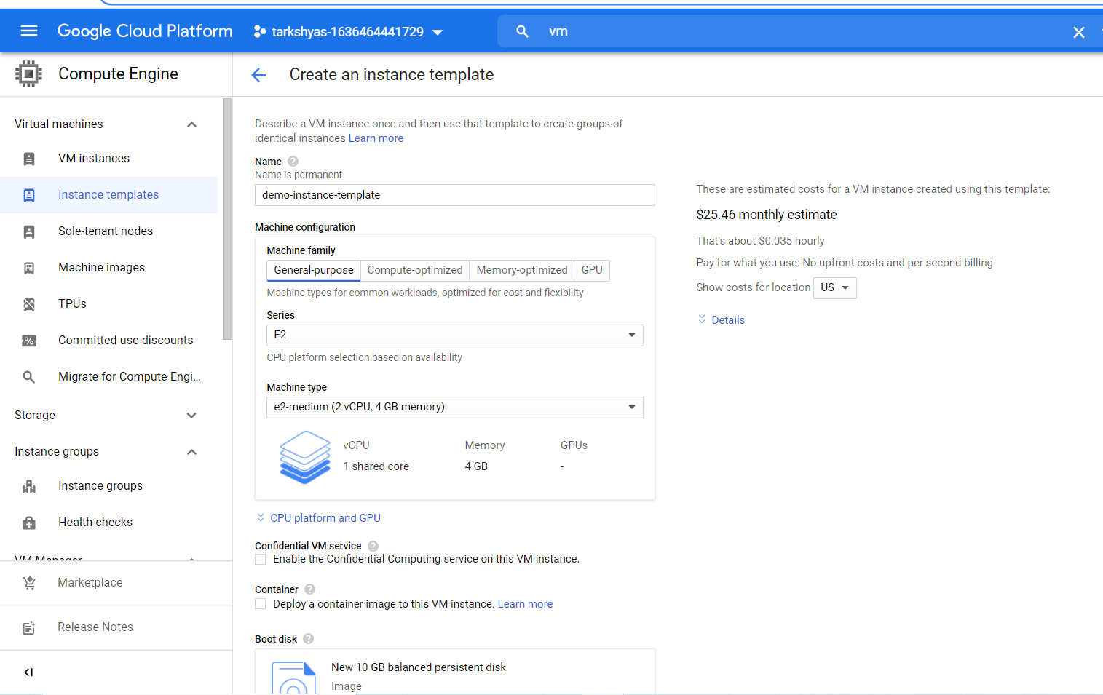

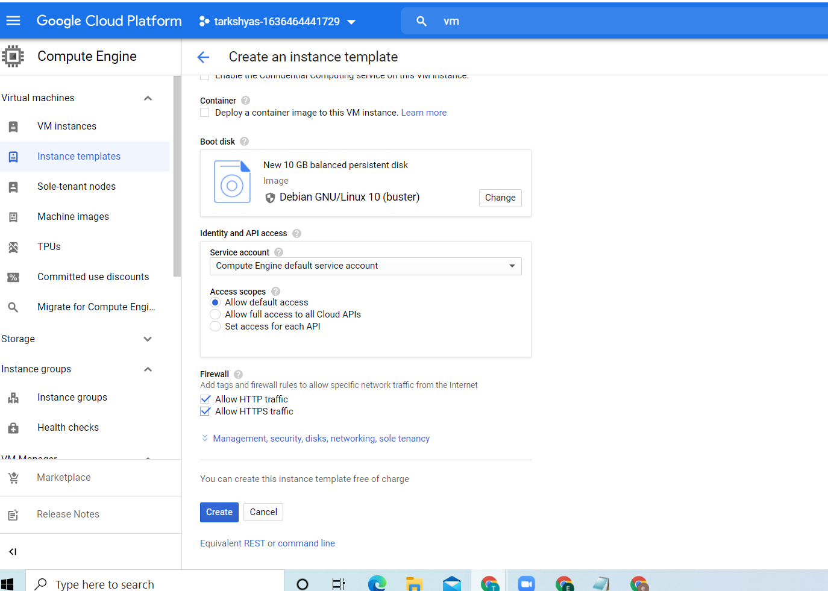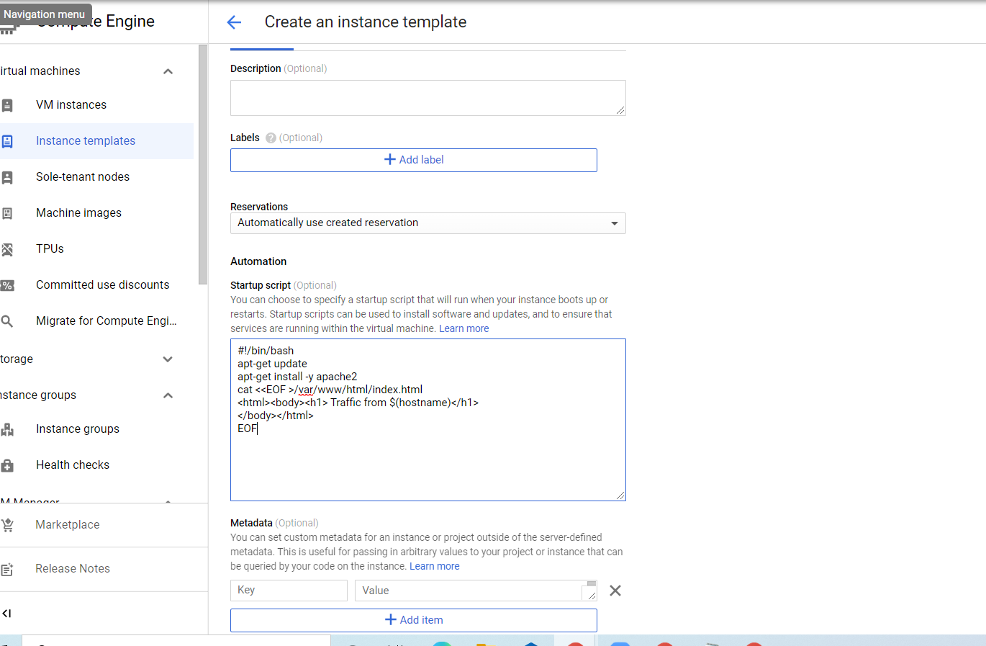

**In the automation, we can mention the startup script.**

**Instance template created.**

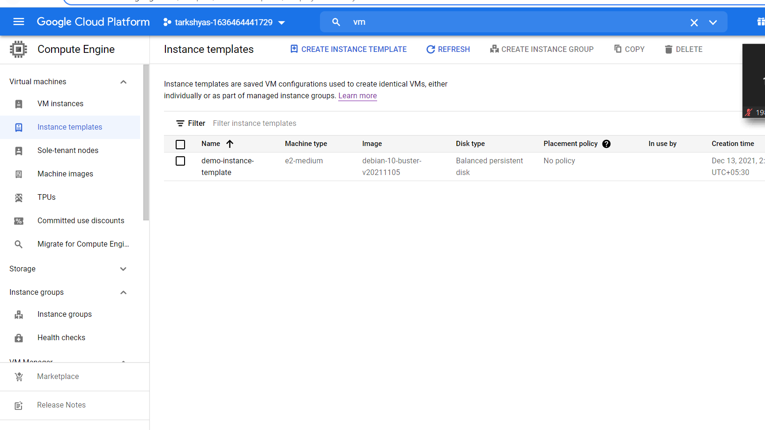

**Then create instance group**

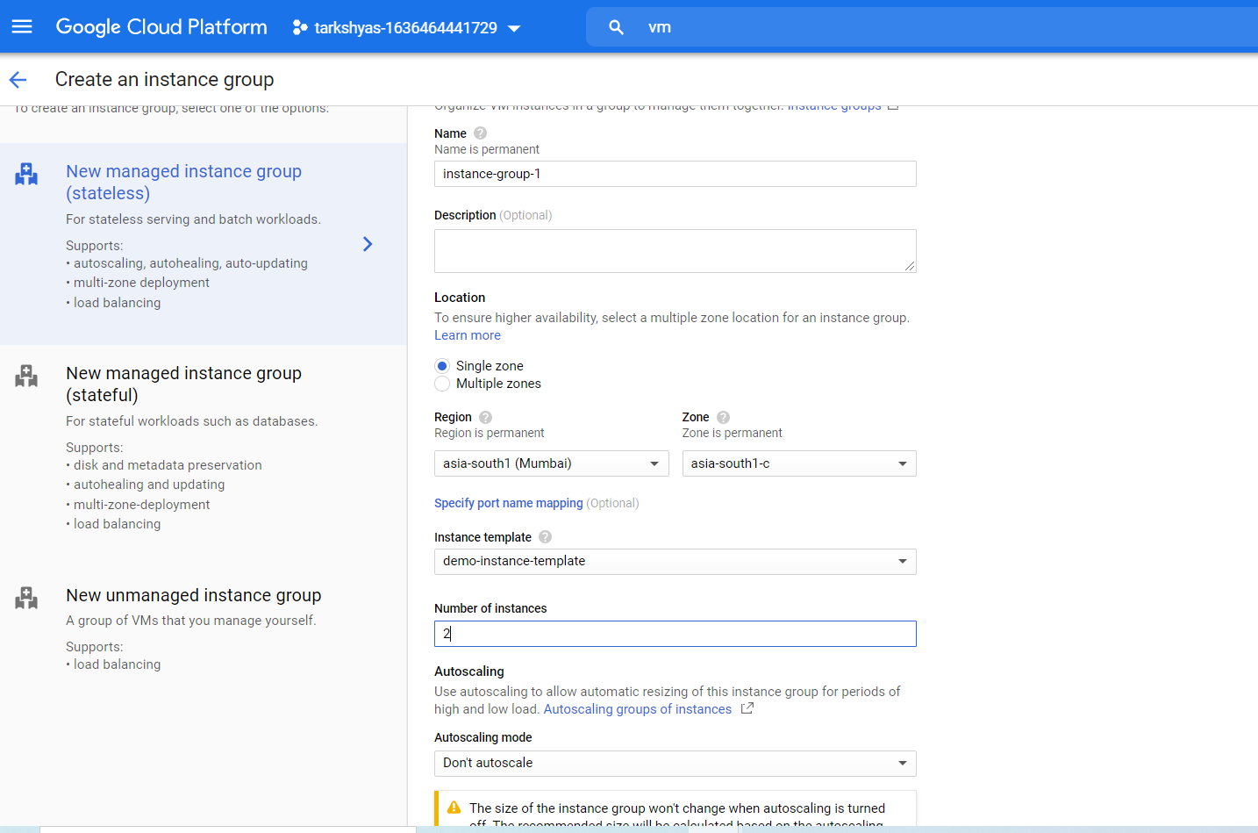

**Create Health check:**

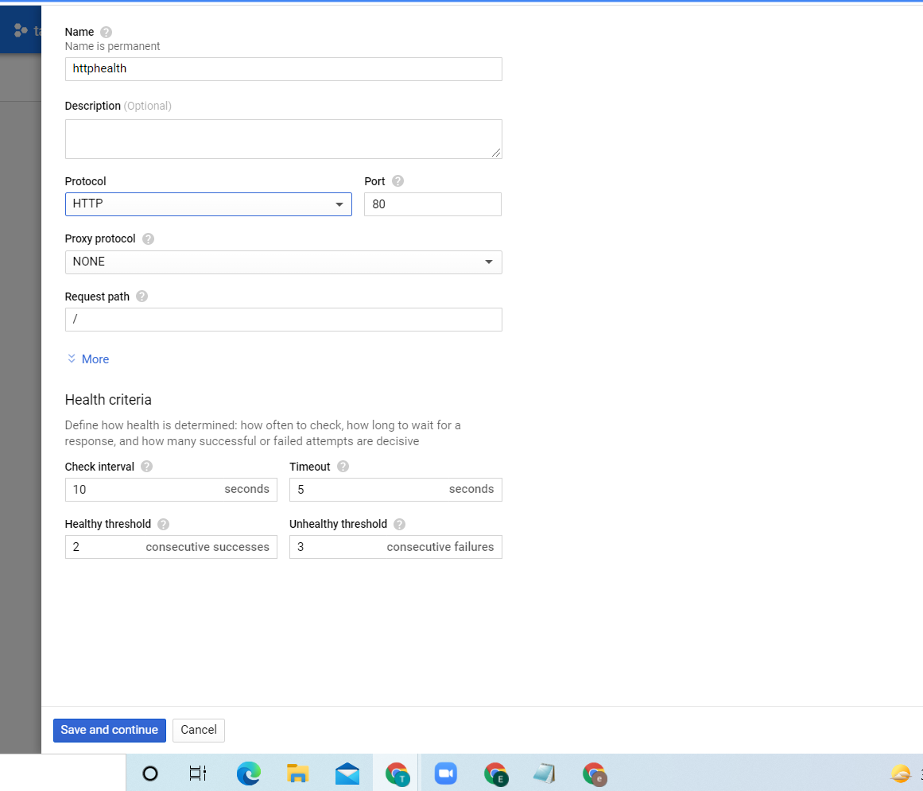

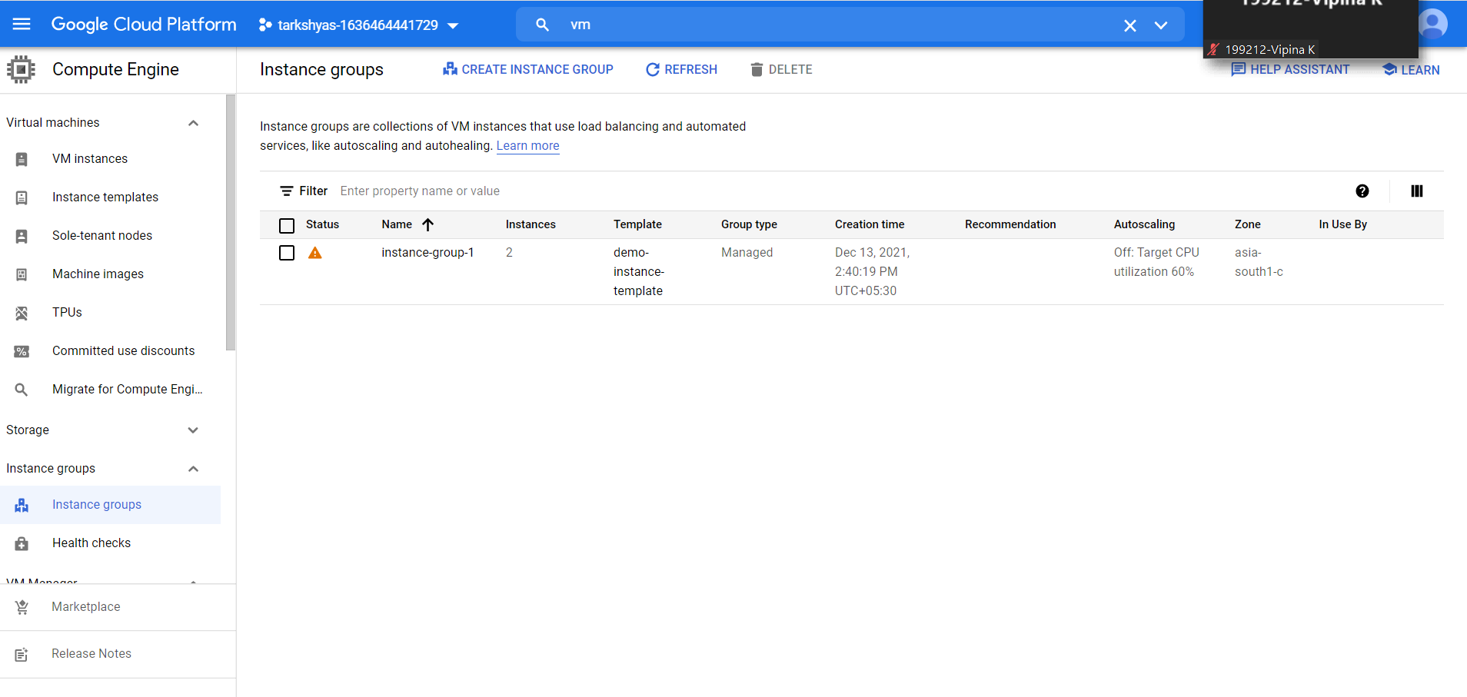

**Instance group created, then go to vm instance.**

**Vm instances are created from the instance group successfully.**

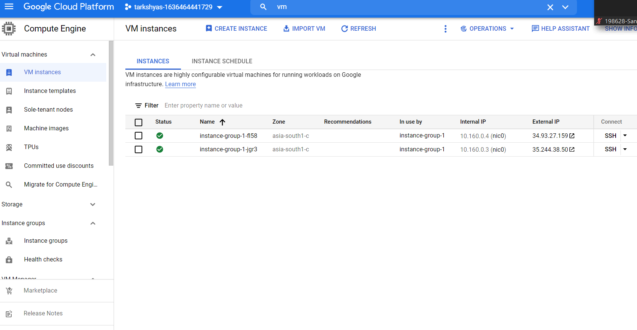

**To create load balancer:**

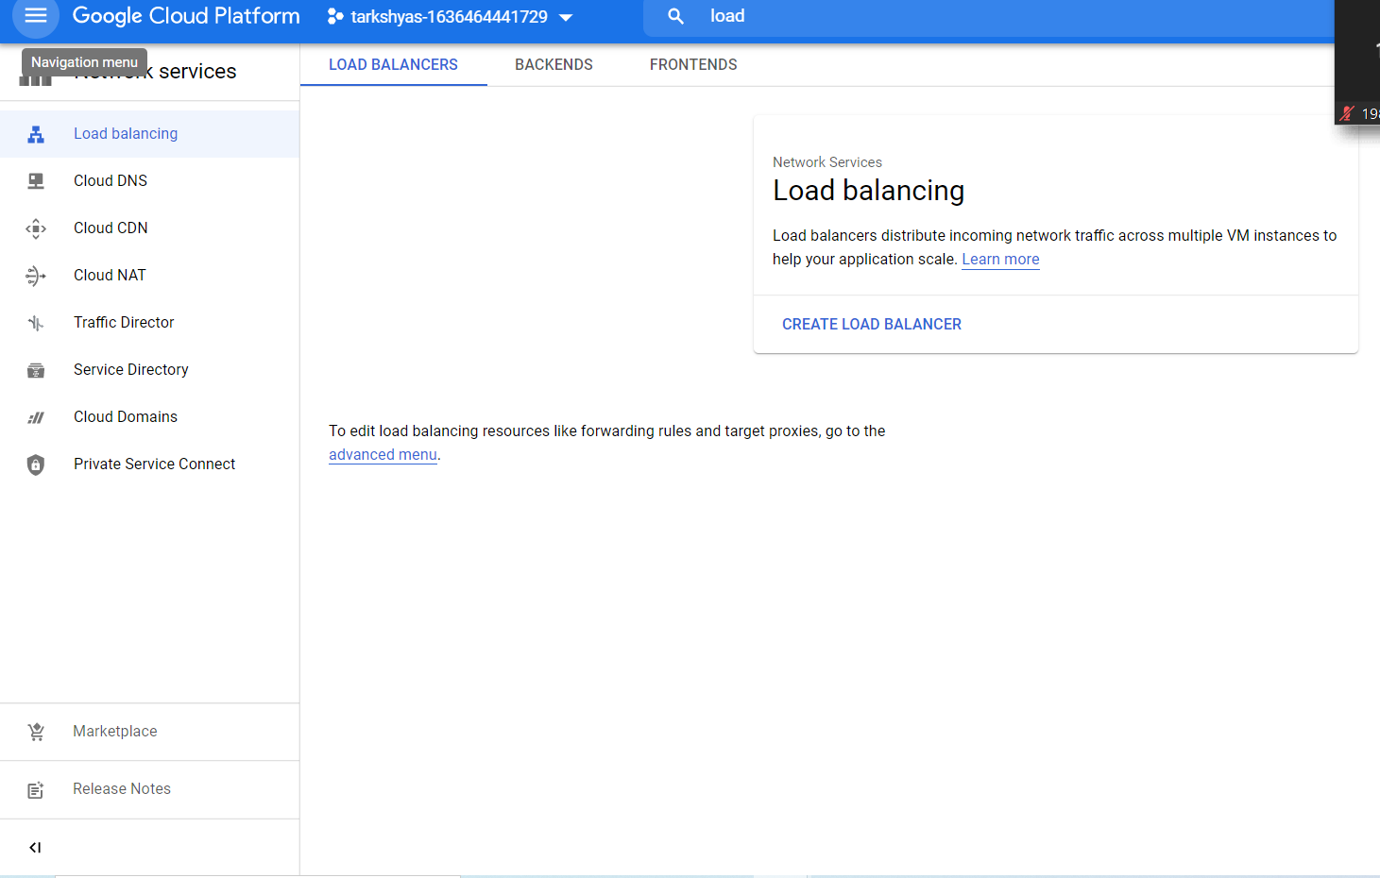

**Select http configuration:**

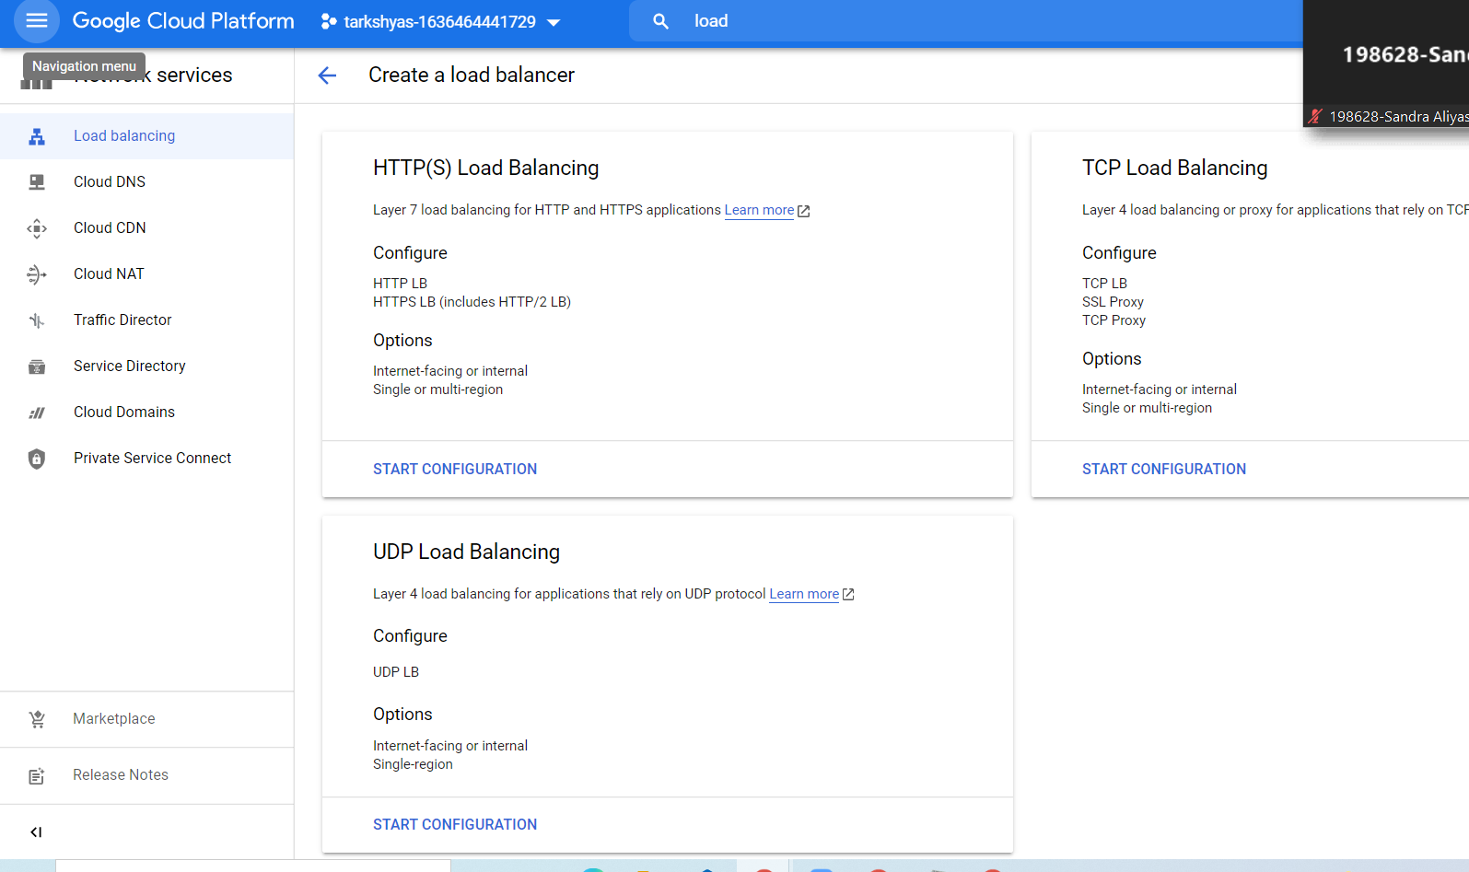

**The create Backend service :**

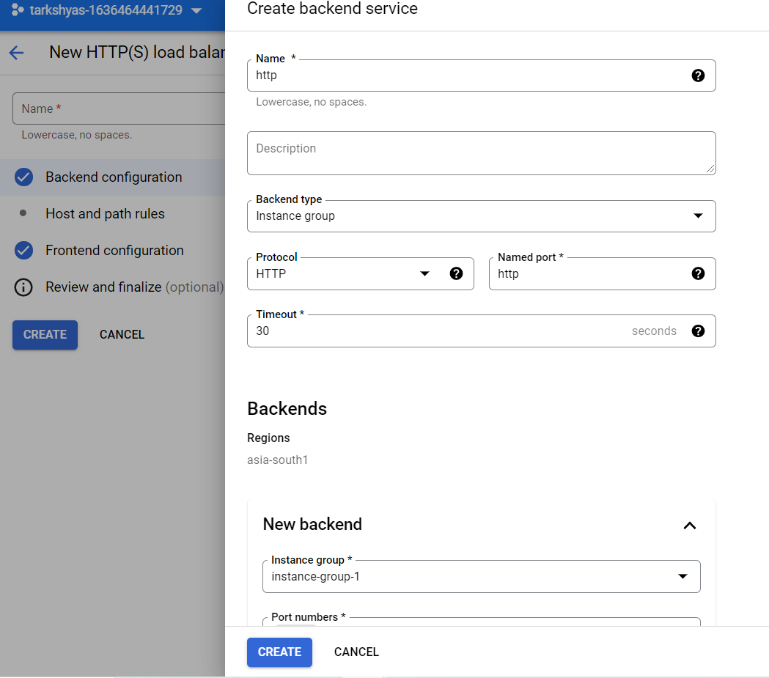

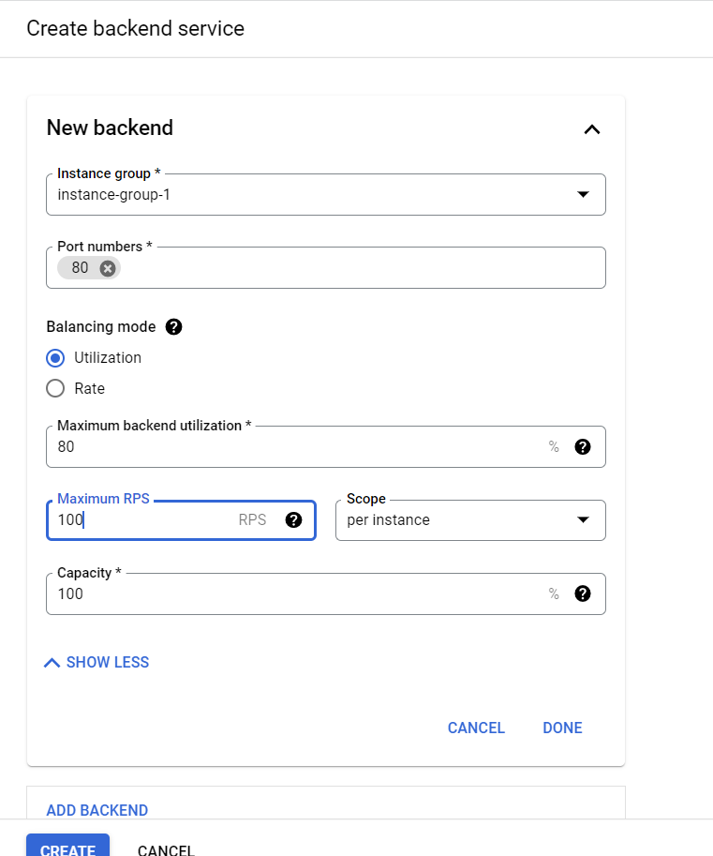

**Create frontend IP and Port**

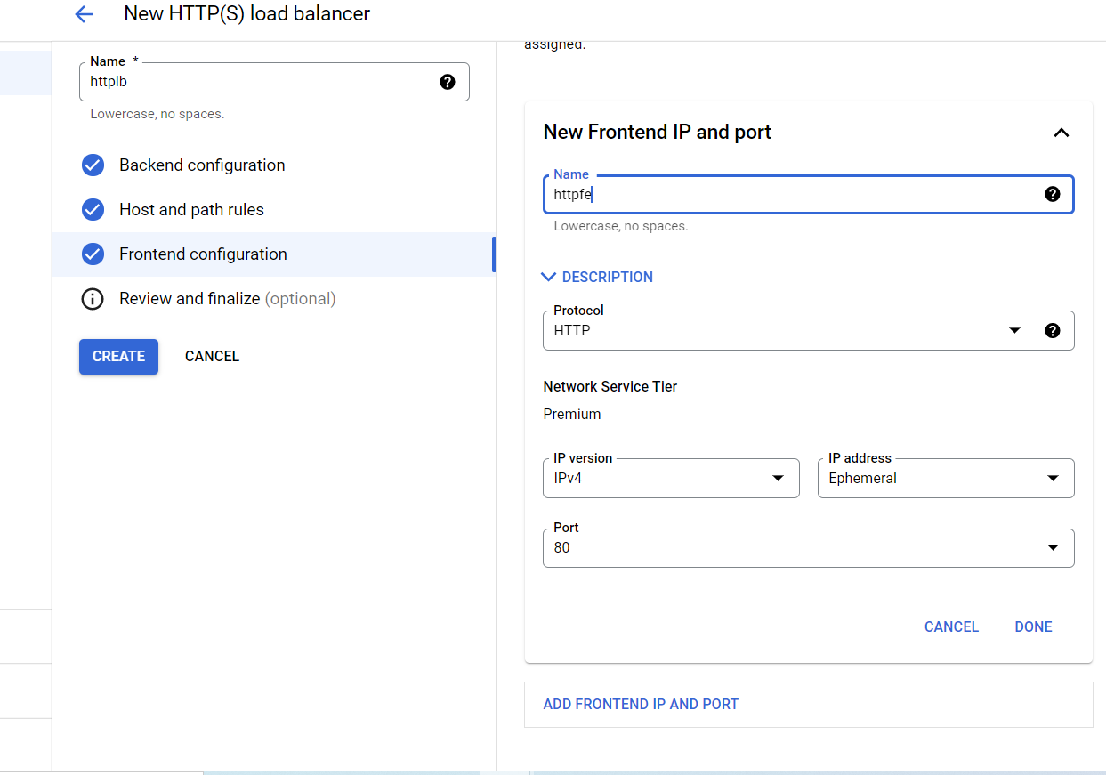

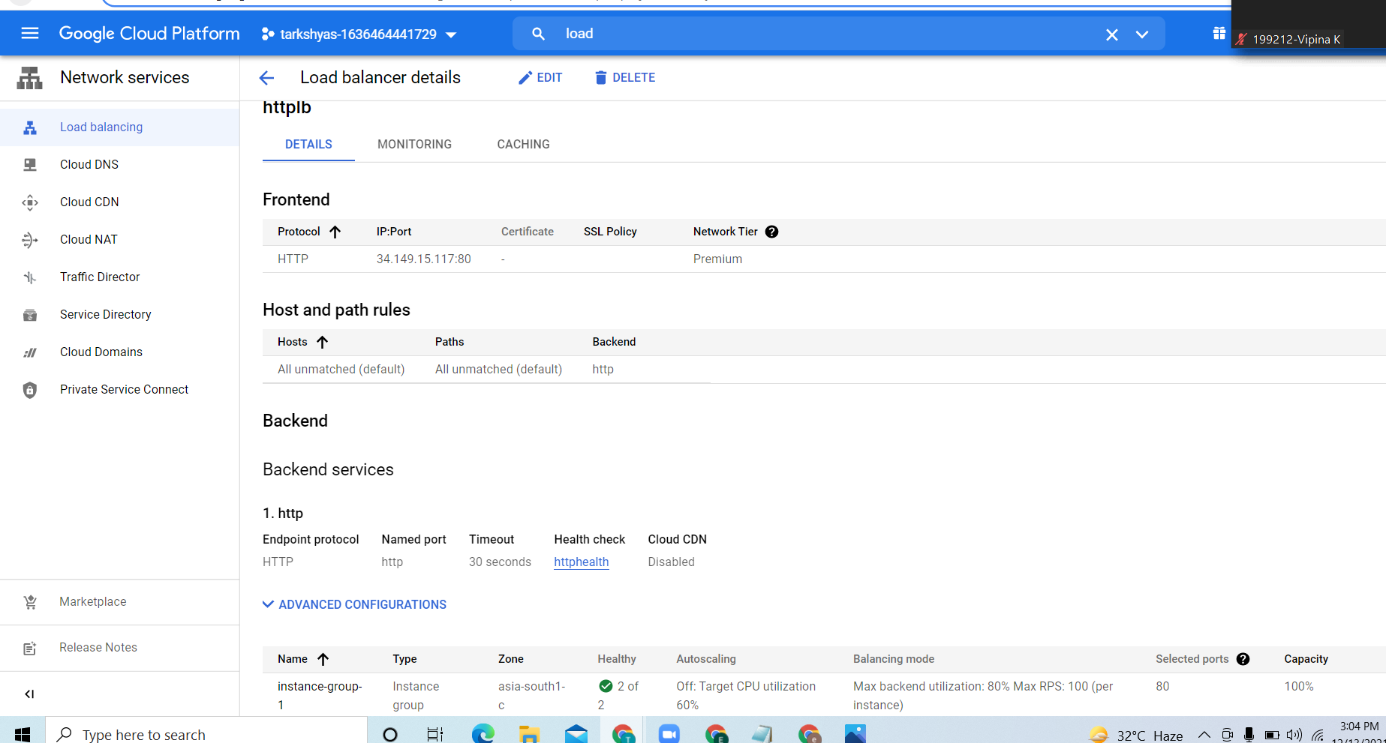

**Copy and search the ip address for the webpage:**

**If requests are at high rate the load balancer balances the requests by share some of the requests to other vm instance in the instance group.**

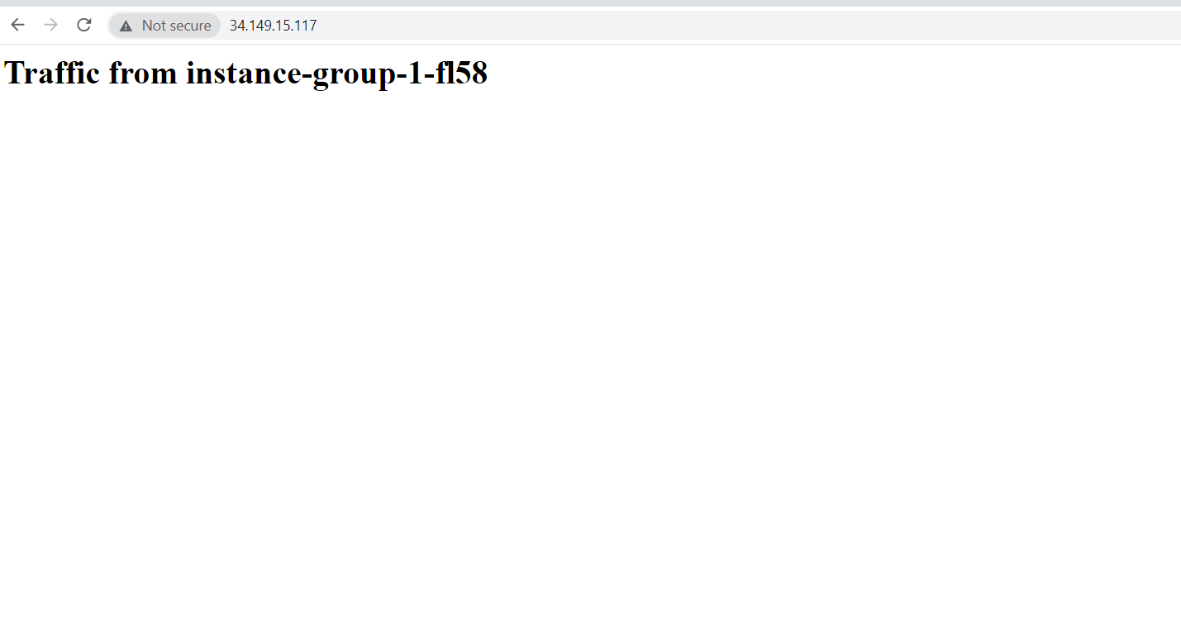

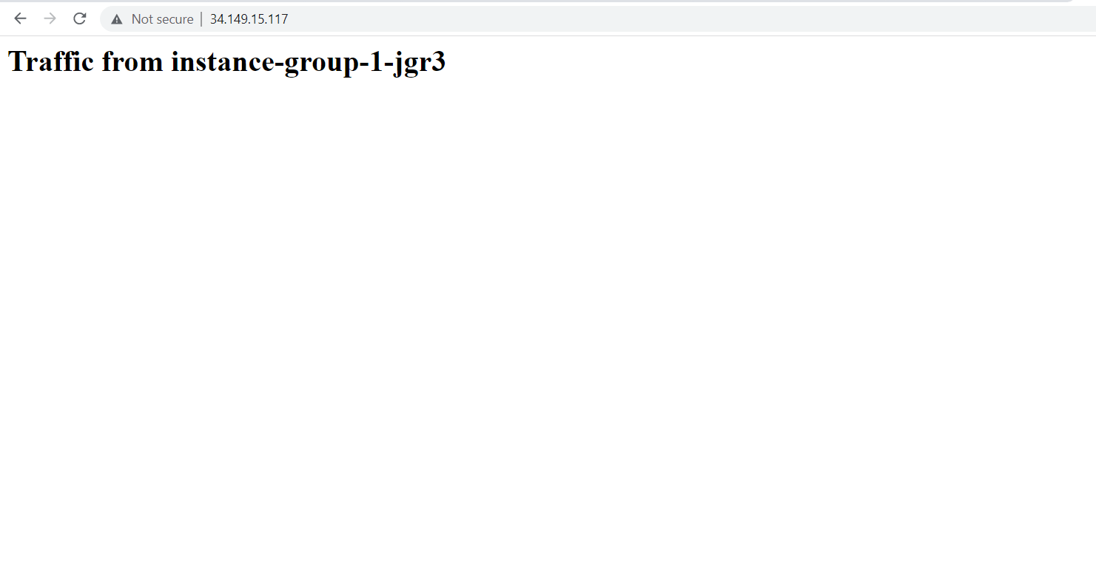

**Q5. CLOUD FUNCTION**

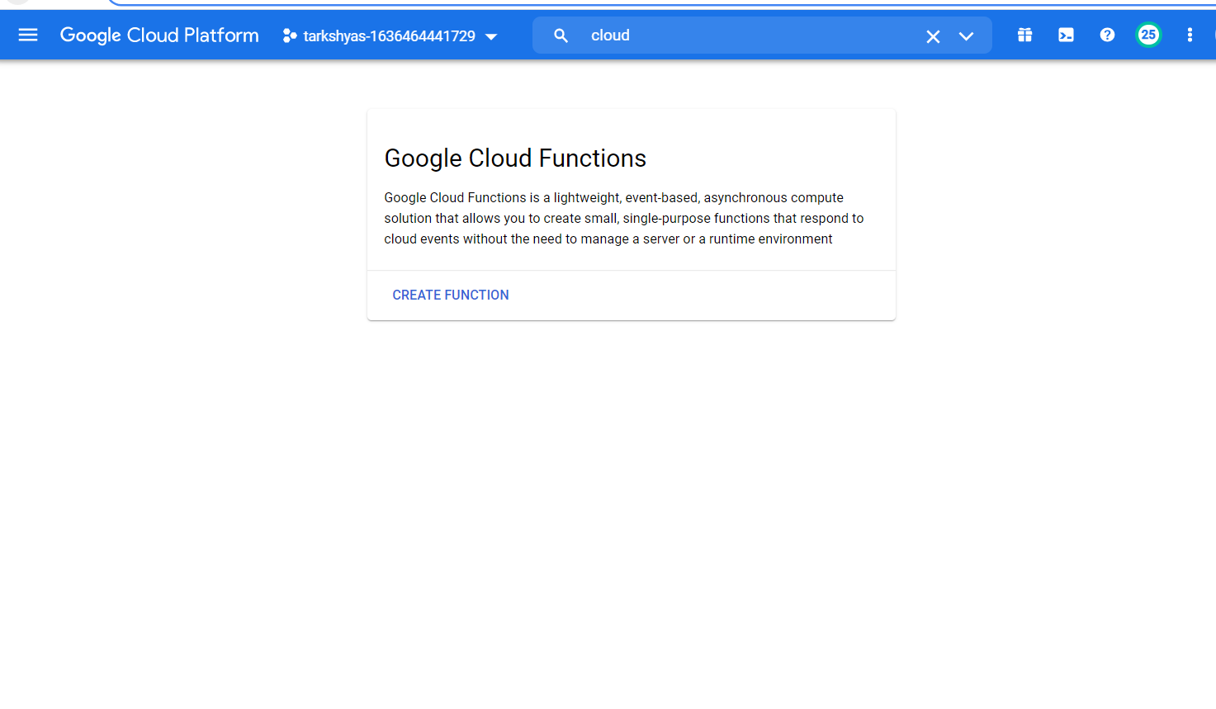

**Create a cloud function.**

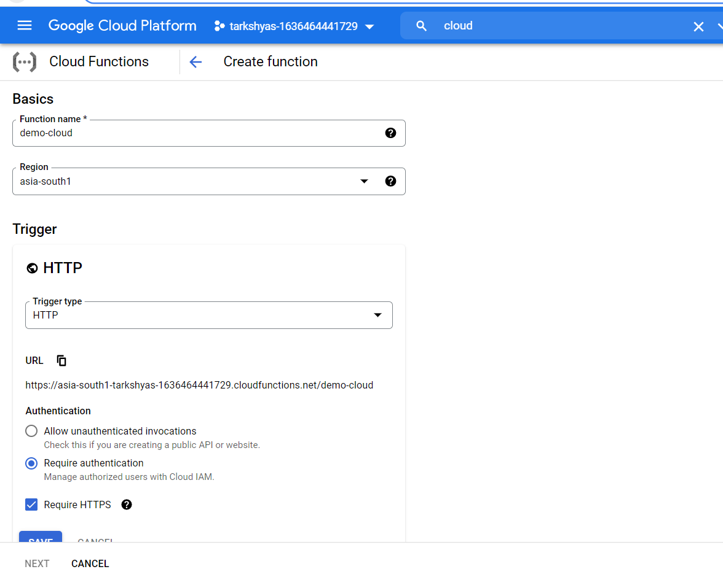

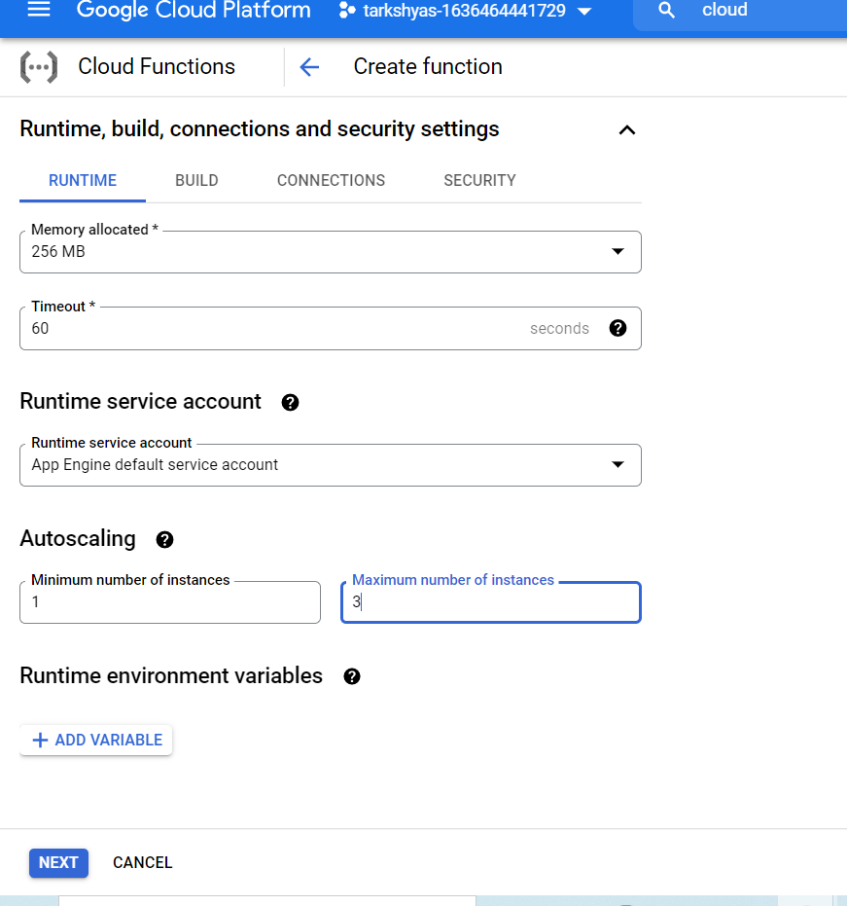

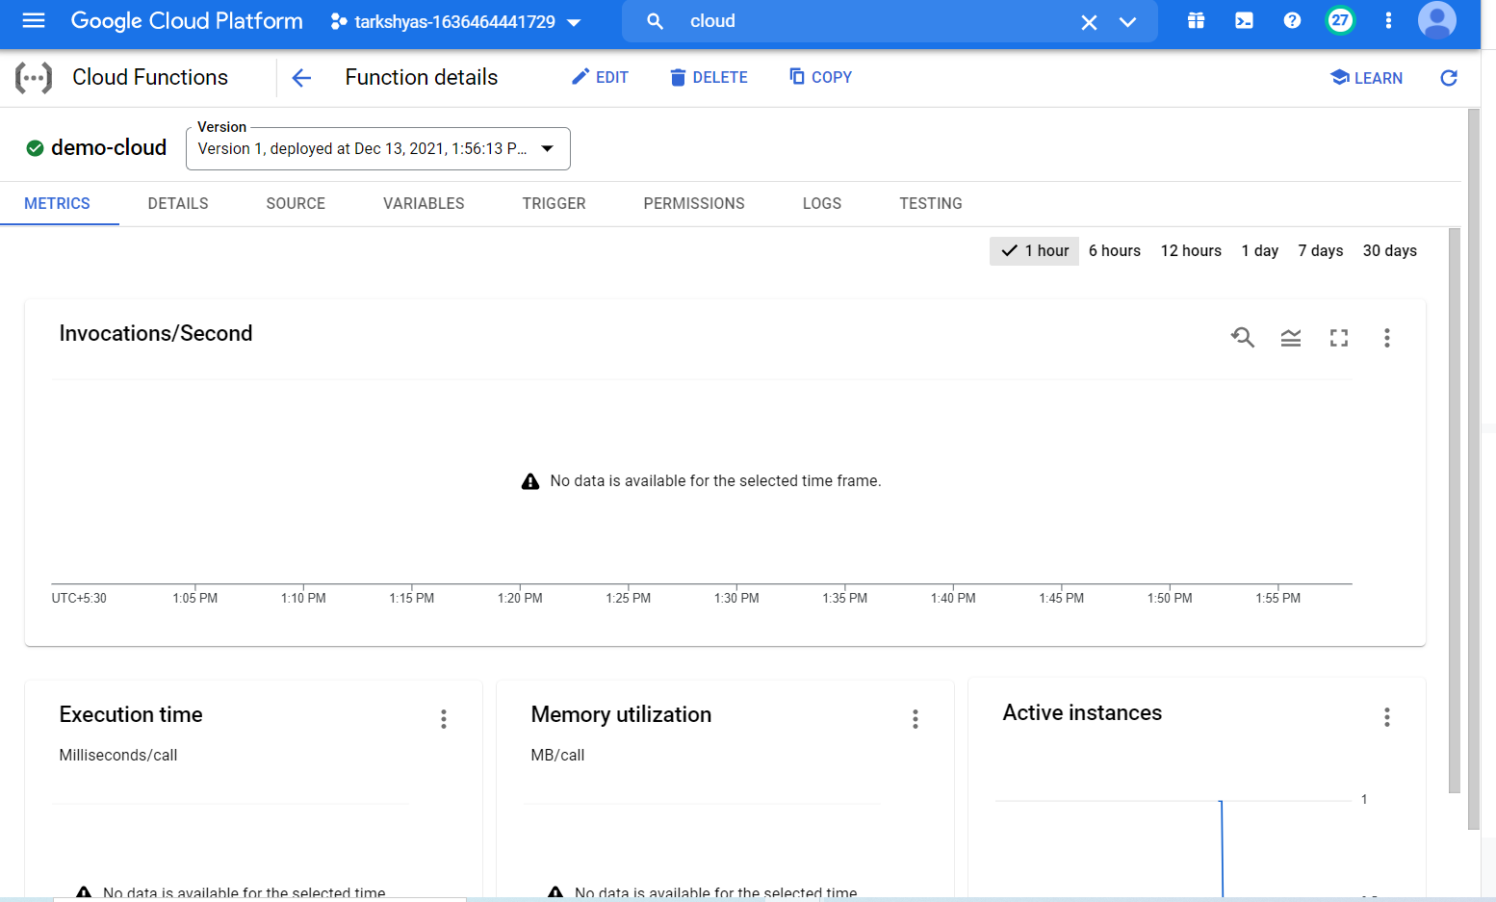

**In the trigger section, we get the webpage link.**

**Output:**

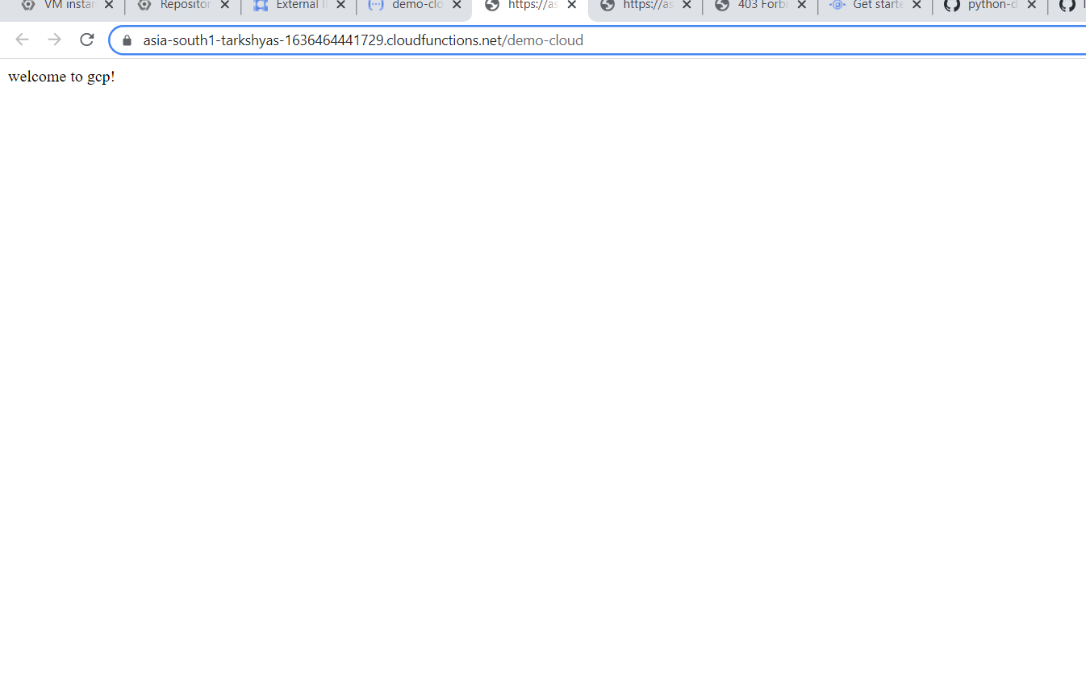

**Q11. TERRAFORM AND ANSIBLE**

**TERRAFORM**

**Terraform is used to create gcp resources.For this we need to install terraform by executing terraform.exe file**

**Then we need to install cloud SDK and visual studio**

**The command used to create resources in the command prompt :**

**>gcloud init(for configuring google account)**

**>terraform init**

**>terraform plan**

**>terraform apply(To deploy the resources )**

**>terraform destroy**

**>terraform registry (for getting documentations)**

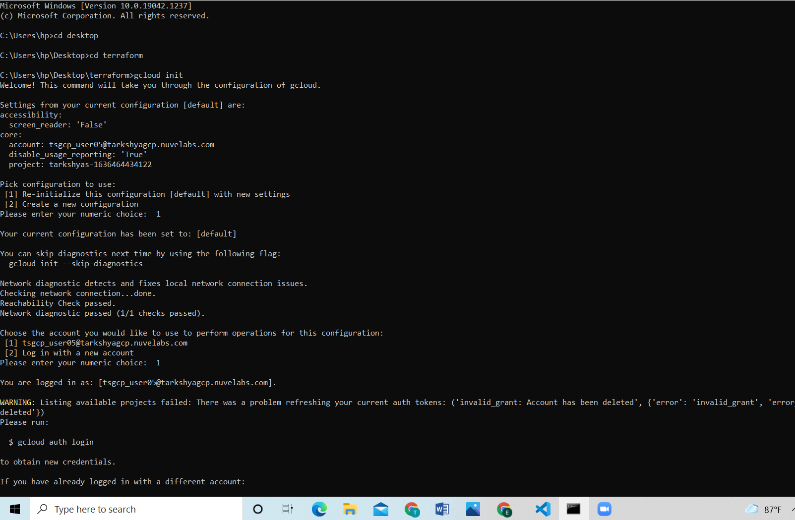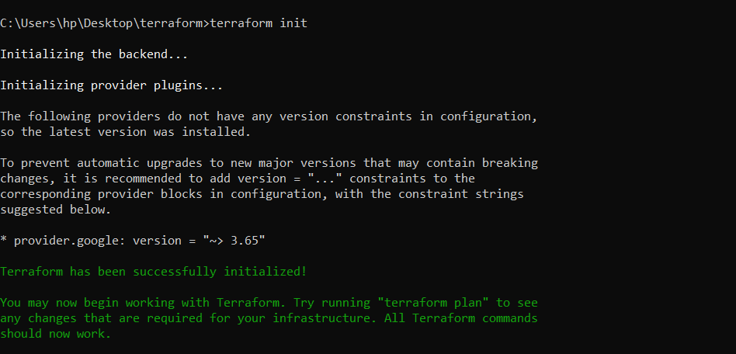

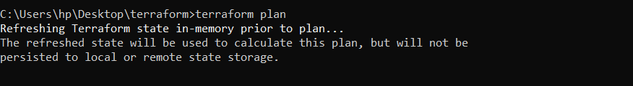

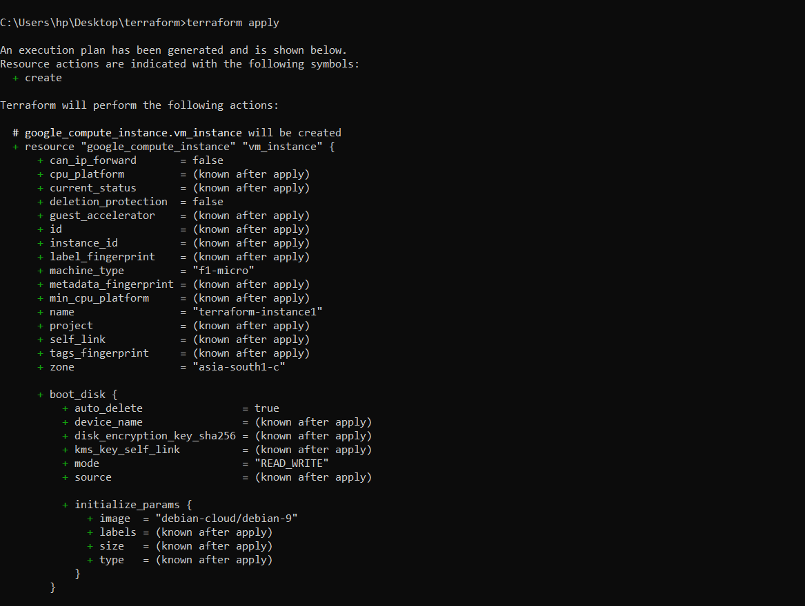

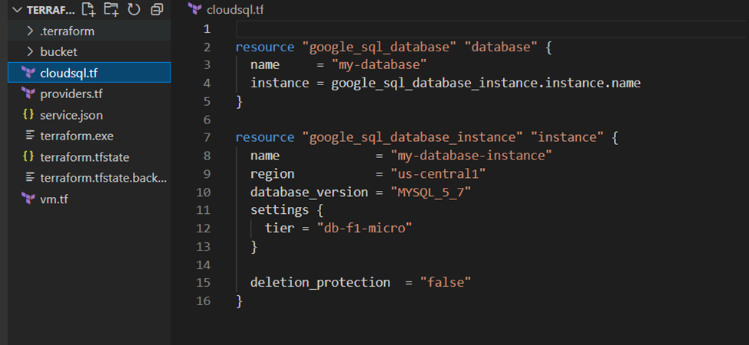

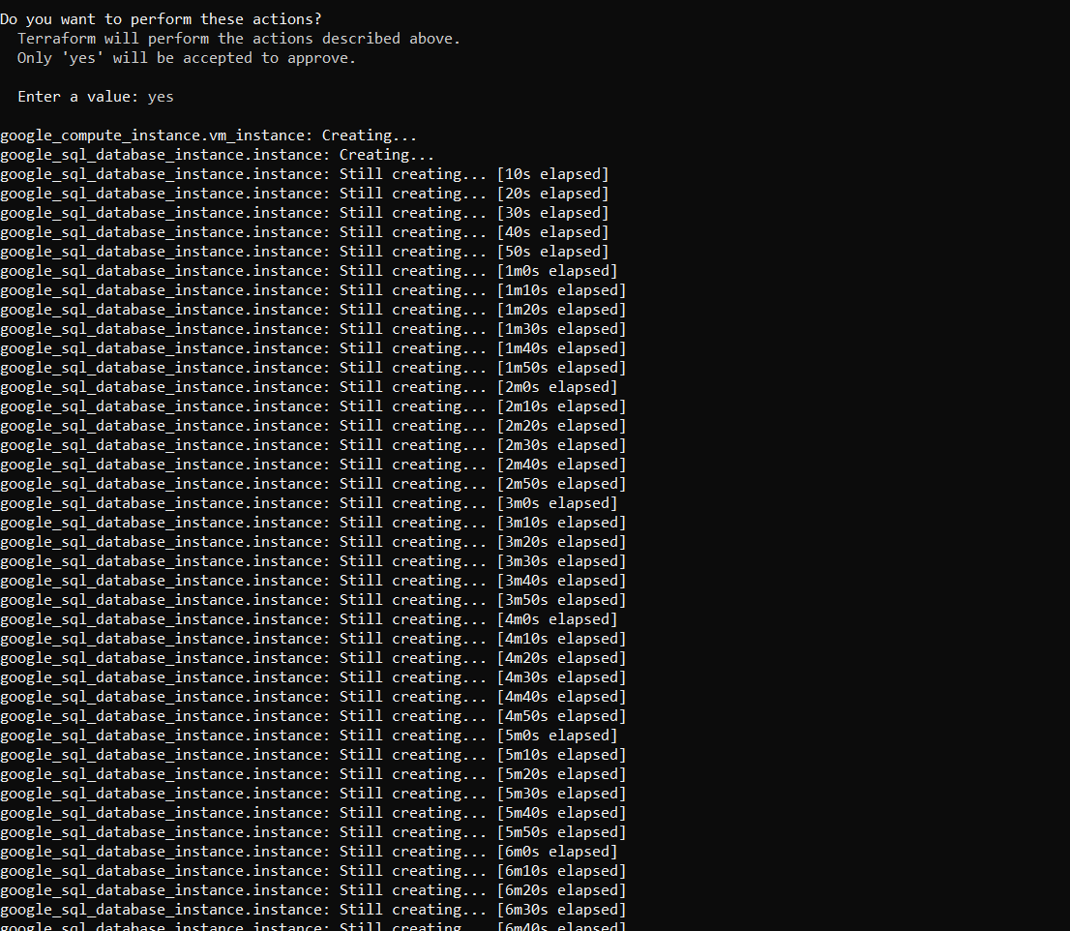

**SQL instance created:**

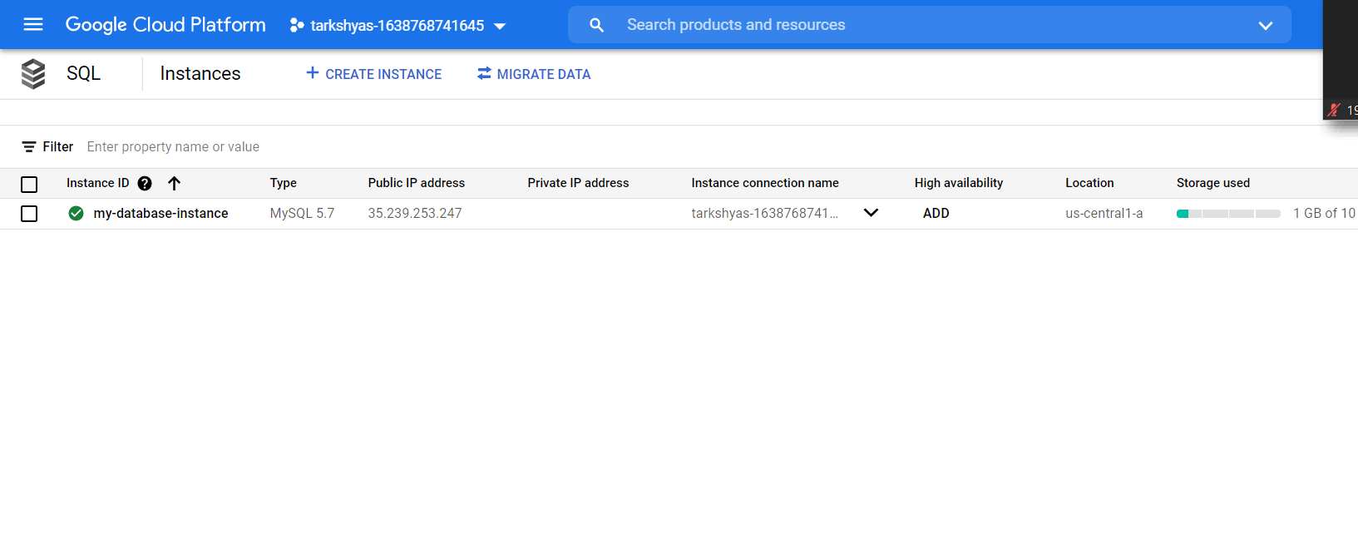

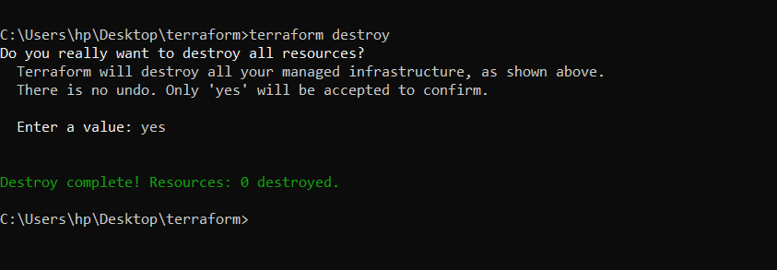

**Then we need a service account.**

**To create service account:**

**And set the permission as owner for the project.**

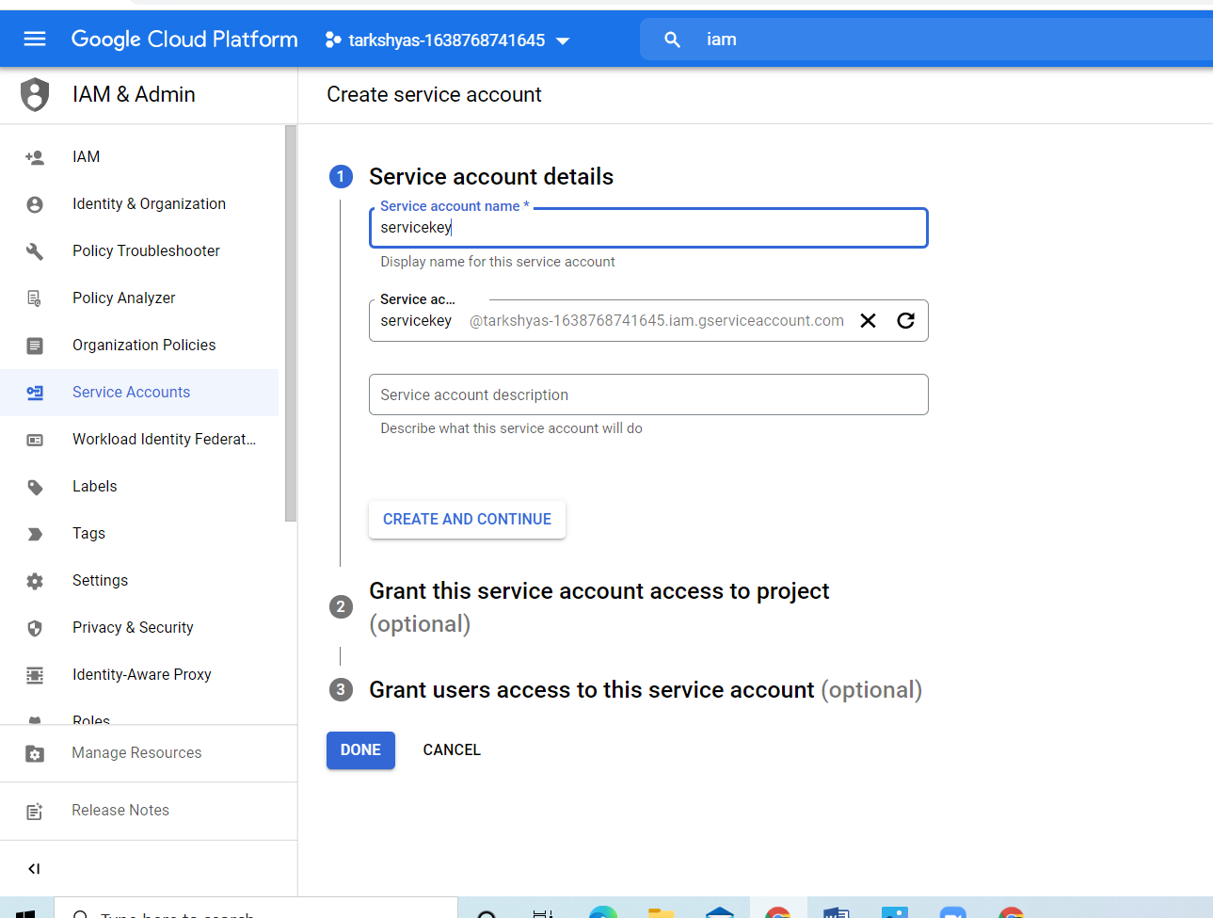

**ANSIBLE**

**First we need to install ansible using the command:**

**>Python –m pip install –user ansible**

**or**

**>Pip install ansible==2.7.0(by mentioning the version)**

**Then create a service account and set permission as owner for the project**

**Then create key for the service account and download the json file.**

**Upload the json file into the shell.**

**Then upload the .yml file containing the code to create the resources.**

**To run the playbook use the command:**

**>ansible-playbook filename.yml**

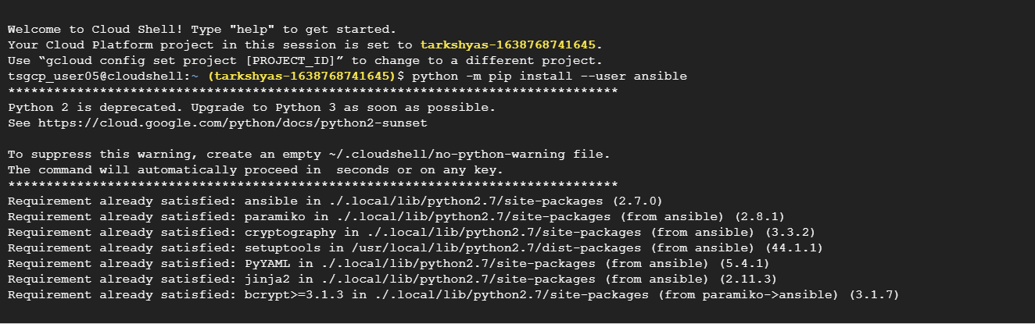

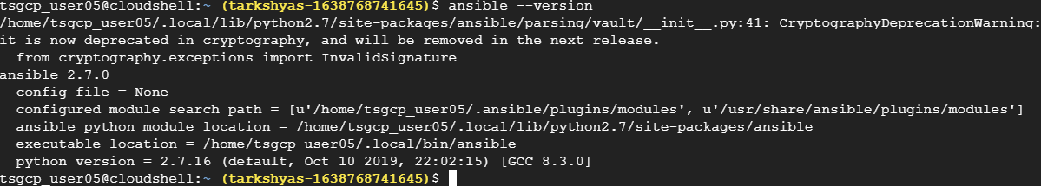

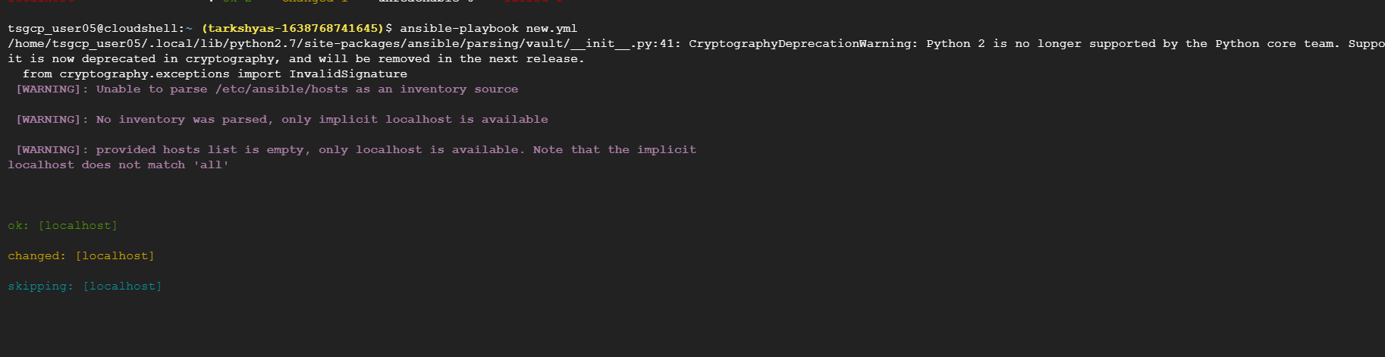

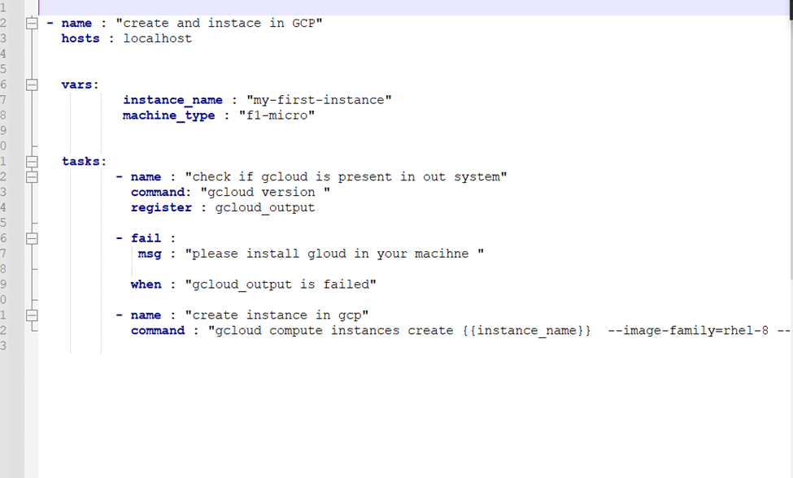

**Code for creating vm instance.**

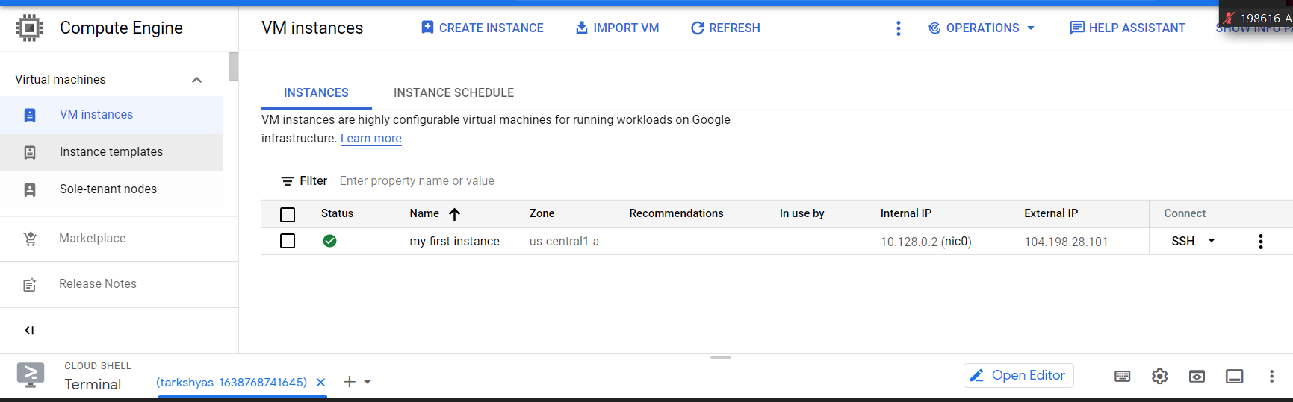

**Vm instance successfully created.**

**Q12. Bigquery**

**create a dataset**

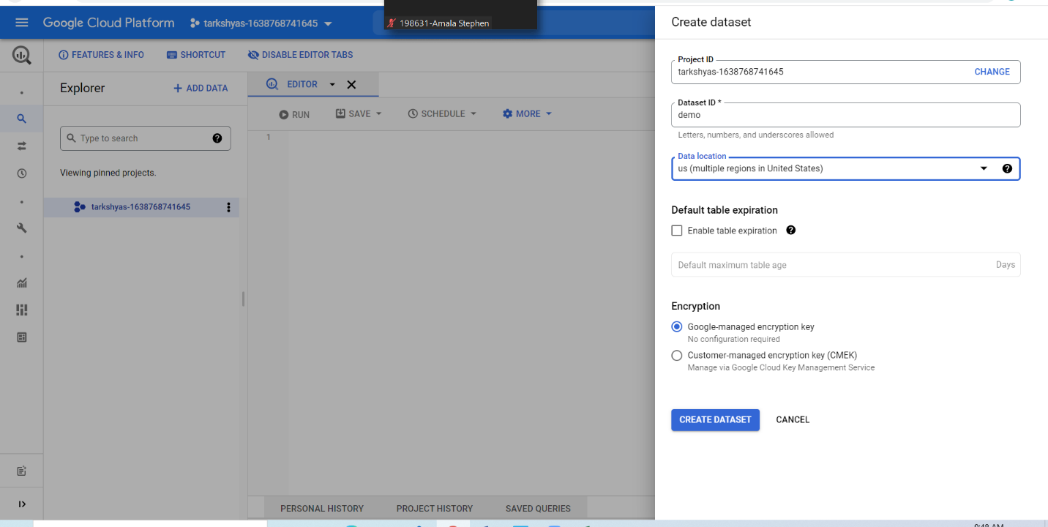

**Then create a bucket**

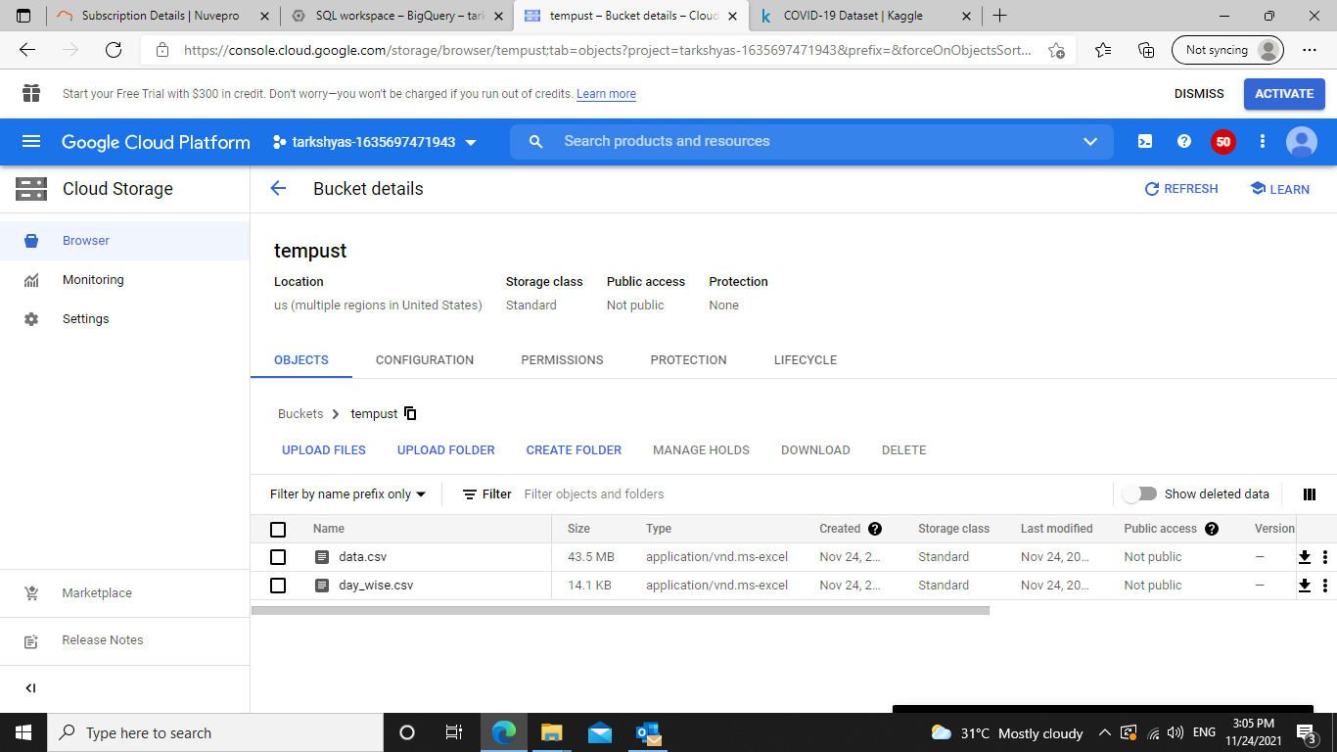

**Files**

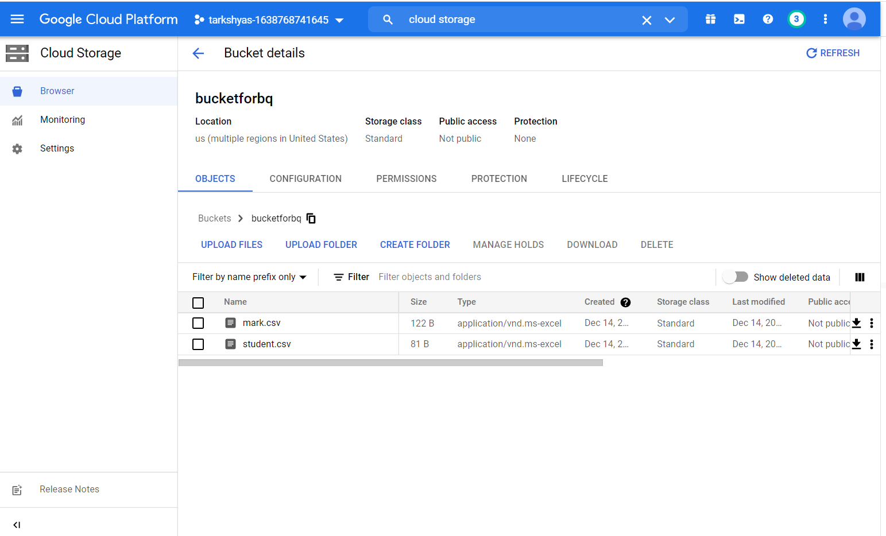

**Table creation :**

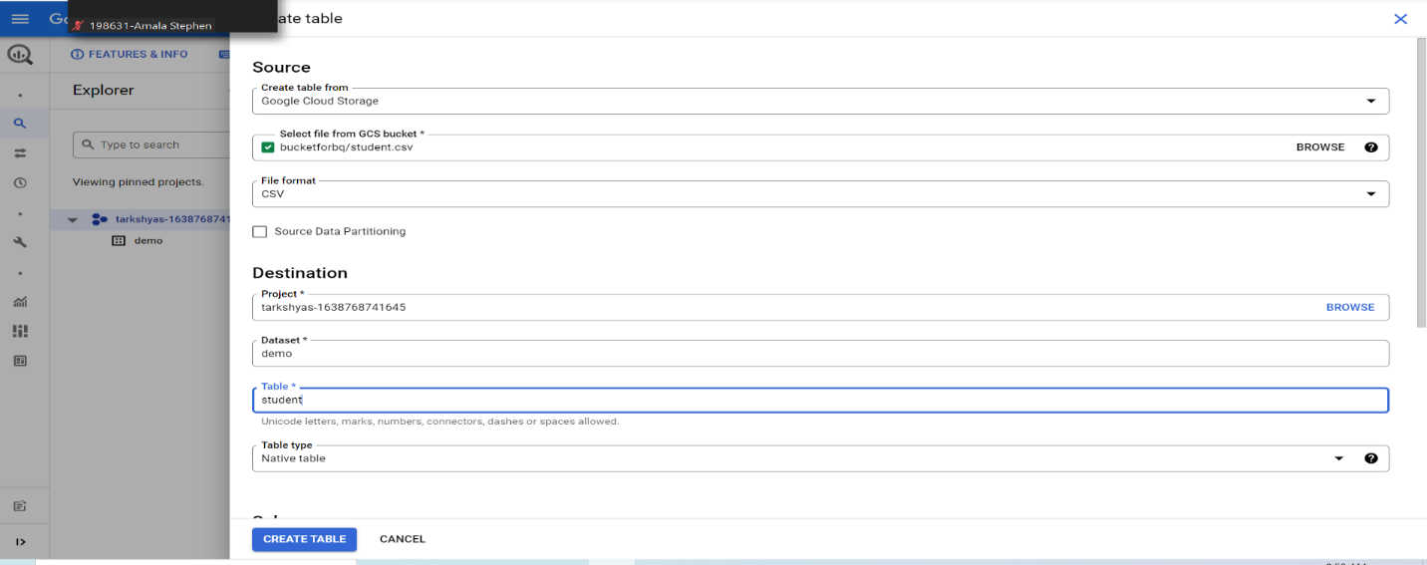

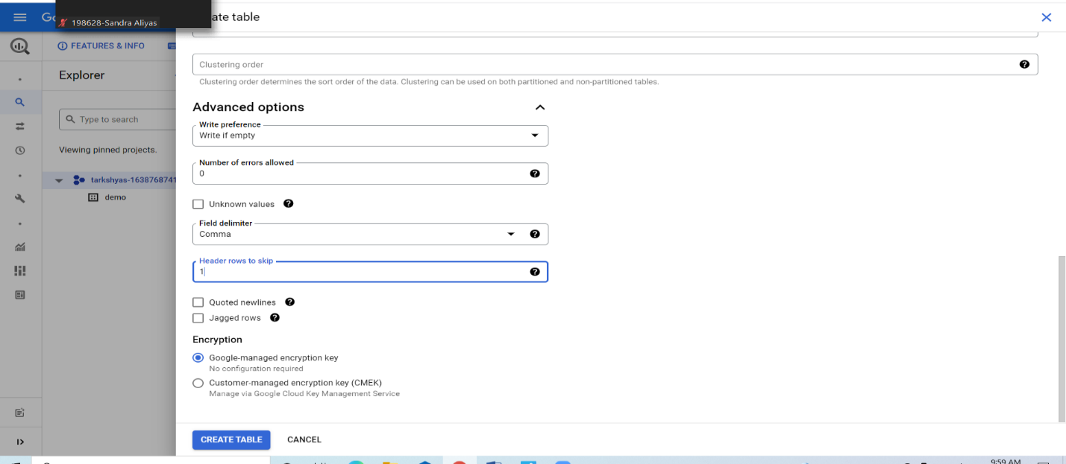

**Creation of 2nd table**

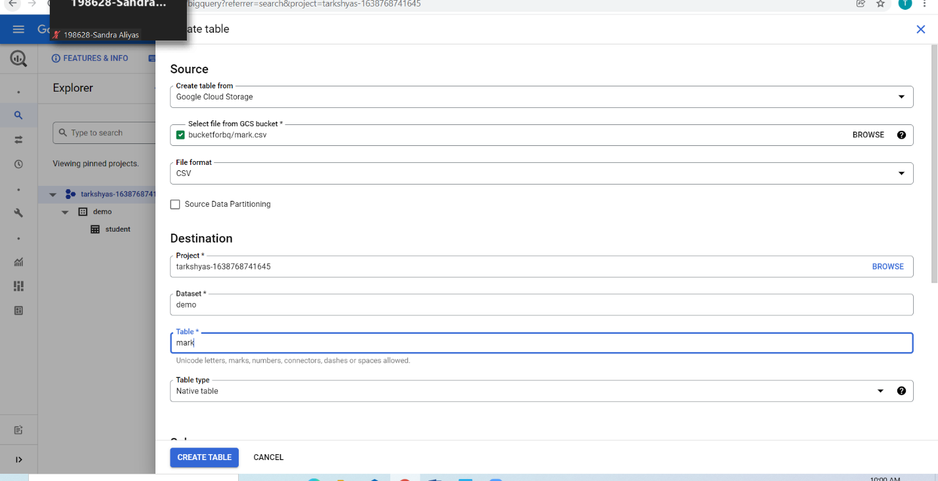

**Sql basics such as where, group by ,order by,join**

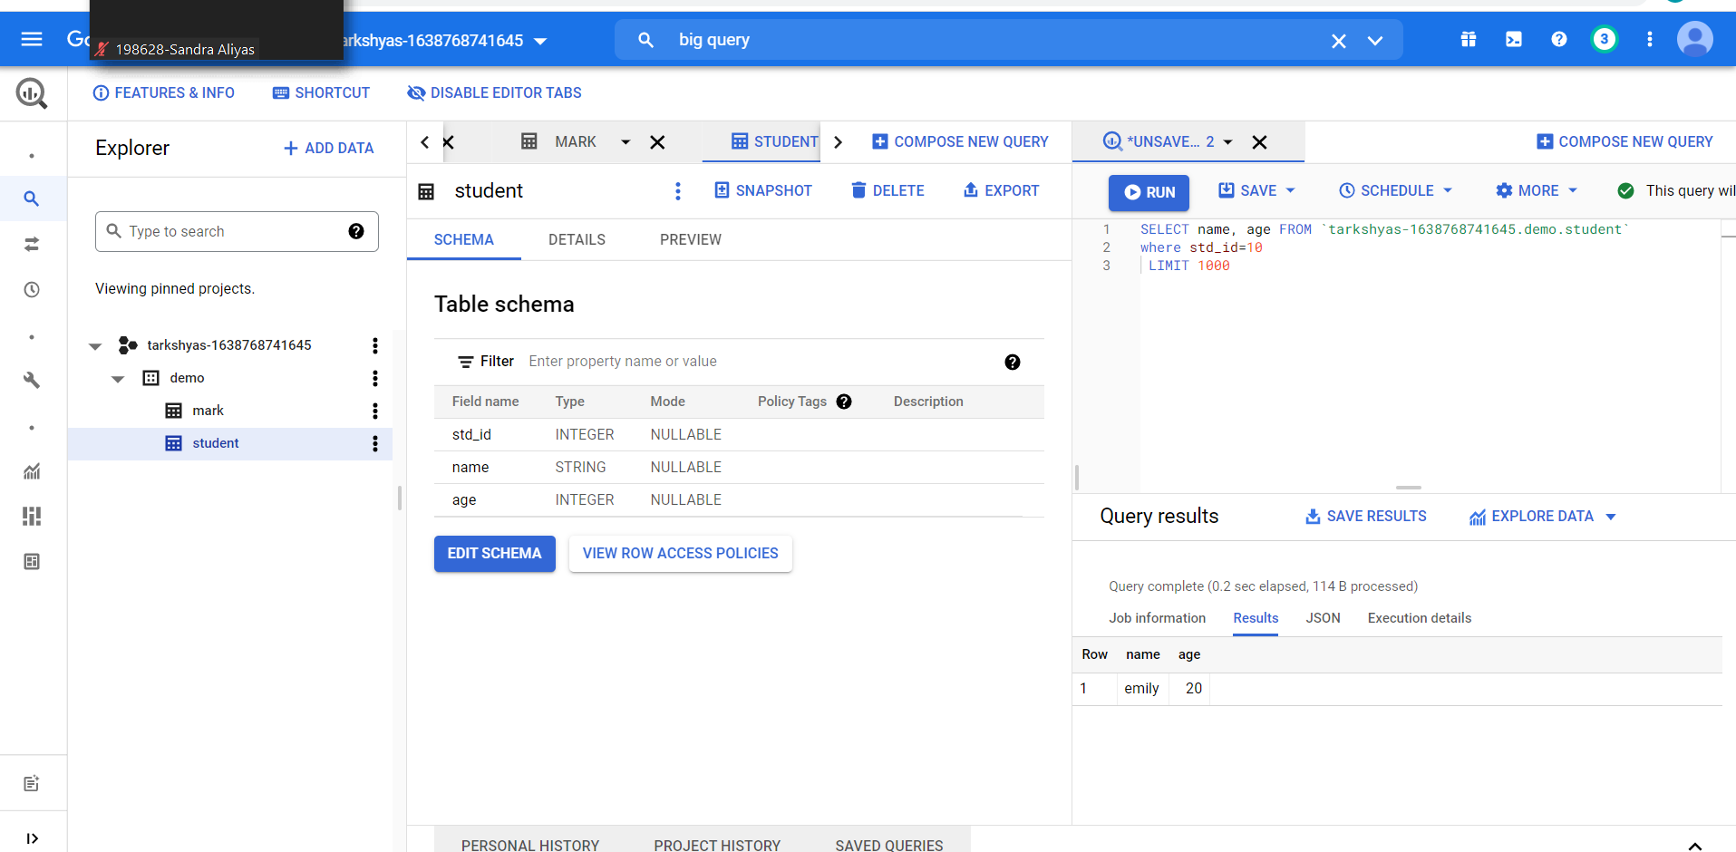

**Order by**

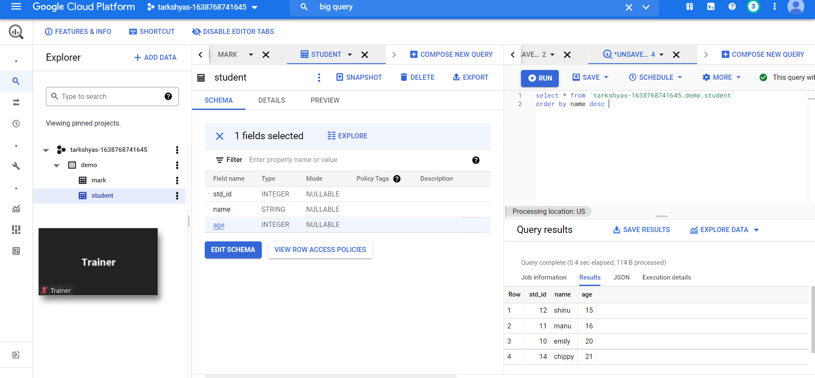

**Group by:**

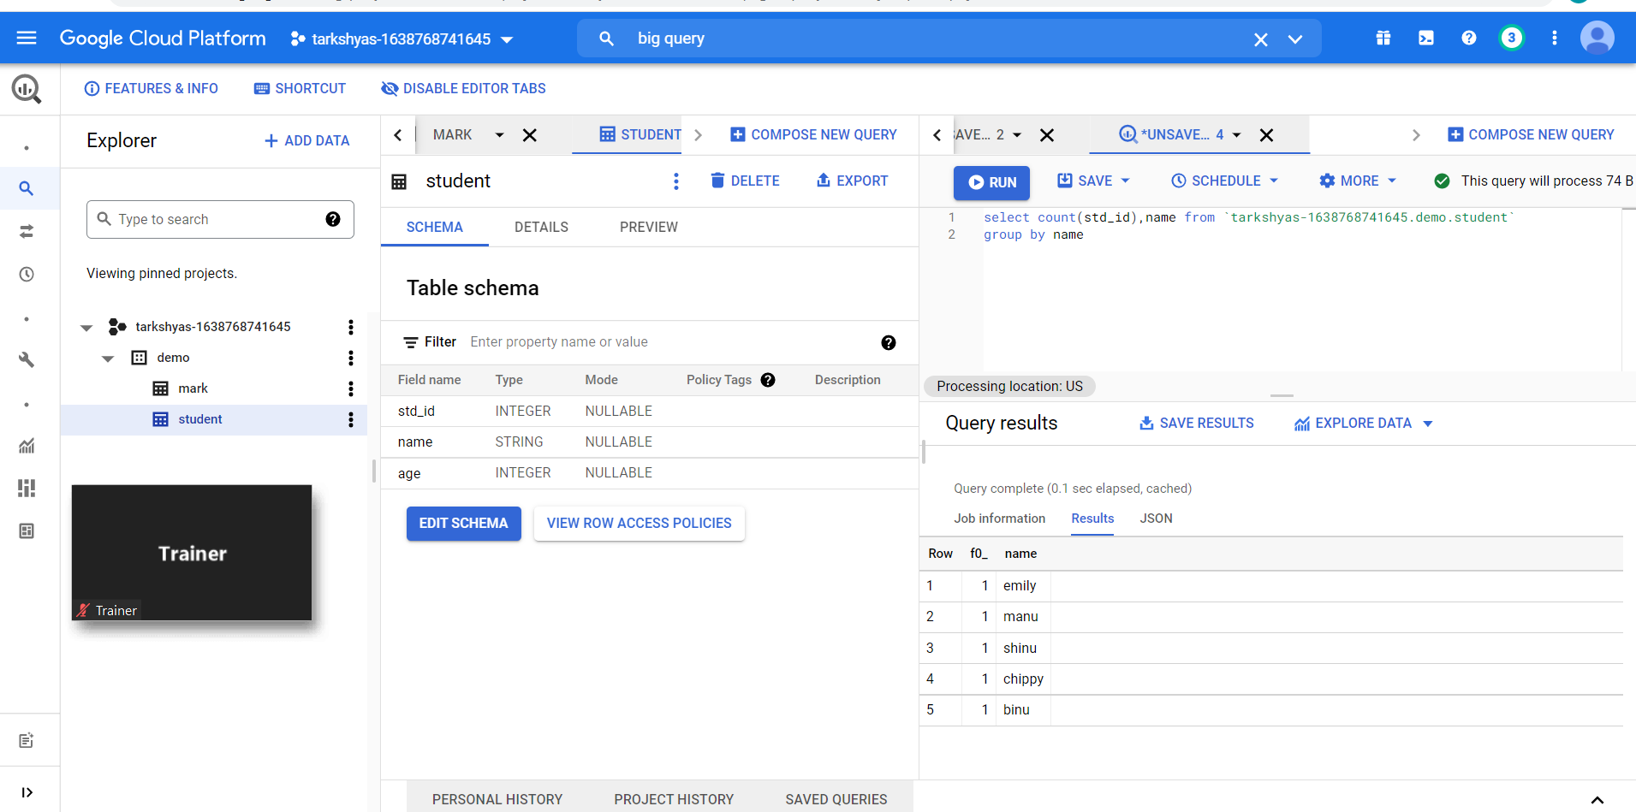

**Join:**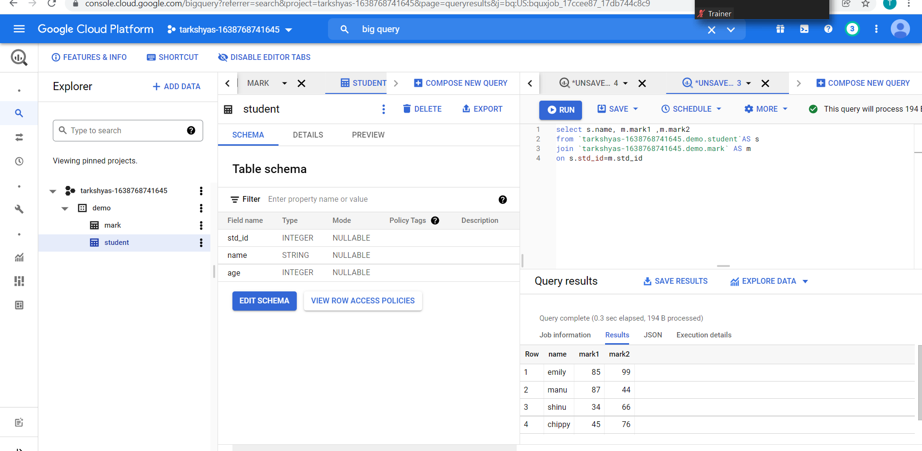

**Clustering and partitioning:**

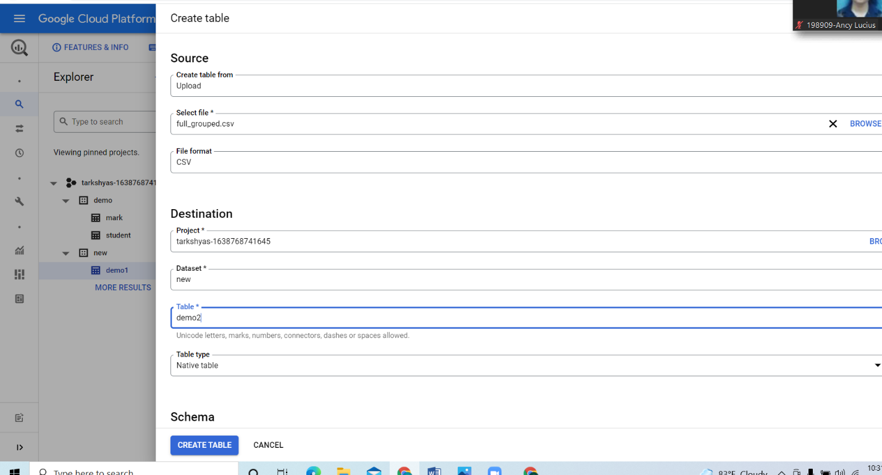

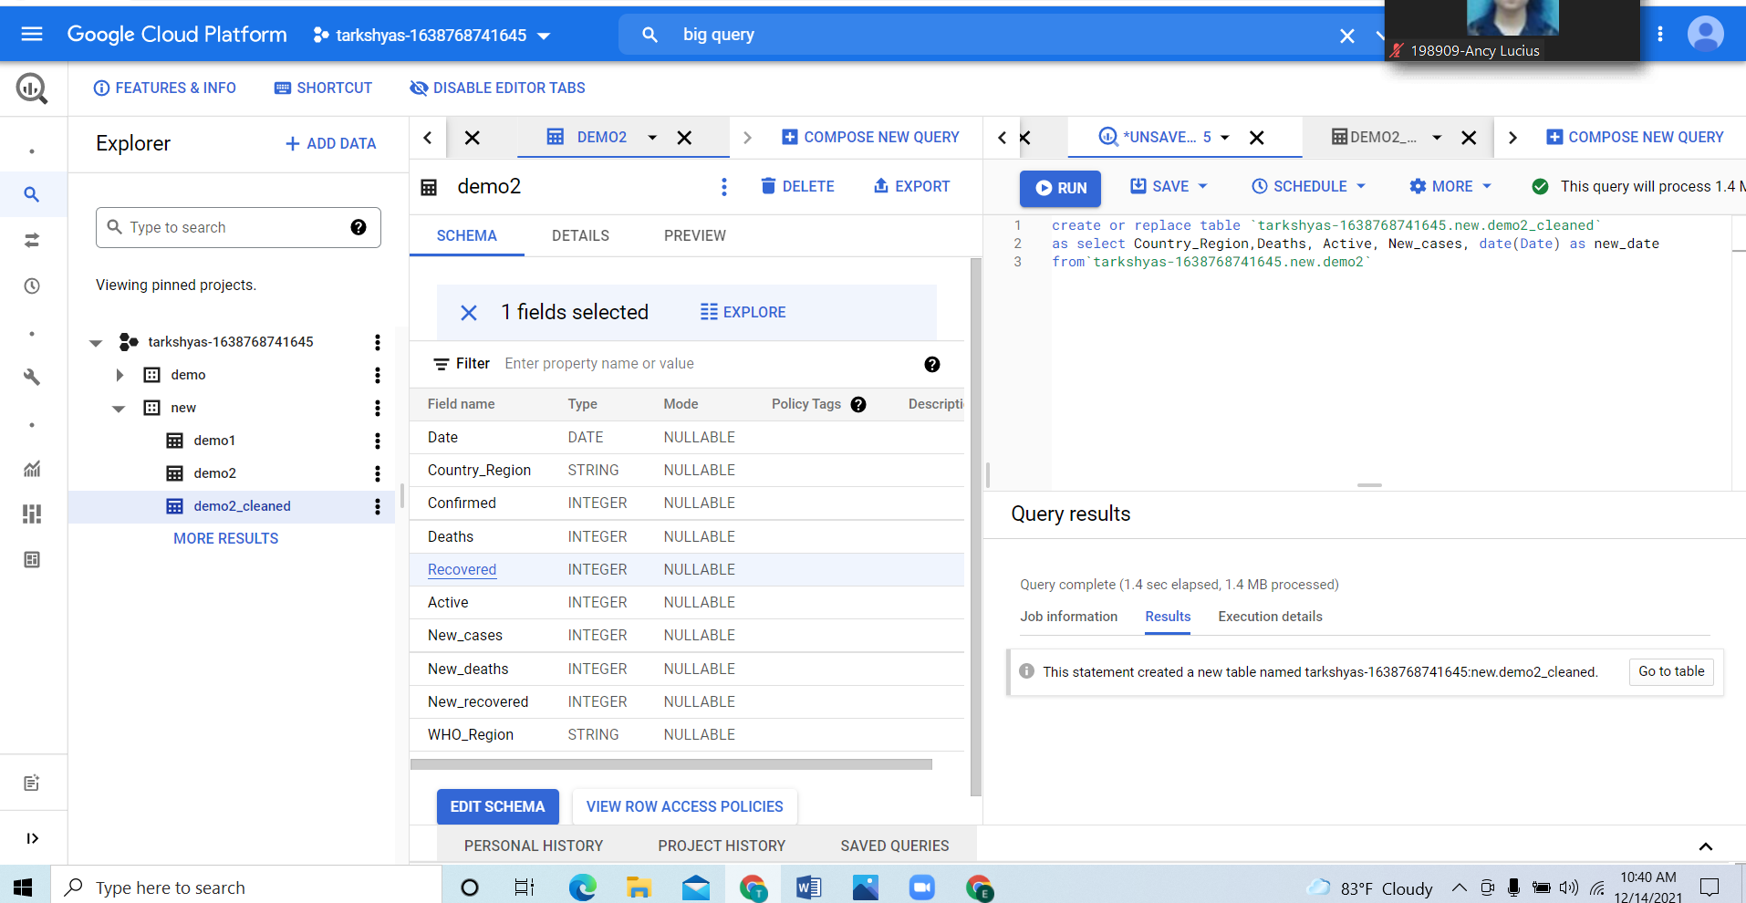

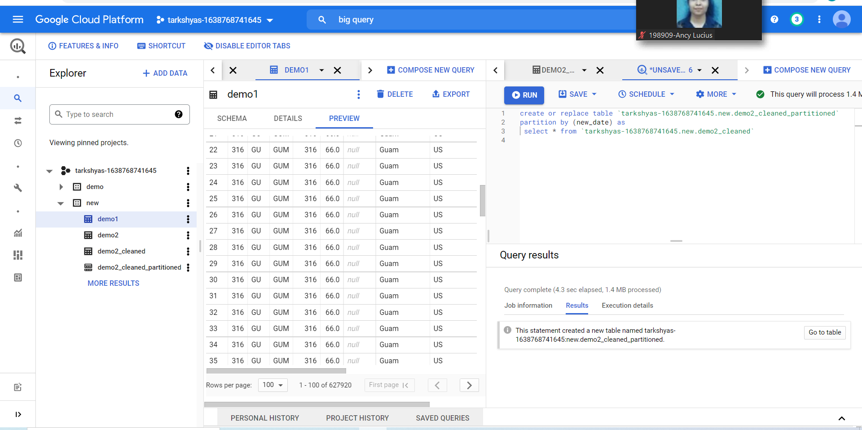

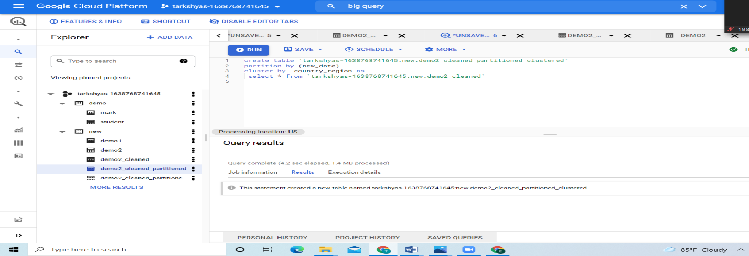

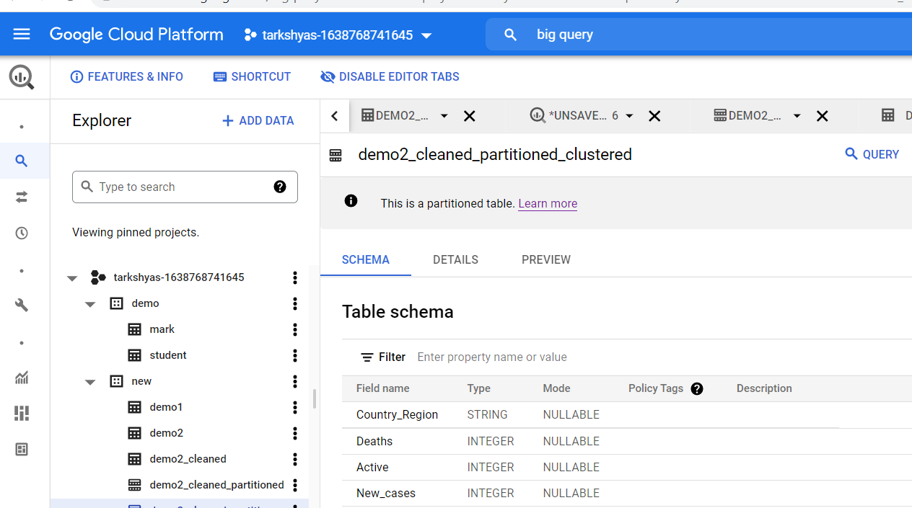

**Big query ML**

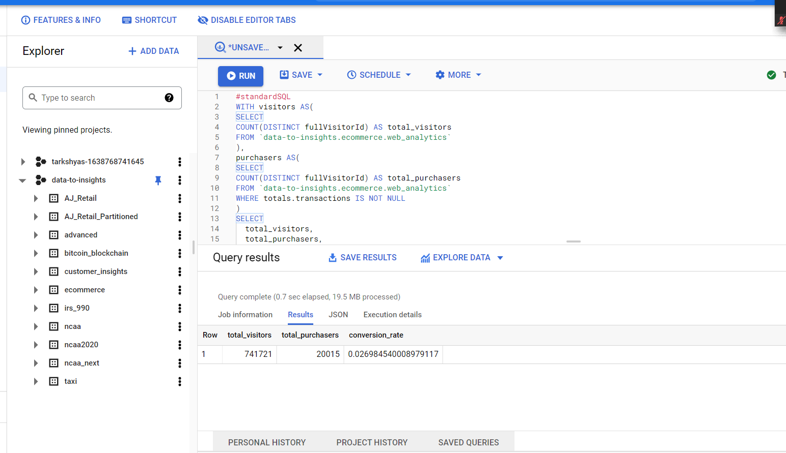

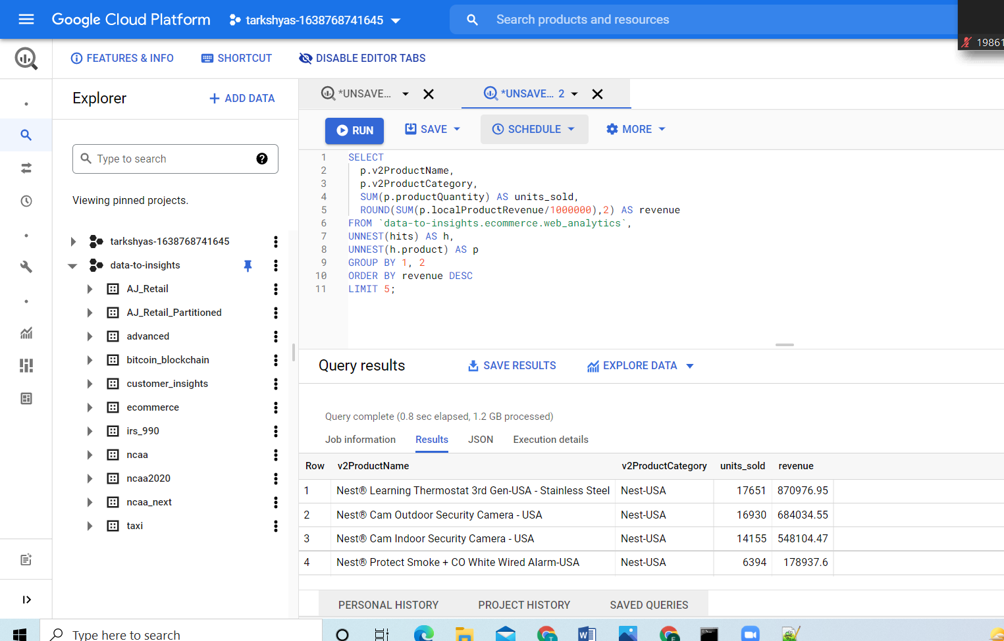

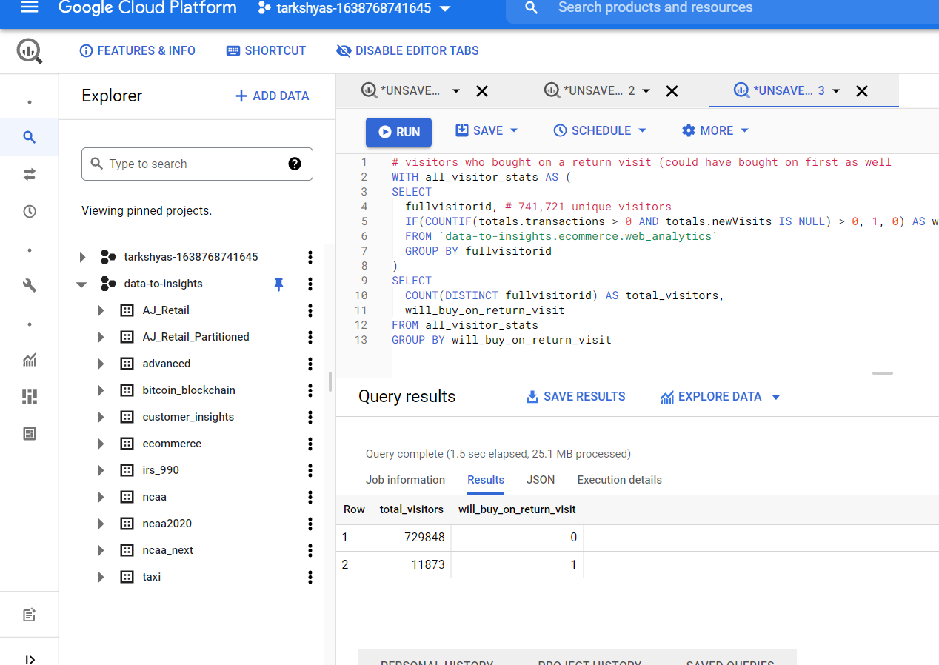

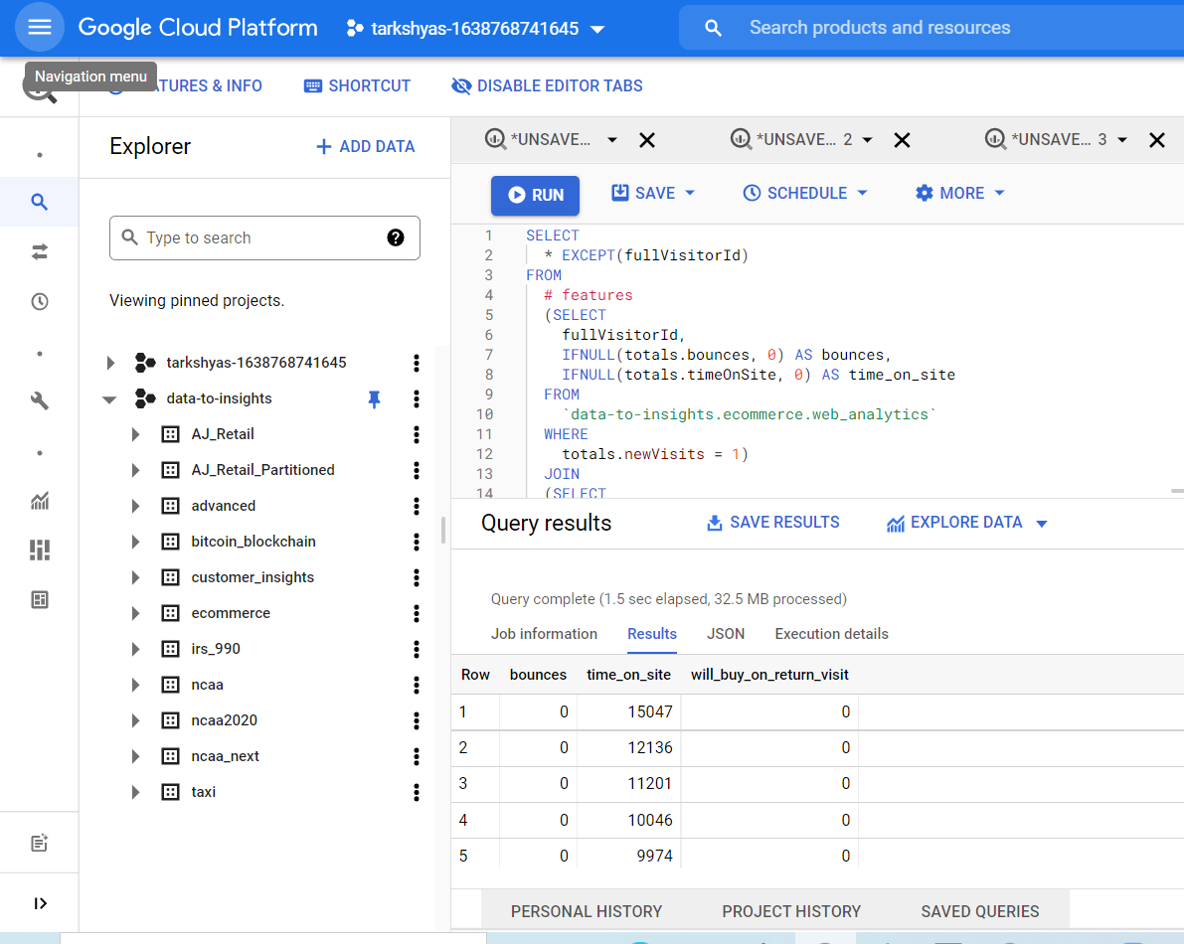

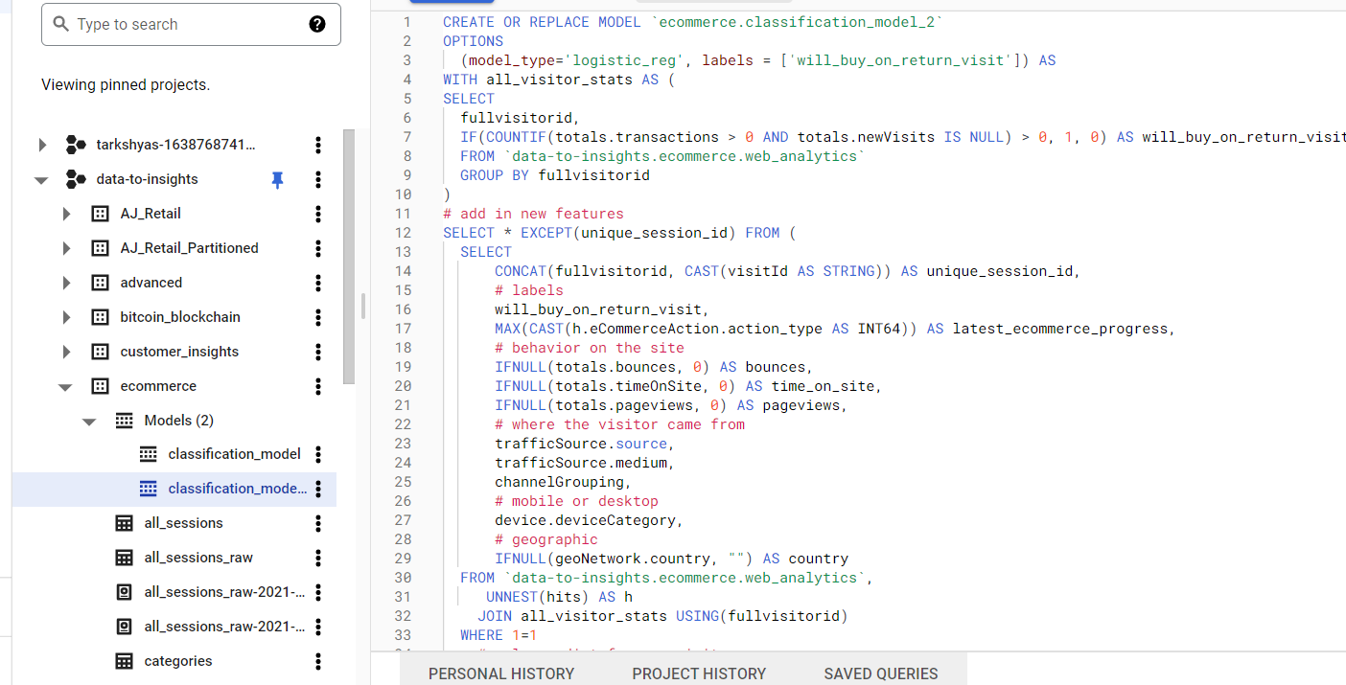

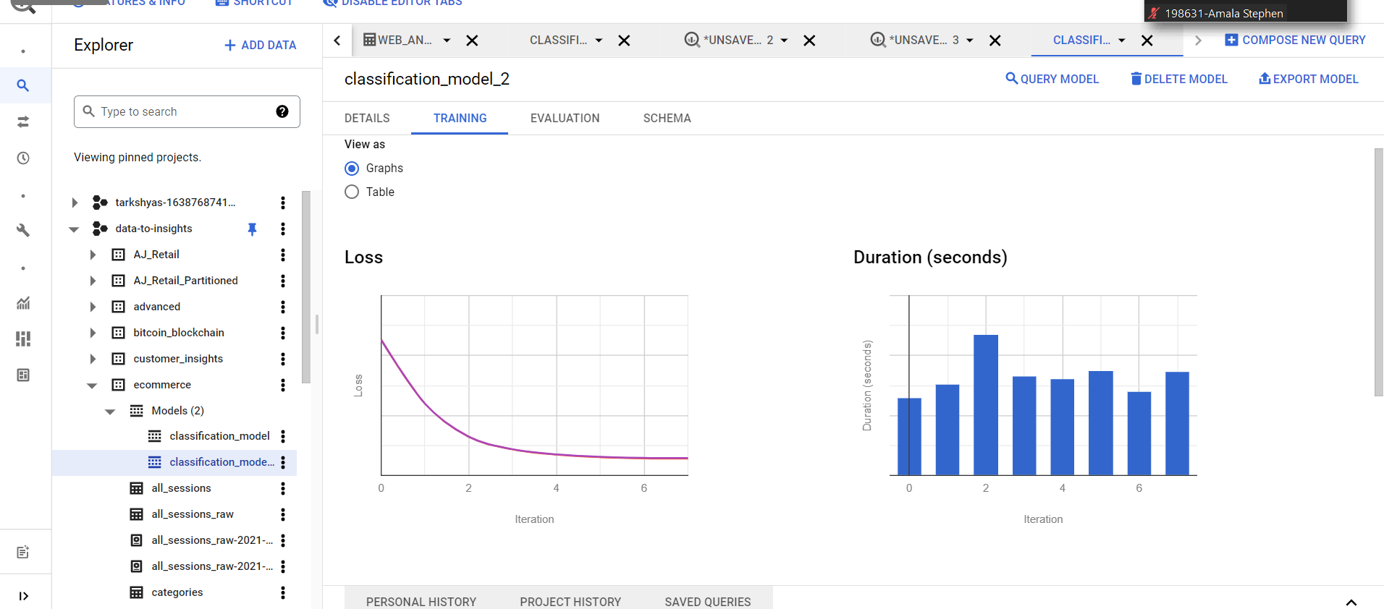

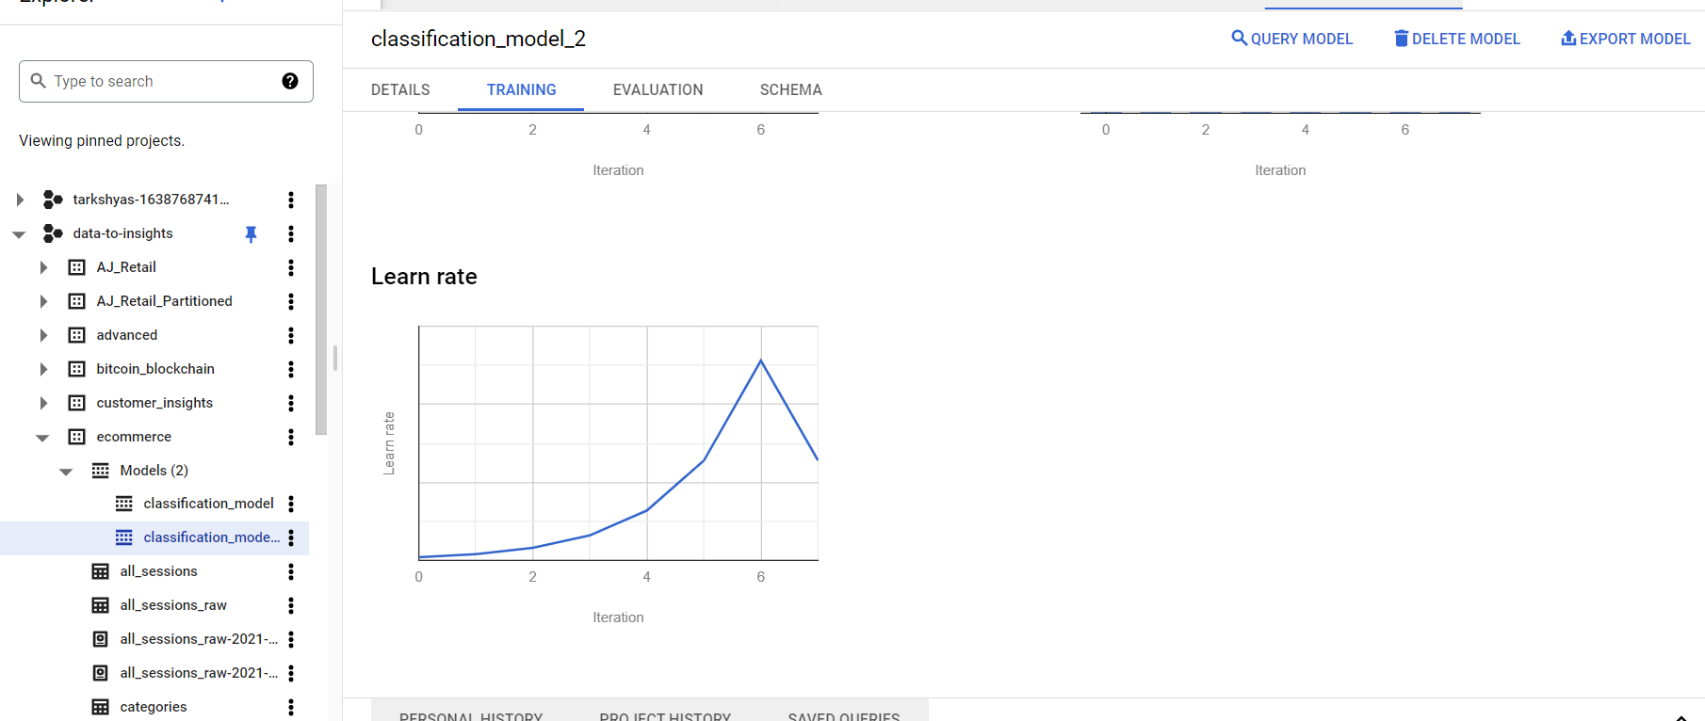

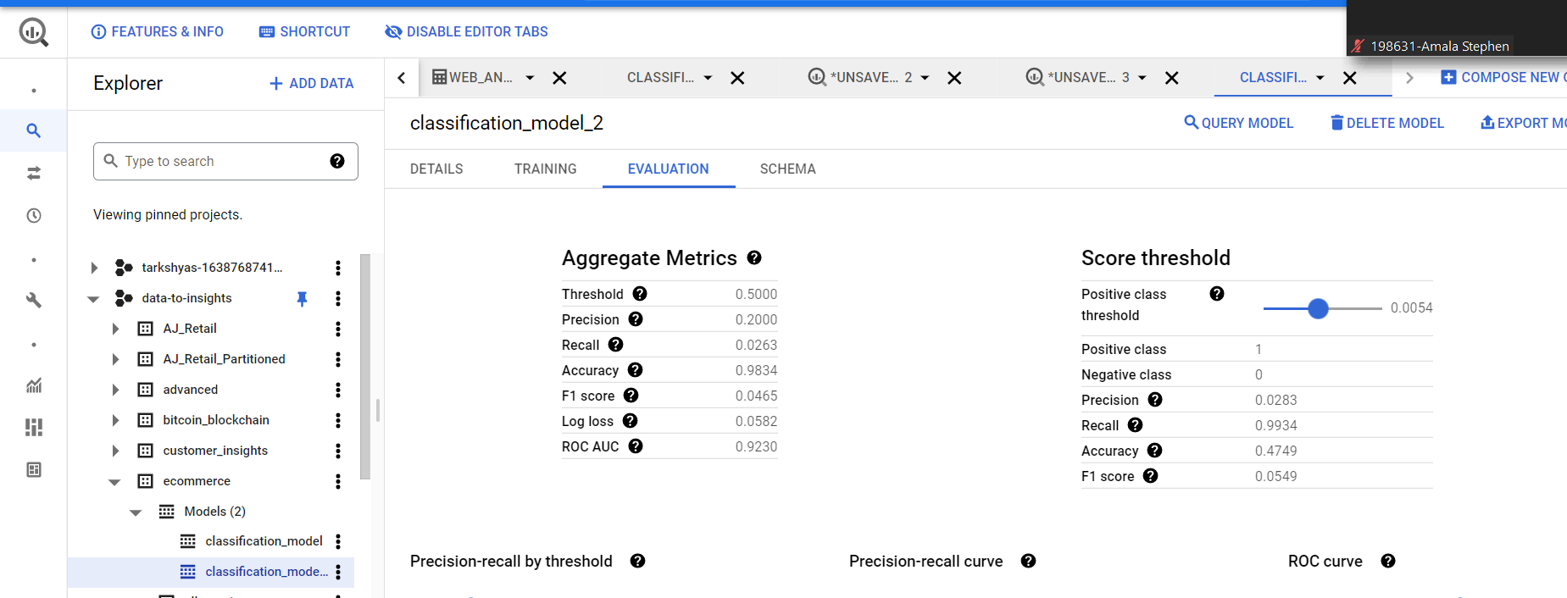

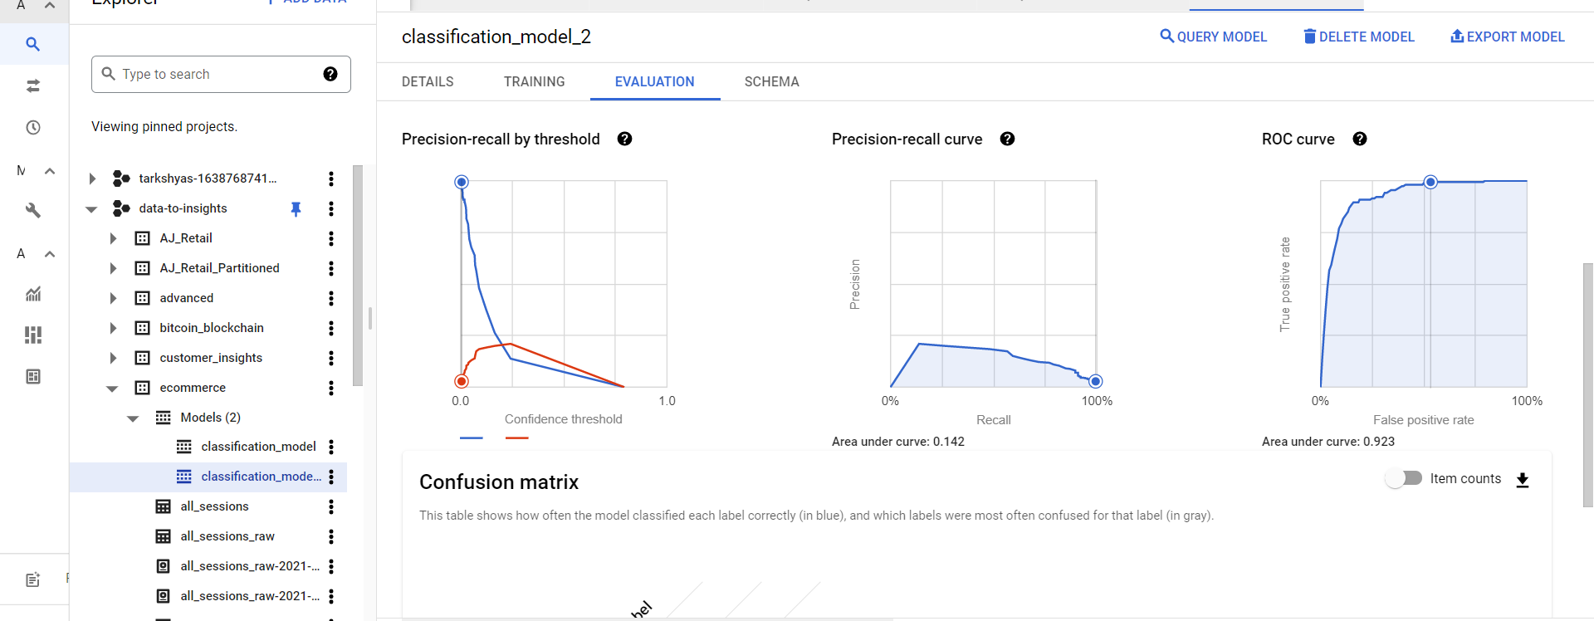

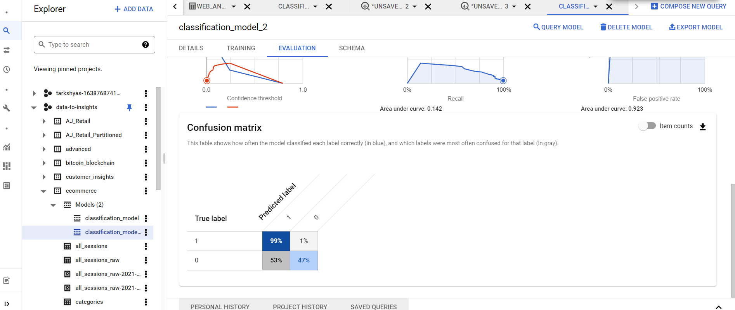

**Q9. TCP**

**Create instance template**

**Create instance group**

**After that configure tcp load balancing**

